IDP PROJECT REPORT ON

**“TRAVEL AND TOURISM MANAGEMENT SYSTEM”**

**Submitted**

In the partial fulfilment of the requirementsfor the award of the degree of

**BACHELOR OF TECHNOLOGY**

In

**DEPARTMENT OF INFORMATION TECHNOLOGY**

By

Juhi kumari (201FA07075)

Ari Nagajajilli (201FA07060)

# (BATCH NO :02)

**Submitted to:**

Mrs. P. lakshmi

Mr. D. Madhusudhan Rao



**DEPARTMENT OF INFORMATION TECHNOLOGY**

**VIGNAN'S FOUNDATION FOR SCIENCE, TECHNOLOGY AND RESEARCH UNIVERSITY**

(**Accredited by NAAC “A+” grade**)

**Vadlamudi, Guntur.**

**CERTIFICATE**

This is to certify that the Major project Report entitled **“TRAVEL AND TOURISM MANAGEMENT SYSTEM”** that is being submitted by **JUHI KUMARI (201FA07075) & NAGA JAJILLI (201FA07060) in** partial fulfilment for the award of B.Tech degree in INFORMATION TECHNOLOGY to the Vignan’s Foundation for Science, Technology and Research, Deemed to be University, is a record of bona fide work carried out by them in the IT Department.

Mrs. P. lakshmi

Mr. D. Madhusudhan Rao Dr. Krishna Kishore

**Under the guidance of Head of the Department**

**External Examiner**

**TABLE OF CONTENTS:**

|  |  |  |
| --- | --- | --- |
| **S.NO** | **CONTENTS** | **PG.NO** |
| **1.** | ABSTRACT | **4** |
| **2.** | INTRODUCTION | **5** |
| **3.** | SYSTEM ENVIRONMENT | **6** |
| **4.** | ANALYSIS | **7** |
| **5.** | DESIGN | **11** |
| **6.** | IMPLEMENTATION | **19** |
| **7.** | RESULTS | **79** |
| **8.** | TESTING | **83** |
| **9.** | CONCLUSION | **84** |

**1.ABSTRACT**

Tourism Management System is a complete tourist fully integrated tourism web site. The web site covers all the areas required for an including tourism; this project is developed to manage the tourist in the tourism management web site. The main module in this project is login, tourist management, complaints and reports. This project mainly deals with Online Bus Reservations.

This project helps customers to reserve bus tickets online. When a customer wishes to book a ticket for a bus, he can visit this website and select the source and destination points along with the date of journey and category of the bus he/she wants.

The objective of the project is to develop a system that automates the processes and activities of a travel and. The purpose is to design a system using which one can perform all operations related to traveling.

**2.INTRODUCTION**

The project is to develop a system that automates the process of a travel. The Travel and Tourism Management System is a web-based application and maintains a centralized repository of all related information. this project is to develop a system that automates the processes and activities of a travel agency. In the present system a customer has to approach various agencies to find details of places and to book tickets. This often requires a lot of time and effort. A customer may not get the desired information from these offices and often the customer may be misguided.

**3.SYSTEM ENVIRONMENT**

**SOFTWARE REQUIREMENTS:**

|  |  |  |
| --- | --- | --- |
| Operating System | : Windows | |
| Technology |  | : Java and J2EE |
| Web Technologies |  | : Html, JavaScript, CSS |
| IDE |  | : My Eclipse |
| Web Server |  | : Tomcat |
| Database |  | : MySql5.0 |
| Java Version |  | : J2SDK1.5 |

**HARDWARE REQUIREMENTS**:

Hardware : Pentium

RAM : 1GB

**4.ANALYSIS**

**EXISTING SYSTEM:**

In the present system a customer has to approach various agencies to find details of places and to book tickets. This often requires a lot of time and effort. A customer may not get the desired information from these offices and often the customer may be misguided. It is tedious for a customer to plan a particular journey and have it executed properly.

**PROPOSED SYSTEM:**

The proposed system is a web based application and maintains a centralized repository of all related information. The system allows one to easily access the relevant information and make necessary travel arrangements. Users can decide about places they want to visit and make bookings online for travel and accommodation.

**SOFTWARE TOOL USED:**

The whole Project is divided in two parts the front end and the back end

**Front end:**

The front end is designed using of Java Swings.

**JAVA SWINGS:**

Java Swing is part of Java Foundation Classes. It is used to create window-based applications which makes it suitable for developing lightweight desktop applications. Java Swing is built on top of an abstract windowing toolkit API purely written in Java programming language. Java Swing provides lightweight and platform-independent components, making it suitable and efficient in designing and developing desktop-based applications (systems).

**Back End:**

The back end is designed using MYSQL which is used to design the databases.

**MYSQL:**

MySQL ("My S-Q-L", officially, but also called "My Sequel") is (as of July 2013) the world's second most widely used open-source relational database management system (RDBMS). It is named after co-founder Michael Widenius daughter, My. The SQL phrase stands for Structured Query Language. The MySQL development project has made its source code available under the terms of the GNU General Public License, as well as under a variety of proprietary agreements.

**Number of Modules**

After careful analysis the system has been identified to have the following modules:

1. Administrator module
2. Travels module
3. Routes module
4. Reservations module
5. Testimonials module.

1. **ADMINISTRATOR MODULE:**

This module provides administrator related functionality. Administrator manages all information and has access rights to add, delete, edit and view the data related to places, travels, routes, bookings, restaurants etc.

1. **TRAVELS MODULE:**

This module provides the details of various travel agencies. A user can select the appropriate agency depending on convenience and accessibility.

1. **ROUTES MODULE:**

This module provides information related to various routes connecting sources and destinations. For each route, information such as source, destination, fare, reservation details, pick up points etc are provides. Only administrator can add , delete, edit and manage the data.

Users can only view the information.

1. **RESERVATIONS MODULE:**

This module provides functionalities that allow a user to book tickets or cancel previously booked tickets. The module maintains the details of all reservations made so far and allows administrator to either confirm or reject the bookings.

1. **TESTIMONIALS MODULE:**

Users of this application can post their opinions, complaints and suggestions regarding this portal and services to the administrator. Accordingly, the administrator can take various steps to act on the complaints and suggestions.

**Architecture flow :(N-Tier)**

N-Tier Applications can easily implement the concepts of Distributed Application Design and Architecture. The N-Tier Applications provide strategic benefits to Enterprise Solutions. While 2-tier, client-server can help us create quick and easy solutions and may be used for Rapid Prototyping, they can easily become maintenance and security night mare The N-tier Applications provide specific advantages that are vital to the business continuity of the enterprise. Typical features of a real life n-tier may include the following:

* + Security
  + Availability and Scalability
  + Manageability
  + Easy Maintenance
  + Data Abstraction

The above mentioned points are some of the key design goals of a successful n-tier application that intends to provide a good Business Solution.

**Definition:**

Simply stated, an n-tier application helps us distribute the overall functionality into various tiers or layers:

* + Presentation Layer
  + Business Logic layer
  + Data Link Layer
  + Database/Data Store

Each layer can be developed independently of the other provided that it adheres to the standards and communicates with the other layers as per the specifications. This is the one of the biggest advantages of the n-tier application. Each layer can potentially treat the other layer as a ‘BlockBox’. In other words, each layer does not care how other layer processes the data as long as it sends the right data in a correct format.

1. **Presentation Layer:**

Also called as client layer, comprises of components that are dedicated to presenting the data to the user. For example: Windows/Web Forms and buttons, edit boxes, Text boxes, labels, grids, etc.

1. **Business Logic Layer:**

This layer encapsulates the Business rules or the business logic of the encapsulations. To have a separate layer for business logic is of a great advantage. This is because any changes in Business Rules can be easily handled in this layer. As long as the interface between the layers remains the same, any changes to the functionality/processing logic in this layer can be made without impacting the others. A lot of client-server apps failed to implement successfully as changing the business logic was a painful process.

1. **Data Link Layer:**

This layer comprises of components that help in accessing the Database. If used in the right way, this layer provides a level of abstraction for the database structures. Simply put changes made to the database, tables, etc. do not affect the rest of the application because of the Data Access layer. The different application layers send the data requests to this layer and receive the response from this layer.

1. **Database Layer:**

This layer comprises of the Database Components such as DB Files, Tables, Views, etc. The Actual database could be created using SQL Server, Oracle, Flat files, etc. In an n-tier application, the entire application can be implemented in such a way that it is independent of the actual Database. For instance, you could change the Database Location with minimal changes to Data Access Layer. The rest of the Application should remain unaffected.

**5.DESIGN**

**DATA FLOW DIAGRAM:**

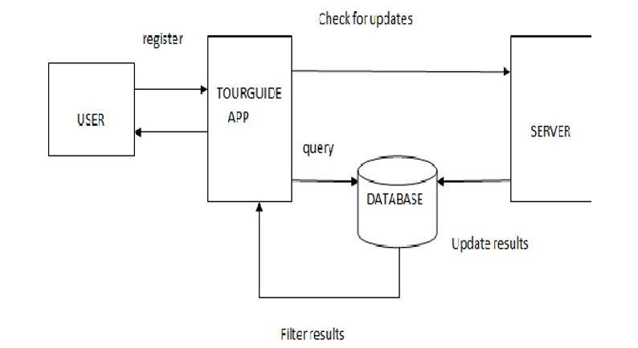

**ER-Diagram:**

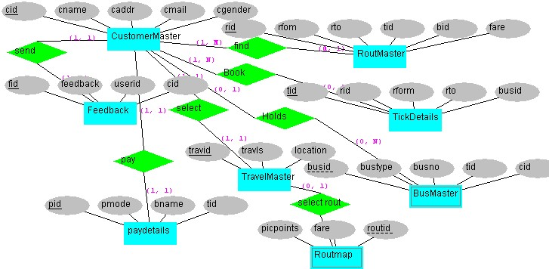

**Level 1 DFD for Administrator:**

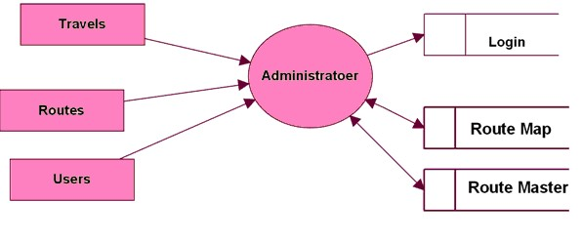

**Level 1 DFD for Users:**

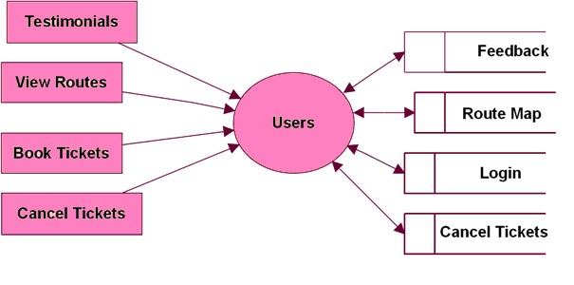

**Level 2 DFD for Travels:**

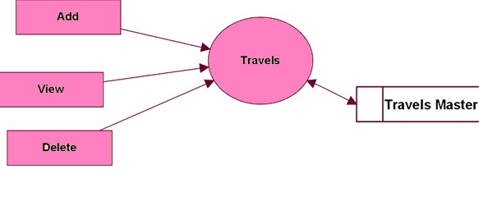

**Level 2 DFD for Routes:**

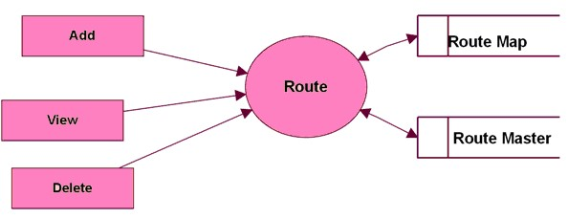

**Level 2 DFD for Pickup Points:**

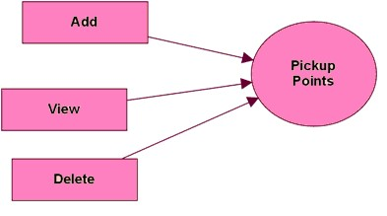

**Level 2 DFD for Booking Modules:**

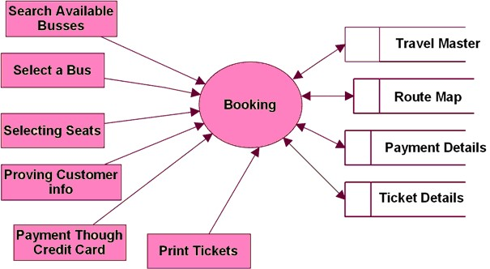

**Level 3 DFD for Testimonial:**

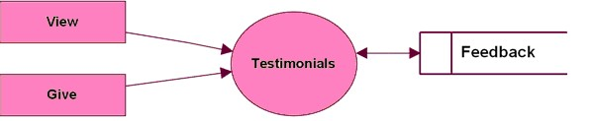

**Use case Diagram:**

Admin

Add

Route

View Routes

Delete Routes

Add Travel

View Travel

s

Delete Travels

Add Busses

View Busses

Add Pickup Points

View Pickup Points

Customer

Search For A Bus

View Seats

Availability

Book Tickets

Cancel Tickets

Feed Back

Testimonials

**Backend Diagrams:**

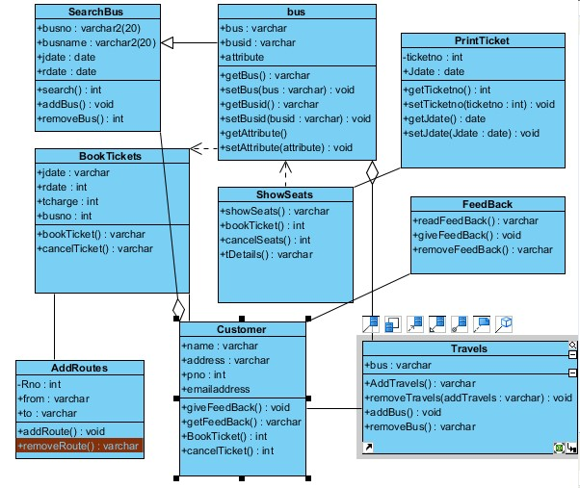

**6. IMPLEMENTATION Database source code:-**

create table aadmin(adminEmail varchar2(60),adminpassword varchar2(30))

desc aadmin

select * from aadmin

insert into aadmin values('Suraj@gmail.com','Suraj@123')

insert into aadmin values('javascript@gmail.com','javascript')

insert into aadmin values('juhi@gmail.com','Juhi@gmail.com')

[create table adminlogin(adminemail varchar(20),adminpassword varchar(20))](javascript:sc_postHistory('732320118266271','SYSTEM');)

[insert into adminlogin values('juhi1@gmail.com','juhikarn')](javascript:sc_postHistory('732505011271293','SYSTEM');)

**HOME1.html:**

<html lang="en">

<head>

<title>Page title</title>

<meta charset="UTF-8">

<meta name="viewport" content="width=device-width,initial-scale=1">

<style>

body{

font-family:Arial;

margin:0;

}

.header {

padding: 10px;

background:white;

color: black;

font-size:30px;

}

.content{

padding: 0px;

border: #FFFF00;

border-width: 5px ;

border-style:solid;

}

.text-footer {

text-align: center;

padding: 30px 0;

font-family: 'Ubuntu', sans-serif;

display: flex;

justify-content: center;

color: black;

}

.dropbtn {

color: black;

font-size: 22px;

border: none;

}

.dropdown {

display: inline-block;

}

.dropdown-content {

display: none;

position: absolute;

background-color: #f1f1f1;

min-width: 100px;

box-shadow: 0px 20px 40px 0px rgba(0,0,0,0.2);

z-index: 1;

}

.dropdown-content a {

color: black;

padding: 80px 100px;

text-decoration: none;

display: block;

}

.dropdown-content a:hover {background-color: none;}

.dropdown:hover .dropdown-content {display: block;}

</style>

</head>

<body>

<div class="header">

<H1><table>

<tr>

<td>

<img src="image/pic2.png" style="width:220px;height:120px;">&nbsp;&nbsp;&nbsp;&nbsp;&nbsp;&nbsp;&nbsp;&nbsp;&nbsp;&nbsp;&nbsp;&nbsp;</td>

<td><a href="HOME1.html" style="text-decoration: none ;color:YELLOW;font-size:20px" > HOME |</a>&nbsp;&nbsp;&nbsp;</td>

<td><a href="MANAGEBOOK.html" style="text-decoration: none ;color:black;font-size:20px" > MANAGE BOOKINGS |</a>&nbsp;&nbsp;&nbsp;</td>

<td><a href="GALLERY.html" style="text-decoration: none ;color:black;font-size:20px" > GALLERY |</a>&nbsp;&nbsp;&nbsp;</td>

<td><a href="TRACK.html" style="text-decoration: none ;color:black;font-size:20px" > TRACK |</a>&nbsp;&nbsp;&nbsp;</td>

<td><a href="CONTACT.html" style="text-decoration: none ;color:black;font-size:20px" > CONTACT |</a>&nbsp;&nbsp;&nbsp;</td>

<td><a href="aboutus.html" style="text-decoration: none ;color:black;font-size:20px" > ABOUT US |</a>&nbsp;&nbsp;&nbsp;</td>

<td><a href="help.html" style="text-decoration: none ;color:black;font-size:20px" >HELP |</a>&nbsp;&nbsp;&nbsp;</td>

<td><a href="logout.html" style="text-decoration: none ;color:black;font-size:20px" > LOGOUT | </a></td>

<td>

<div class="dropdown">

<button class="dropbtn">LOGIN</button>

<div class="dropdown-content">

<form action="admin.html">

<center><button type="submit">Admin login</button></center>

</form>

<form action="user.html">

<center><button type="submit">User login</button></center>

</form>

</div>

</div>

</td>

</tr>

</table>

</H1>

</div>

<div class="content">

<img src="image/pic1.jpg" style="width:1514px;height:600px;">

</div>

<footer class="background">

<p class="text-footer">

Copyright ©-All rights are reserved

</p>

</footer>

</body>

</html>

**Contact.html:**

<html lang="en">

<head>

<title>Page title</title>

<meta charset="UTF-8">

<meta name="viewport" content="width=device-width,initial-scale=1">

<style>

body{

font-family:Arial;

margin:0;

}

.header {

padding: 10px;

background:white;

color: black;

font-size:30px;

}

.content{

padding: 0px;

background-color:#D3D3D3;

border: #FFFF00;

border-width: 5px 1px;

border-style:solid;

}

.text-footer {

text-align: center;

padding: 30px 0;

font-family: 'Ubuntu', sans-serif;

display: flex;

justify-content: center;

color: black;

}

.dropbtn {

color: black;

font-size: 22px;

border: none;

}

.dropdown {

display: inline-block;

}

.dropdown-content {

display: none;

position: absolute;

background-color: #f1f1f1;

min-width: 90px;

box-shadow: 0px 8px 16px 0px rgba(0,0,0,0.2);

z-index: 1;

}

.dropdown-content a {

color: black;

padding: 14px 16px;

text-decoration: none;

display: block;

}

.dropdown-content a:hover {background-color: none;}

.dropdown:hover .dropdown-content {display: block;}

</style>

</head>

<body>

<div class="header">

<H1><table><tr><td>

<img src="image/pic2.png" style="width:220px;height:120px;">&nbsp;&nbsp;&nbsp;&nbsp;&nbsp;&nbsp;&nbsp;&nbsp;&nbsp;&nbsp;&nbsp;&nbsp;</td>

<td><a href="HOME1.html" style="text-decoration: none ;color:YELLOW;font-size:20px" > HOME |</a>&nbsp;&nbsp;&nbsp;</td>

<td><a href="magagebook.html" style="text-decoration: none ;color:black;font-size:20px" > MANAGE BOOKINGS |</a>&nbsp;&nbsp;&nbsp;</td>

<td><a href="GALLERY.html" style="text-decoration: none ;color:black;font-size:20px" > GALLERY |</a>&nbsp;&nbsp;&nbsp;</td>

<td><a href="TRACK.html" style="text-decoration: none ;color:black;font-size:20px" > TRACK |</a>&nbsp;&nbsp;&nbsp;</td>

<td><a href="CONTACT.html" style="text-decoration: none ;color:black;font-size:20px" > CONTACT |</a>&nbsp;&nbsp;&nbsp;</td>

<td><a href="aboutus.html" style="text-decoration: none ;color:black;font-size:20px" > ABOUT US |</a>&nbsp;&nbsp;&nbsp;</td>

<td><a href="help.html" style="text-decoration: none ;color:black;font-size:20px" >HELP |</a>&nbsp;&nbsp;&nbsp;</td>

<td><a href="logout.html" style="text-decoration: none ;color:black;font-size:20px" > LOGOUT | </a></td>

<td>

<div class="dropdown">

<button class="dropbtn">LOGIN</button>

<div class="dropdown-content">

<form action="admin.html">

<center><button type="submit">Admin login</button></center>

</form>

<form action="user.html">

<center><button type="submit">User login</button></center>

</form>

</div>

</div>

</td>

</tr>

</table>

</H1>

<div class="content">

<table><tr><td>

<h2 class="page_title"> Contact Us</h2>

<div class="contact_detail">

<ul class="contact-info">

<li class="office"> <p>Corporate Office</p></li>

<li> <p>

<b>Vignan University,vadlamudi</b><br>

Tenali,

Guntur,<br/>

Andhrapradesh-522213</p></li>

<li class="phone"><p><i class="fa fa-phone fa-fw"></i>9142074956, 9441490483</p></li>

<li><p><i class="fa fa-envelope fa-fw"></i><a href="mailto:support@spbus.in" target="_blank">support@spbus.in</a></p></li>

</ul>

</div>

</td>

<td>state:<select name="forma" onchange="location = this.value;">

<option>chhaisgarh</option>

<option>bengal</option>

<option>karnataka</option>

<option>tamilnadu</option>

<option>bihar</option>

<option>telangana</option>

<option>jammu kashmir</option>

<option>ladakh</option>

<option>Himachal pradesh</option>

<option>uttrakhand</option>

<option>punjab</option>

<option>Hariyana</option>

<option>rajsthan</option>

<option>madhyapradesh</option>

<option>Uttarpradesh</option>

<option value="delhi.html">Delhi</option>

<option>jharkhand</option>

<option>Assam</option>

<option>Arunachal pradesh</option>

<option>Manipur</option>

<option>Meghalaya</option>

<option>mizoram</option>

<option>nagaland</option>

<option>odisha</option>

<option>sikkim</option>

<option>tamilnadu</option>

<option>gujrat</option>

<option>tripura</option>

<option>maharastra</option>

<option>kerala</option>

<option selected>Andhrapradesh</option>

</select> <br>

</td>

</tr>

</table>

</div>

<footer class="background">

<p class="text-footer">

Copyright ©-All rights are reserved

</p>

</footer>

</body>

</html>

**Gallery.html:**

<html lang="en">

<head>

<title>Page title</title>

<meta charset="UTF-8">

<meta name="viewport" content="width=device-width,initial-scale=1">

<style>

body{

font-family:Arial;

margin:0;

}

.header {

padding: 10px;

background:white;

color: black;

font-size:30px;

}

.content{

padding: 0px;

background-color:#D3D3D3;

border: #FFFF00;

border-width: 5px 1px;

border-style:solid;

}

.text-footer {

text-align: center;

padding: 30px 0;

font-family: 'Ubuntu', sans-serif;

display: flex;

justify-content: center;

color: black;

}

.dropbtn {

color: black;

font-size: 22px;

border: none;

}

.dropdown {

display: inline-block;

}

.dropdown-content {

display: none;

position: absolute;

background-color: #f1f1f1;

min-width: 90px;

box-shadow: 0px 8px 16px 0px rgba(0,0,0,0.2);

z-index: 1;

}

.dropdown-content a {

color: black;

padding: 14px 16px;

text-decoration: none;

display: block;

}

.dropdown-content a:hover {background-color: none;}

.dropdown:hover .dropdown-content {display: block;}

</style>

</head>

<body>

<div class="header">

<H1><table><tr><td>

<img src="image/pic2.png" style="width:220px;height:120px;">&nbsp;&nbsp;&nbsp;&nbsp;&nbsp;&nbsp;&nbsp;&nbsp;&nbsp;&nbsp;&nbsp;&nbsp;</td>

<td><a href="HOME1.html" style="text-decoration: none ;color:YELLOW;font-size:20px" > HOME |</a>&nbsp;&nbsp;&nbsp;</td>

<td><a href="magagebook.html" style="text-decoration: none ;color:black;font-size:20px" > MANAGE BOOKINGS |</a>&nbsp;&nbsp;&nbsp;</td>

<td><a href="GALLERY.html" style="text-decoration: none ;color:black;font-size:20px" > GALLERY |</a>&nbsp;&nbsp;&nbsp;</td>

<td><a href="TRACK.html" style="text-decoration: none ;color:black;font-size:20px" > TRACK |</a>&nbsp;&nbsp;&nbsp;</td>

<td><a href="CONTACT.html" style="text-decoration: none ;color:black;font-size:20px" > CONTACT |</a>&nbsp;&nbsp;&nbsp;</td>

<td><a href="aboutus.html" style="text-decoration: none ;color:black;font-size:20px" > ABOUT US |</a>&nbsp;&nbsp;&nbsp;</td>

<td><a href="help.html" style="text-decoration: none ;color:black;font-size:20px" >HELP |</a>&nbsp;&nbsp;&nbsp;</td>

<td><a href="logout.html" style="text-decoration: none ;color:black;font-size:20px" > LOGOUT | </a></td>

<!DOCTYPE html>

<td>

<div class="dropdown">

<button class="dropbtn">LOGIN</button>

<div class="dropdown-content">

<form action="admin.html">

<center><button type="submit">Admin login</button></center>

</form>

<form action="user.html">

<center><button type="submit">User login</button></center>

</form>

</div>

</div>

</td>

</tr>

</table>

</H1>

<div class="content">

<table>

<tr>

<th>Speed</th>

<th>Safety</th>

<th>Comfort</th>

</tr>

<tr>

<td>&nbsp;&nbsp;&nbsp;&nbsp;&nbsp;&nbsp;&nbsp;&nbsp;<a href="#"> <img src="image/bus1.png" style="width:400px;height:300px;"> </a>&nbsp;&nbsp;&nbsp;&nbsp;&nbsp;&nbsp;&nbsp;&nbsp;&nbsp;&nbsp;&nbsp;&nbsp;&nbsp;&nbsp;&nbsp;&nbsp;&nbsp;&nbsp;&nbsp;&nbsp;&nbsp;&nbsp;</td>

<td><a href="#"> <img src="image/bus2.png" style="width:400px;height:300px;"> </a>&nbsp;&nbsp;&nbsp;&nbsp;&nbsp;&nbsp;&nbsp;&nbsp;&nbsp;&nbsp;&nbsp;&nbsp;&nbsp;&nbsp;&nbsp;&nbsp;&nbsp;&nbsp;&nbsp;&nbsp;&nbsp;&nbsp;</td>

<td><a href="#"> <img src="image/bus3.png" style="width:400px;height:300px;"> </a>

</td>

</tr>

</table>

</div>

<footer class="background">

<p class="text-footer">

Copyright ©-All rights are reserved

</p>

</footer>

</body>

</html>

**Managebook.html:**

<html lang="en">

<head>

<title>Page title</title>

<meta charset="UTF-8">

<meta name="viewport" content="width=device-width,initial-scale=1">

<style>

body{

font-family:Arial;

margin:0;

}

.header {

padding: 10px;

background:white;

color: black;

font-size:30px;

}

.text-footer {

text-align: center;

padding: 30px 0;

font-family: 'Ubuntu', sans-serif;

display: flex;

justify-content: center;

color: black;

}

.dropbtn {

color: black;

font-size: 22px;

border: none;

}

.dropdown {

display: inline-block;

}

.dropdown-content {

display: none;

position: absolute;

background-color: #f1f1f1;

min-width: 90px;

box-shadow: 0px 8px 16px 0px rgba(0,0,0,0.2);

z-index: 1;

}

.dropdown-content a {

color: black;

padding: 14px 16px;

text-decoration: none;

display: block;

}

.dropdown-content a:hover {background-color: none;}

.dropdown:hover .dropdown-content {display: block;}

* {

box-sizing: border-box;

}

/* Style inputs */

input[type=text], select, textarea {

width: 50%;

padding: 12px;

border: 1px solid #ccc;

margin-top: 6px;

margin-bottom: 16px;

resize: vertical;

}

input[type=submit] {

background-color:yellow;

color: black;

padding: 12px 20px;

border: none;

cursor: pointer;

}

input[type=submit]:hover {

background-color: black;

}

/* Style the container/contact section */

.container {

border-radius: 5px;

background-color: #f2f2f2;

padding: 5px;

border: #FFFF00;

border-width: 5px 1px;

border-style:solid;

}

/* Clear floats after the columns */

.row:after {

content: "";

display: table;

clear: both;

}

.column {

width: 50%;

margin-top: 6px;

padding: 20px;

}

/* Responsive layout - when the screen is less than 600px wide, make the two columns stack on top of each other instead of next to each other */

@media screen and (max-width: 600px) {

.column, input[type=submit] {

width: 100%;

margin-top: 0;

}

}

</style>

</head>

<body>

<div class="header">

<H1><table><tr><td>

<img src="image/pic2.png" style="width:220px;height:120px;">&nbsp;&nbsp;&nbsp;&nbsp;&nbsp;&nbsp;&nbsp;&nbsp;&nbsp;&nbsp;&nbsp;&nbsp;</td>

<td><a href="HOME1.html" style="text-decoration: none ;color:YELLOW;font-size:20px" > HOME |</a>&nbsp;&nbsp;&nbsp;</td>

<td><a href="MANAGEBOOK.html" style="text-decoration: none ;color:black;font-size:20px" > MANAGE BOOKINGS |</a>&nbsp;&nbsp;&nbsp;</td>

<td><a href="GALLERY.html" style="text-decoration: none ;color:black;font-size:20px" > GALLERY |</a>&nbsp;&nbsp;&nbsp;</td>

<td><a href="TRACK.html" style="text-decoration: none ;color:black;font-size:20px" > TRACK |</a>&nbsp;&nbsp;&nbsp;</td>

<td><a href="CONTACT.html" style="text-decoration: none ;color:black;font-size:20px" > CONTACT |</a>&nbsp;&nbsp;&nbsp;</td>

<td><a href="aboutus.html" style="text-decoration: none ;color:black;font-size:20px" > ABOUT US |</a>&nbsp;&nbsp;&nbsp;</td>

<td><a href="help.html" style="text-decoration: none ;color:black;font-size:20px" >HELP |</a>&nbsp;&nbsp;&nbsp;</td>

<td><a href="logout.html" style="text-decoration: none ;color:black;font-size:20px" > LOGOUT | </a></td>

<td>

<div class="dropdown">

<button class="dropbtn">LOGIN</button>

<div class="dropdown-content">

<form action="admin.html">

<center><button type="submit">Admin login</button></center>

</form>

<form action="user.html">

<center><button type="submit">User login</button></center>

</form>

</div>

</div>

</td>

</tr>

</table>

</H1>

<div class="container">

<div class="column">

<h2 style="color:black;">Manage Bookings</h2>

</div>

<div class="row">

<form action="/action_page.php">

<input type="text" id="fname" name="firstname" placeholder="Ticket Number">

<input type="text" id="lname" name="lastname" placeholder="Email or Phone Number"><br>

<input type="submit" value="Submit">

</form>

</div>

</div>

</div>

<footer class="background">

<p class="text-footer">

Copyright ©-All rights are reserved

</p>

</footer>

</body>

</html>

**Track.html:**

<html lang="en">

<head>

<title>Page title</title>

<meta charset="UTF-8">

<meta name="viewport" content="width=device-width,initial-scale=1">

<style>

body{

font-family:Arial;

margin:0;

}

.header {

padding: 10px;

background:white;

color: black;

font-size:30px;

}

.text-footer {

text-align: center;

padding: 30px 0;

font-family: 'Ubuntu', sans-serif;

display: flex;

justify-content: center;

color: black;

}

.dropbtn {

color: black;

font-size: 22px;

border: none;

}

.dropdown {

display: inline-block;

}

.dropdown-content {

display: none;

position: absolute;

background-color: #f1f1f1;

min-width: 90px;

box-shadow: 0px 8px 16px 0px rgba(0,0,0,0.2);

z-index: 1;

}

.dropdown-content a {

color: black;

padding: 14px 16px;

text-decoration: none;

display: block;

}

.dropdown-content a:hover {background-color: none;}

.dropdown:hover .dropdown-content {display: block;}

* {

box-sizing: border-box;

}

/* Style inputs */

input[type=number], select, textarea {

width: 50%;

padding: 12px;

border: 1px solid #ccc;

margin-top: 6px;

margin-bottom: 16px;

resize: vertical;

}

input[type=submit] {

background-color:yellow;

color: black;

padding: 12px 20px;

border: none;

cursor: pointer;

}

input[type=submit]:hover {

background-color: black;

}

/* Style the container/contact section */

.container {

border-radius: 5px;

background-color: #f2f2f2;

padding: 5px;

border: #FFFF00;

border-width: 5px 1px;

border-style:solid;

}

/* Clear floats after the columns */

.row:after {

content: "";

display: table;

clear: both;

}

.column {

width: 50%;

margin-top: 6px;

padding: 20px;

}

/* Responsive layout - when the screen is less than 600px wide, make the two columns stack on top of each other instead of next to each other */

@media screen and (max-width: 600px) {

.column, input[type=submit] {

width: 100%;

margin-top: 0;

}

}

</style>

</head>

<body>

<div class="header">

<H1><table><tr><td>

<img src="image/pic2.png" style="width:220px;height:120px;">&nbsp;&nbsp;&nbsp;&nbsp;&nbsp;&nbsp;&nbsp;&nbsp;&nbsp;&nbsp;&nbsp;&nbsp;</td>

<td><a href="HOME1.html" style="text-decoration: none ;color:YELLOW;font-size:20px" > HOME |</a>&nbsp;&nbsp;&nbsp;</td>

<td><a href="magagebook.html" style="text-decoration: none ;color:black;font-size:20px" > MANAGE BOOKINGS |</a>&nbsp;&nbsp;&nbsp;</td>

<td><a href="GALLERY.html" style="text-decoration: none ;color:black;font-size:20px" > GALLERY |</a>&nbsp;&nbsp;&nbsp;</td>

<td><a href="TRACK.html" style="text-decoration: none ;color:black;font-size:20px" > TRACK |</a>&nbsp;&nbsp;&nbsp;</td>

<td><a href="CONTACT.html" style="text-decoration: none ;color:black;font-size:20px" > CONTACT |</a>&nbsp;&nbsp;&nbsp;</td>

<td><a href="aboutus.html" style="text-decoration: none ;color:black;font-size:20px" > ABOUT US |</a>&nbsp;&nbsp;&nbsp;</td>

<td><a href="help.html" style="text-decoration: none ;color:black;font-size:20px" >HELP |</a>&nbsp;&nbsp;&nbsp;</td>

<td><a href="logout.html" style="text-decoration: none ;color:black;font-size:20px" > LOGOUT | </a></td>

<td>

<div class="dropdown">

<button class="dropbtn">LOGIN</button>

<div class="dropdown-content">

<form action="admin.html">

<center><button type="submit">Admin login</button></center>

</form>

<form action="user.html">

<center><button type="submit">User login</button></center>

</form>

</div>

</div>

</td>

</tr>

</table>

</H1>

<div class="container">

<div class="column">

<h2 style="color:black;">Track Your Shipment</h2>

</div>

<div class="row">

<form action="/action_page.php">

<input type="number" id="fname" name="firstname" placeholder="Your Tracking Number"><br>

<input type="submit" value="Search">

</form>

</div>

</div>

</div>

<footer class="background">

<p class="text-footer">

Copyright ©-All rights are reserved

</p>

</footer>

</body>

</html>

**aboutus.html:**

<html lang="en">

<head>

<title>Page title</title>

<meta charset="UTF-8">

<meta name="viewport" content="width=device-width,initial-scale=1">

<style>

body{

font-family:Arial;

margin:0;

}

.header {

padding: 10px;

background:white;

color: black;

font-size:30px;

}

.content{padding: 0px;

background-color:#D3D3D3;

border: #FFFF00;

border-width: 5px 1px;

border-style:solid;

}

.text-footer {

text-align: center;

padding: 30px 0;

font-family: 'Ubuntu', sans-serif;

display: flex;

justify-content: center;

color: black;

}

.dropbtn {

color: black;

font-size: 22px;

border: none;

}

.dropdown {

display: inline-block;

}

.dropdown-content {

display: none;

position: absolute;

background-color: #f1f1f1;

min-width: 90px;

box-shadow: 0px 8px 16px 0px rgba(0,0,0,0.2);

z-index: 1;

}

.dropdown-content a {

color: black;

padding: 14px 16px;

text-decoration: none;

display: block;

}

.dropdown-content a:hover {background-color: none;}

.dropdown:hover .dropdown-content {display: block;}

</style>

</head>

<body>

<div class="header">

<H1><table><tr><td>

<img src="image/pic2.png" style="width:220px;height:120px;">&nbsp;&nbsp;&nbsp;&nbsp;&nbsp;&nbsp;&nbsp;&nbsp;&nbsp;&nbsp;&nbsp;&nbsp;</td>

<td><a href="HOME1.html" style="text-decoration: none ;color:YELLOW;font-size:20px" > HOME |</a>&nbsp;&nbsp;&nbsp;</td>

<td><a href="magagebook.html" style="text-decoration: none ;color:black;font-size:20px" > MANAGE BOOKINGS |</a>&nbsp;&nbsp;&nbsp;</td>

<td><a href="GALLERY.html" style="text-decoration: none ;color:black;font-size:20px" > GALLERY |</a>&nbsp;&nbsp;&nbsp;</td>

<td><a href="TRACK.html" style="text-decoration: none ;color:black;font-size:20px" > TRACK |</a>&nbsp;&nbsp;&nbsp;</td>

<td><a href="CONTACT.html" style="text-decoration: none ;color:black;font-size:20px" > CONTACT |</a>&nbsp;&nbsp;&nbsp;</td>

<td><a href="aboutus.html" style="text-decoration: none ;color:black;font-size:20px" > ABOUT US |</a>&nbsp;&nbsp;&nbsp;</td>

<td><a href="help.html" style="text-decoration: none ;color:black;font-size:20px" >HELP |</a>&nbsp;&nbsp;&nbsp;</td>

<td><a href="logout.html" style="text-decoration: none ;color:black;font-size:20px" > LOGOUT | </a></td>

<td>

<div class="dropdown">

<button class="dropbtn">LOGIN</button>

<div class="dropdown-content">

<form action="admin.html">

<center><button type="submit">Admin login</button></center>

</form>

<form action="user.html">

<center><button type="submit">User login</button></center>

</form>

</div>

</div>

</td>

</tr>

</table>

</H1>

</div>

<div class="content">

<h2 style="color:yellow;">Safely promenade Speed - An Overview</h2><br>

<p style="font-size:25px; font-family: Cambria, Cochin, Georgia, Times, 'Times New Roman', serif;">we have many bus stand across Andhrapradesh,Gujarat, Maharashtra, MP, Rajasthan ,bihar,delhi ,UP,and Assam. <br>

You can buy bus ticket, look for bus route, bus timings, video buses, and book bus online at spbus.in. <br>

Our buses are available for booking at red bus, paytm, and other OTAs.<br><br>

SP Bus is one of India's leading passenger mobility companies. Its synonymous with affordable long and <br>

short distance travel in Central, Western and North Eastern India. We service approximately 4.2 million passengers<br>

in our Intercity division every year.<br><br>

SP Bus a subsidiary of Safely Promenade Speed which is present across various modes of transport such as Citybuses,<br>

BRTS, School bus, Staff Bus, Airport bus, Taxis and Bike sharing. SP Speed also run Volvo buses for APSRTC <br>

all across AP and you can book APSRTC bus tickets at our branch offices. We’ve also partnered with other STUs such <br>

as Atal Indore city Transport Services Limited (AiCTSL), Bhopal City Link Limited (BCLL) and Assam State Transport <br>

Corporation (ASTC) for providing government approved stage carriage buses. Travel by our buses for a smooth and comfortable <br>

journey.</p><br><br>

<h2 style="color:yellow;">Corporate Culture</h2><br>

<p style="font-size:25px; font-family: Cambria, Cochin, Georgia, Times, 'Times New Roman', serif;">SP Speed promotes and fosters a unique business environment<br>

through a strong emphasis on combining solid business practices with high character standards and values.</p><br><br>

<h2 style="color:yellow;">Mission & Vision</h2><br>

<p style="font-size:25px; font-family: Cambria, Cochin, Georgia, Times, 'Times New Roman', serif;">Mission:<br>

To be India’s most safe and premium holistic passenger transport company.</p><br><br><br>

<h2 style="color:yellow;">Vision</h2><br>

<p style="font-size:25px; font-family: Cambria, Cochin, Georgia, Times, 'Times New Roman', serif;">With a very strong presence in transportation industry, Chartered Speed will continue<br>

to develop, produce and refine the best and safest products while providing comprehensive support services to promote<br>

customer loyalty and long-term prosperity for all our partners.</p><br><br>

<h2 style="color:yellow;">Strengths</h2><br>

<p style="font-size:25px; font-family: Cambria, Cochin, Georgia, Times, 'Times New Roman', serif;">20+ Years of Experience<br>

<li>Aggressive Team</li><br>

<li>Strong Presence</li><br>

<li> inventory space</li><br>

<li>Larger depot space</li><br>

<li>Skilled manpower</li></p>

<br><br>

<h2 style="color:yellow;">Values</h2><br>

<p style="font-size:25px; font-family: Cambria, Cochin, Georgia, Times, 'Times New Roman', serif;">Reliability<br>

<li>Quality</li><br>

<li>Responsibility</li><br>

<li>Sincerity</li><br>

<li>Vitality</li><br>

<li>Strong Business Ethics</li></p>

</div>

</body>

</html>

**Addroute.html:**

<!DOCTYPE html>

<html>

<head>

<meta name="viewport" content="width=device-width, initial-scale=1">

<style>

.button {

background: linear-gradient(to right,#ffd700,#0000cd);

border: none;

color: black;

padding: 10px 20px;

text-align: center;

text-decoration: none;

display: inline-block;

margin: 4px 2px;

cursor: pointer;

border-radius: 16px;

}

.button:hover {

background-color: #f1f1f1;

}

.sec2{padding: 0px;

background-color: #D3D3D3;

border: #FFFF00;

border-width: 2px 1px;

border-style: solid;}

.sec3{padding: 0px;}

.sec31{background-color: #D3D3D3;

margin-left: 600px;

}

</style>

</head>

<body>

<center> <a href="addroute.html"><button class="button">Add route</button></a>

<a href="deleteroute.html"><button class="button">Delete route</button></a>

<a href="viewroute.html"><button class="button">View route</button></a>

<a href="addtravel.html"><button class="button">Add Travel</button></a>

<a href="deletetravel.html"><button class="button">Delete Travel</button></a>

<a href="viewtravel.html"><button class="button">View Travel</button><br></a>

<a href="logout.html"><button class="button">logout</button></a>

</center><br><br><br><br><br><br>

<div class="sec2">

<p > Add route</p>

</div>

<div class="sec3">

<table><tr><td></td>

<td>

<center>

<div class="sec31">

<form action=" " method="post" name="form1">

<center><p> Add route</p><br></center>

<table>

<tr><td>From:</td>

<td>

<select name="select">

<option value="chhaisgarh">chhaisgarh</option>

<option value="bengal">bengal</option>

<option value="karnataka">karnataka</option>

<option value="tamilnadu">tamilnadu</option>

<option value="bihar">bihar</option>

<option value="telangana">telangana</option>

<option value="goa">goa</option>

<option value="maharastra" >maharastra</option>

<option selected="selected" value="guntur">Guntur</option>

<option value="A.S.Peta">A.S.Peta</option>

<option value="Ahmedabad">Ahmedabad</option>

<option value="Amalapuram">Amalapuram</option>

<option value="Ambaji">Ambaji </option>

<option value="Anakapalli">Anakapalli</option>

<option value="Anantapur">Anantapur</option>

<option value="Annavaram">Annavaram</option>

<option value="Atmakur">Atmakur</option>

<option value="Aurangabad">Aurangabad </option>

<option value="Bangalore">Bangalore</option>

<option value="Bapatla">Bapatla</option>

<option value="Bhopal">Bhopal</option>

<option value="Bhuj">Bhuj</option>

<option value="Chandigarh">Chandigarh </option>

<option value="Chennai">Chennai</option>

<option value="Chilakaluripet">Chilakaluripet</option>

<option value="Chirala">Chirala</option>

<option value="Cochin">Cochin</option>

<option value="Delhi">Delhi</option>

<option value="Devarpalli">Devarpalli</option>

<option value="Gandhidham">Gandhidham </option>

<option value="Goa">Goa</option>

<option value="Gokavaram">Gokavaram</option>

<option value="Guduru">Guduru</option>

<option value="Guntur">Guntur</option>

<option value="Hubli">Hubli</option>

<option value="Hyderabad">Hyderabad</option>

<option value="Indore">Indore </option>

<option value="Inkollu">Inkollu</option>

<option value="Jaggampet">Jaggampet</option>

<option value="Jaipur">Jaipur</option>

<option value="Jammu">Jammu</option>

<option value="Jamnagar">Jamnagar </option>

<option value="Jangareddy Gudem">Jangareddy Gudem</option>

<option value="Kadapa">Kadapa</option>

<option value="Kakinada">Kakinada</option>

<option value="Kaligiri">Kaligiri</option>

<option value="Karimnagar">Karimnagar</option>

<option value="Kathipudi">Kathipudi</option>

<option value="Katra">Katra </option>

<option value="Kavali">Kavali</option>

<option value="Kolhapur">Kolhapur </option>

<option value="Kovvuru">Kovvuru</option>

<option value="Kurnool">Kurnool</option>

<option value="Mahabaleshwar">Mahabaleshwar</option>

<option value="Mahabalipuram">Mahabalipuram </option>

<option value="Manali">Manali </option>

<option value="Mangalore">Mangalore </option>

<option value="MountAbu">MountAbu</option>

<option value="Mumbai">Mumbai</option>

<option value="Naidupeta">Naidupeta</option>

<option value="Narasaraopet">Narasaraopet</option>

<option value="Nasik">Nasik</option>

<option value="Nellore">Nellore</option>

<option value="Ongole">Ongole</option>

<option value="Palitana">Palitana </option>

<option value="Pangidi">Pangidi</option>

<option value="Peddapuram">Peddapuram</option>

<option value="Ponnur">Ponnur</option>

<option value="Pune">Pune</option>

<option value="Railway Koduru">Railway Koduru</option>

<option value="Raja Nagaram">Raja Nagaram</option>

<option value="Rajampet">Rajampet</option>

<option value="Rajamundry">Rajamundry</option>

<option value="Rajkot">Rajkot</option>

<option value="Rangampeta">Rangampeta</option>

<option value="Razole">Razole</option>

<option value="S.Konda">S.Konda</option>

<option value="Samarla Kota">Samarla Kota</option>

<option value="Sathenpalli">Sathenpalli</option>

<option value="Shiridi">Shiridi</option>

<option value="Shreenathji">Shreenathji </option>

<option value="Srikakulam">Srikakulam</option>

<option value="Srinagar">Srinagar </option>

<option value="Sullurupeta">Sullurupeta</option>

<option value="Surat">Surat</option>

<option value="Tenali">Tenali</option>

<option value="Thrissur">Thrissur </option>

<option value="Tiruchirapally">Tiruchirapally </option>

<option value="Tirupathi">Tirupathi</option>

<option value="Tuni">Tuni</option>

<option value="Udaipur">Udaipur</option>

<option value="Ujjain">Ujjain</option>

<option value="Ulavapadu">Ulavapadu</option>

<option value="Vadodara">Vadodara</option>

<option value="Vetapalem">Vetapalem</option>

<option value="Vijayanagaram">Vijayanagaram</option>

<option value="Vijayawada">Vijayawada</option>

<option value="Vinjamoor">Vinjamoor</option>

<option value="Vizag">Vizag</option>

<option value="Warangal">Warangal</option></select>

</td></tr><br>

<tr><td>To:</td>

<td>

<select name="select">

<option value="chhaisgarh">chhaisgarh</option>

<option value="bengal">bengal</option>

<option value="karnataka">karnataka</option>

<option value="tamilnadu">tamilnadu</option>

<option value="bihar">bihar</option>

<option value="telangana">telangana</option>

<option value="goa">goa</option>

<option value="maharastra" >maharastra</option>

<option selected="selected" value="patna">patna</option>

<option value="A.S.Peta">A.S.Peta</option>

<option value="Ahmedabad">Ahmedabad</option>

<option value="Amalapuram">Amalapuram</option>

<option value="Ambaji">Ambaji </option>

<option value="Anakapalli">Anakapalli</option>

<option value="Anantapur">Anantapur</option>

<option value="Annavaram">Annavaram</option>

<option value="Atmakur">Atmakur</option>

<option value="Aurangabad">Aurangabad </option>

<option value="Bangalore">Bangalore</option>

<option value="Bapatla">Bapatla</option>

<option value="Bhopal">Bhopal</option>

<option value="Bhuj">Bhuj</option>

<option value="Chandigarh">Chandigarh </option>

<option value="Chennai">Chennai</option>

<option value="Chilakaluripet">Chilakaluripet</option>

<option value="Chirala">Chirala</option>

<option value="Cochin">Cochin</option>

<option value="Delhi">Delhi</option>

<option value="Devarpalli">Devarpalli</option>

<option value="Gandhidham">Gandhidham </option>

<option value="Goa">Goa</option>

<option value="Gokavaram">Gokavaram</option>

<option value="Guduru">Guduru</option>

<option value="Guntur">Guntur</option>

<option value="Hubli">Hubli</option>

<option value="Hyderabad">Hyderabad</option>

<option value="Indore">Indore </option>

<option value="Inkollu">Inkollu</option>

<option value="Jaggampet">Jaggampet</option>

<option value="Jaipur">Jaipur</option>

<option value="Jammu">Jammu</option>

<option value="Jamnagar">Jamnagar </option>

<option value="Jangareddy Gudem">Jangareddy Gudem</option>

<option value="Kadapa">Kadapa</option>

<option value="Kakinada">Kakinada</option>

<option value="Kaligiri">Kaligiri</option>

<option value="Karimnagar">Karimnagar</option>

<option value="Kathipudi">Kathipudi</option>

<option value="Katra">Katra </option>

<option value="Kavali">Kavali</option>

<option value="Kolhapur">Kolhapur </option>

<option value="Kovvuru">Kovvuru</option>

<option value="Kurnool">Kurnool</option>

<option value="Mahabaleshwar">Mahabaleshwar</option>

<option value="Mahabalipuram">Mahabalipuram </option>

<option value="Manali">Manali </option>

<option value="Mangalore">Mangalore </option>

<option value="MountAbu">MountAbu</option>

<option value="Mumbai">Mumbai</option>

<option value="Naidupeta">Naidupeta</option>

<option value="Narasaraopet">Narasaraopet</option>

<option value="Nasik">Nasik</option>

<option value="Nellore">Nellore</option>

<option value="Ongole">Ongole</option>

<option value="Palitana">Palitana </option>

<option value="Pangidi">Pangidi</option>

<option value="Peddapuram">Peddapuram</option>

<option value="Ponnur">Ponnur</option>

<option value="Pune">Pune</option>

<option value="Railway Koduru">Railway Koduru</option>

<option value="Raja Nagaram">Raja Nagaram</option>

<option value="Rajampet">Rajampet</option>

<option value="Rajamundry">Rajamundry</option>

<option value="Rajkot">Rajkot</option>

<option value="Rangampeta">Rangampeta</option>

<option value="Razole">Razole</option>

<option value="S.Konda">S.Konda</option>

<option value="Samarla Kota">Samarla Kota</option>

<option value="Sathenpalli">Sathenpalli</option>

<option value="Shiridi">Shiridi</option>

<option value="Shreenathji">Shreenathji </option>

<option value="Srikakulam">Srikakulam</option>

<option value="Srinagar">Srinagar </option>

<option value="Sullurupeta">Sullurupeta</option>

<option value="Surat">Surat</option>

<option value="Tenali">Tenali</option>

<option value="Thrissur">Thrissur </option>

<option value="Tiruchirapally">Tiruchirapally </option>

<option value="Tirupathi">Tirupathi</option>

<option value="Tuni">Tuni</option>

<option value="Udaipur">Udaipur</option>

<option value="Ujjain">Ujjain</option>

<option value="Ulavapadu">Ulavapadu</option>

<option value="Vadodara">Vadodara</option>

<option value="Vetapalem">Vetapalem</option>

<option value="Vijayanagaram">Vijayanagaram</option>

<option value="Vijayawada">Vijayawada</option>

<option value="Vinjamoor">Vinjamoor</option>

<option value="Vizag">Vizag</option>

<option value="Warangal">Warangal</option>

</select> </td></tr> <br>

<tr><td><label for="ftravelid">Travel id:</label></td>

<td><input type="text" id="ftravel" name="ftravelid" ></td></tr>

<tr><td><label for="fbusid">Bus id:</label></td>

<td><input type="text" id="fbus" name="fbusid" ></td></tr>

<tr><td><label for="Departure">Departure:</label></td> <td><input type="time" id="fdeparture" name="fdeparture" >HH:MM</td></tr>

<tr><td><label for="Arrival">Arrival:</label></td> <td><input type="time" id="fArrival" name="fArrival" >HH:MM</td></tr>

<tr><td><label for="fare">Fare:</label></td> <td><input type="number" id="ffare" name="fare" ></td></tr>

</table>

<a href="submit.html"><button class="button">Submit</button></a>

<a href="clear.html"><button class="button">Clear</button></a>

</div>

</center>

</td>

<td></td>

</tr></table>

</div>

</body></html>

**Addtravel.html:**

<!DOCTYPE html>

<html>

<head>

<meta name="viewport" content="width=device-width, initial-scale=1">

<style>

.button {

background: linear-gradient(to right,#ffd700,#0000cd);

border: none;

color: black;

padding: 10px 20px;

text-align: center;

text-decoration: none;

display: inline-block;

margin: 4px 2px;

cursor: pointer;

border-radius: 16px;

}

.button:hover {

background-color: #f1f1f1;

}

.sec2{padding: 0px;

background-color: #D3D3D3;

border: #FFFF00;

border-width: 2px 1px;

border-style: solid;}

.sec3{padding: 0px;}

.sec31{background-color: #D3D3D3;

margin-left: 600px;

}

</style>

</head>

<body>

<center> <a href="addroute.html"><button class="button">Add route</button></a>

<a href="deleteroute.html"><button class="button">Delete route</button></a>

<a href="viewroute.html"><button class="button">View route</button></a>

<a href="addtravel.html"><button class="button">Add Travel</button></a>

<a href="deletetravel.html"><button class="button">Delete Travel</button></a>

<a href="viewtravel.html"><button class="button">View Travel</button><br></a>

<a href="logout.html"><button class="button">logout</button></a>

</center><br><br><br><br><br><br>

<div class="sec2">

<p > Add travel</p>

</div>

<div class="sec3">

<table><tr><td></td>

<td>

<center>

<div class="sec31">

<form action=" " method="post" name="form1">

<center><p> Add travel</p><br></center>

<table>

<tr><td><label for="ftravelid">Travels Name:</label></td>

<td><input type="text" id="ftravel" name="ftravelid" ></td></tr><br>

<tr><td>Location:</td>

<td>

<select name="select">

<option value="chhaisgarh">chhaisgarh</option>

<option value="bengal">bengal</option>

<option value="karnataka">karnataka</option>

<option value="tamilnadu">tamilnadu</option>

<option value="bihar">bihar</option>

<option value="telangana">telangana</option>

<option value="goa">goa</option>

<option value="maharastra" >maharastra</option>

<option selected="selected" value="patna">patna</option>

<option value="A.S.Peta">A.S.Peta</option>

<option value="Ahmedabad">Ahmedabad</option>

<option value="Amalapuram">Amalapuram</option>

<option value="Ambaji">Ambaji </option>

<option value="Anakapalli">Anakapalli</option>

<option value="Anantapur">Anantapur</option>

<option value="Annavaram">Annavaram</option>

<option value="Atmakur">Atmakur</option>

<option value="Aurangabad">Aurangabad </option>

<option value="Bangalore">Bangalore</option>

<option value="Bapatla">Bapatla</option>

<option value="Bhopal">Bhopal</option>

<option value="Bhuj">Bhuj</option>

<option value="Chandigarh">Chandigarh </option>

<option value="Chennai">Chennai</option>

<option value="Chilakaluripet">Chilakaluripet</option>

<option value="Chirala">Chirala</option>

<option value="Cochin">Cochin</option>

<option value="Delhi">Delhi</option>

<option value="Devarpalli">Devarpalli</option>

<option value="Gandhidham">Gandhidham </option>

<option value="Goa">Goa</option>

<option value="Gokavaram">Gokavaram</option>

<option value="Guduru">Guduru</option>

<option value="Guntur">Guntur</option>

<option value="Hubli">Hubli</option>

<option value="Hyderabad">Hyderabad</option>

<option value="Indore">Indore </option>

<option value="Inkollu">Inkollu</option>

<option value="Jaggampet">Jaggampet</option>

<option value="Jaipur">Jaipur</option>

<option value="Jammu">Jammu</option>

<option value="Jamnagar">Jamnagar </option>

<option value="Jangareddy Gudem">Jangareddy Gudem</option>

<option value="Kadapa">Kadapa</option>

<option value="Kakinada">Kakinada</option>

<option value="Kaligiri">Kaligiri</option>

<option value="Karimnagar">Karimnagar</option>

<option value="Kathipudi">Kathipudi</option>

<option value="Katra">Katra </option>

<option value="Kavali">Kavali</option>

<option value="Kolhapur">Kolhapur </option>

<option value="Kovvuru">Kovvuru</option>

<option value="Kurnool">Kurnool</option>

<option value="Mahabaleshwar">Mahabaleshwar</option>

<option value="Mahabalipuram">Mahabalipuram </option>

<option value="Manali">Manali </option>

<option value="Mangalore">Mangalore </option>

<option value="MountAbu">MountAbu</option>

<option value="Mumbai">Mumbai</option>

<option value="Naidupeta">Naidupeta</option>

<option value="Narasaraopet">Narasaraopet</option>

<option value="Nasik">Nasik</option>

<option value="Nellore">Nellore</option>

<option value="Ongole">Ongole</option>

<option value="Palitana">Palitana </option>

<option value="Pangidi">Pangidi</option>

<option value="Peddapuram">Peddapuram</option>

<option value="Ponnur">Ponnur</option>

<option value="Pune">Pune</option>

<option value="Railway Koduru">Railway Koduru</option>

<option value="Raja Nagaram">Raja Nagaram</option>

<option value="Rajampet">Rajampet</option>

<option value="Rajamundry">Rajamundry</option>

<option value="Rajkot">Rajkot</option>

<option value="Rangampeta">Rangampeta</option>

<option value="Razole">Razole</option>

<option value="S.Konda">S.Konda</option>

<option value="Samarla Kota">Samarla Kota</option>

<option value="Sathenpalli">Sathenpalli</option>

<option value="Shiridi">Shiridi</option>

<option value="Shreenathji">Shreenathji </option>

<option value="Srikakulam">Srikakulam</option>

<option value="Srinagar">Srinagar </option>

<option value="Sullurupeta">Sullurupeta</option>

<option value="Surat">Surat</option>

<option value="Tenali">Tenali</option>

<option value="Thrissur">Thrissur </option>

<option value="Tiruchirapally">Tiruchirapally </option>

<option value="Tirupathi">Tirupathi</option>

<option value="Tuni">Tuni</option>

<option value="Udaipur">Udaipur</option>

<option value="Ujjain">Ujjain</option>

<option value="Ulavapadu">Ulavapadu</option>

<option value="Vadodara">Vadodara</option>

<option value="Vetapalem">Vetapalem</option>

<option value="Vijayanagaram">Vijayanagaram</option>

<option value="Vijayawada">Vijayawada</option>

<option value="Vinjamoor">Vinjamoor</option>

<option value="Vizag">Vizag</option>

<option value="Warangal">Warangal</option>

</select> </td></tr> <br>

<tr><td><label for="ftravelid">Address:</label></td>

<td><input type="text" id="ftravel" name="ftravelid" ></td></tr>

<tr><td><label for="fbusid">Agent Name:</label></td>

<td><input type="text" id="fbus" name="fbusid" ></td></tr>

<tr><td><label for="Departure">Phone Number:</label></td> <td><input type="number" id="fdeparture" name="fdeparture" ></td></tr>

</table>

<a href="submit2.html"><button class="button">Submit</button></a>

<a href="clear.html"><button class="button">Clear</button></a>

</div>

</center>

</td>

<td></td>

</tr></table>

</div>

</body></html>

**Admin.html:**

<html>

<head>

<style>

*{

margin: 0;

padding: 0;

font-family: sans-serif;

}

.hero{

height: 100%;

width: 100%;

background-image: linear-gradient(rgba(0,0,0,0.4),rgba(0,0,0,0.4)),url(image/pic2.png);

background-position: center;

background-size: cover;

position: absolute;

}

.form-box{

width: 380px;

height: 480px;

position: relative;

margin: 6% auto;

background: #fff;

padding: 5px;

overflow: hidden;

}

.button-box{

width:135px;

margin: 30px auto;

position: relative;

box-shadow: 0 0 20px 9px #ff61241f;

border-radius: 30px;

}

.toggle-btn{

padding: 10px 40px;

cursor: pointer;

background: transparent;

border: 0;

outline: none;

position: relative;

}

#btn{

top: 0;

left:0;

position: absolute;

width: 150px;

height: 100%;

background: linear-gradient(to right,#ffd700,#0000cd);

border-radius: 30px;

transition: .5s;

}

.input-group{

top: 180px;

position: absolute;

width: 280px;

transition: .5s;

}

.input-field{

width: 100%;

padding: 10px 0;

margin: 5px 0;

border-left: 0;

border-top: 0;

border-right: 0;

border-bottom: 1px solid #999;

outline: none;

background: transparent;

}

.submit-btn{

width: 85%;

padding: 10px 30px;

cursor: pointer;

display: block;

margin: auto;

background: linear-gradient(to right,#ffd700,#0000cd);

border: 0;

outline: none;

border-radius: 30px;

}

#Login{

left: 50px;

}

body{

font-family:Arial;

margin:0;

}

.header {

padding: 10px;

background:white;

color: black;

font-size:30px;

}

.dropbtn {

color: black;

font-size: 22px;

border: none;

}

.dropdown {

display: inline-block;

}

.dropdown-content {

display: none;

position: absolute;

background-color: #f1f1f1;

min-width: 100px;

box-shadow: 0px 20px 40px 0px rgba(0,0,0,0.2);

z-index: 1;

}

.dropdown-content a {

color: black;

padding: 80px 100px;

text-decoration: none;

display: block;

}

.dropdown-content a:hover {background-color: none;}

.dropdown:hover .dropdown-content {display: block;}

</style>

</head>

<body>

<div class="header">

<H1><table><tr><td>

<img src="image/pic2.png" style="width:220px;height:120px;">&nbsp;&nbsp;&nbsp;&nbsp;&nbsp;&nbsp;&nbsp;&nbsp;&nbsp;&nbsp;&nbsp;&nbsp;</td>

<td><a href="HOME1.html" style="text-decoration: none ;color:YELLOW;font-size:20px" > HOME |</a>&nbsp;&nbsp;&nbsp;</td>

<td><a href="MANAGEBOOK.html" style="text-decoration: none ;color:black;font-size:20px" > MANAGE BOOKINGS |</a>&nbsp;&nbsp;&nbsp;</td>

<td><a href="GALLERY.html" style="text-decoration: none ;color:black;font-size:20px" > GALLERY |</a>&nbsp;&nbsp;&nbsp;</td>

<td><a href="TRACK.html" style="text-decoration: none ;color:black;font-size:20px" > TRACK |</a>&nbsp;&nbsp;&nbsp;</td>

<td><a href="CONTACT.html" style="text-decoration: none ;color:black;font-size:20px" > CONTACT |</a>&nbsp;&nbsp;&nbsp;</td>

<td><a href="ABOUTUS.html" style="text-decoration: none ;color:black;font-size:20px" > ABOUT US |</a>&nbsp;&nbsp;&nbsp;</td>

<td><a href="help.html" style="text-decoration: none ;color:black;font-size:20px" >HELP |</a>&nbsp;&nbsp;&nbsp;</td>

<td><a href="logout.html" style="text-decoration: none ;color:black;font-size:20px" > LOGOUT | </a></td>

<td>

<div class="dropdown">

<button class="dropbtn">LOGIN</button>

<div class="dropdown-content">

<form action="admin.html">

<center><button type="submit">Admin login</button></center>

</form><br>

<form action="user.html">

<center><button type="submit">User login</button></center>

</form>

</div>

</div>

</td>

</tr>

</table>

</H1>

</div>

<div class="hero">

<div class="form-box">

<div class="button-box">

<div id="btn"></div>

<button type="button" class="toggle-btn" ><table><tr><td>Admin</td> <td>Login</td></tr></table></button>

</div>

<form id="Login" action="kjsfkdfi" method="post" class="input-group">

<input type="email" id="Email" name="Email" class="input-field" placeholder="Enter Email here" required>

<input type="password" id="Password" name="Password" class="input-field" placeholder="Enter Password here" required><br><br>

<center><a href="recover.html">Recover Password</a><br><br><br></center>

<button class="submit-btn"> Log In</button>

</form>

</div>

</div>

</body>

</html>

**Admin1.html:**

<!DOCTYPE html>

<html>

<head>

<meta name="viewport" content="width=device-width, initial-scale=1">

<style>

.button {

background: linear-gradient(to right,#ffd700,#0000cd);

border: none;

color: black;

padding: 10px 20px;

text-align: center;

text-decoration: none;

display: inline-block;

margin: 4px 2px;

cursor: pointer;

border-radius: 16px;

}

.button:hover {

background-color: #f1f1f1;

}

.sec2{padding: 0px;}

.sec3{padding: 0px;}

</style>

</head>

<body>

<center> <a href="addroute.html"><button class="button">Add route</button></a>

<a href="deleteroute.html"><button class="button">Delete route</button></a>

<a href="viewroute.html"><button class="button">View route</button></a>

<a href="addtravel.html"><button class="button">Add Travel</button></a>

<a href="deletetravel.html"><button class="button">Delete Travel</button></a>

<a href="viewtravel.html"><button class="button">View Travel</button><br></a>

<a href="logout.html"><button class="button">logout</button></a>

</center><br><br><br><br><br><br>

<div class="sec2">

<center> <p > Administrator options</p></center>

</div>

</body></html>

available.html: <html>

<head>

<style>

.juhi{ padding: 0px;background-color: #D3D3D3;

margin-right: 300px;

margin-left: 300px;

background-color: #D3D3D3;

border: #FFFF00;

border-width: 2px 1px;

border-style: solid;}

.button {

background: linear-gradient(to right,#ffd700,#0000cd);

border: none;

color: black;

padding: 10px 20px;

text-align: center;

text-decoration: none;

display: inline-block;

margin: 4px 2px;

cursor: pointer;

border-radius: 16px;

}

.button:hover {

background-color: #f1f1f1;

}

</style>

</head>

<body>

<table width="100%" style="height:100%; border: 3px solid yellow;border-collapse: collapse;">

<tr>

<td colspan="2" style="height:100px;border: 3px solid yellow;border-collapse: collapse;" bgcolor="#0000FF">

<h1>USER OPTIONS</h1></td></tr>

<tr>

<td width="20%" valign="top" bgcolor="#f2f2f2">

<a href="view.html" style="text-decoration: none ; color:black;font-size:20px"><center>View Routes</center></a><br><br>

<a href="book.html" style="text-decoration: none ; color:black;font-size:20px"><center>Book Tickets</center></a><br><br>

<a href="cancel.html" style="text-decoration: none ; color:black;font-size:20px"><center>Cancel Tickets</center></a><br><br>

<a href="givetest.html" style="text-decoration: none ; color:black;font-size:20px"><center>Give testimonial</center></a><br><br>

<a href="viewtest.html" style="text-decoration: none ; color:black;font-size:20px"><center>View testimonial</center></a><br><br>

<a href="HOME1.html" style="text-decoration: none ; color:black;font-size:20px"><center>Home</center></a>

</td>

<td width="80%" style="height:100%; border: 3px solid yellow;border-collapse: collapse;" valign="top" bgcolor="#f2f2f2">

<center><p style="font-size:20px">View routes</p></center>

<div class="juhi">

<html>

<head>

<style>

table, th, td {

border: 1px solid black;

border-collapse: collapse;

}

</style>

</head>

<body>

<center><table>

<tr>

<th>select</th>

<th>Route Id</th>

<th>Travels</th>

<th>Agent Name</th>

<th>Phone Number</th>

<th>Bus Type</th>

<th>Bus Number</th>

<th>Fare</th>

<th>Departure</th>

<th>Arrival</th>

</tr>

<tr>

<td></td>

<td>R1</td>

<td>Raj Travels </td>

<td>srinivas</td>

<td>9298994567</td>

<td>null</td>

<td>null</td>

<td>251</td>

<td>2:15</td>

<td>05:50</td>

</tr>

</table><br>

<a href="booknow.html"><button class="button">Book Now</button></a></center></body>

</html></div>

</td>

</tr>

</table>

</body>

</html>

</td></tr></table>

</body>

</html>

**book.html:**

<html>

<head>

<style>

.juhi{ padding: 0px;

background-color: #D3D3D3;

margin-right: 400px;

margin-left: 400px;

background-color: #D3D3D3;

border: #FFFF00;

border-width: 2px 1px;

border-style: solid;}

.button {

background: linear-gradient(to right,#ffd700,#0000cd);

border: none;

color: black;

padding: 10px 20px;

text-align: center;

text-decoration: none;

display: inline-block;

margin: 4px 2px;

cursor: pointer;

border-radius: 16px;

}

.button:hover {

background-color: #f1f1f1;

}

</style>

</head>

<body>

<table width="100%" style="height:100%; border: 3px solid yellow;border-collapse: collapse;">

<tr>

<td colspan="2" style="height:100px;border: 3px solid yellow;border-collapse: collapse;" bgcolor="#0000FF">

<h1>USER OPTIONS</h1></td></tr>

<tr>

<td width="20%" valign="top" bgcolor="#f2f2f2">

<a href="view.html" style="text-decoration: none ; color:black;font-size:20px"><center>View Routes</center></a><br><br>

<a href="book.html" style="text-decoration: none ; color:black;font-size:20px"><center>Book Tickets</center></a><br><br>

<a href="cancel.html" style="text-decoration: none ; color:black;font-size:20px"><center>Cancel Tickets</center></a><br><br>

<a href="givetest.html" style="text-decoration: none ; color:black;font-size:20px"><center>Give testimonial</center></a><br><br>

<a href="viewtest.html" style="text-decoration: none ; color:black;font-size:20px"><center>View testimonial</center></a><br><br>

<a href="HOME1.html" style="text-decoration: none ; color:black;font-size:20px"><center>Home</center></a>

</td>

<td width="80%" style="height:100%; border: 3px solid yellow;border-collapse: collapse;" valign="top" bgcolor="#f2f2f2">

<center><p style="font-size:20px">Book tickets Now</p></center>

<div class="juhi">

<center><table>

<tr><td>From:</td>

<td>

<select name="select">

<option value="chhaisgarh">chhaisgarh</option>

<option value="bengal">bengal</option>

<option value="karnataka">karnataka</option>

<option value="tamilnadu">tamilnadu</option>

<option value="bihar">bihar</option>

<option value="telangana">telangana</option>

<option value="goa">goa</option>

<option value="maharastra" >maharastra</option>

<option selected="selected" value="guntur">Guntur</option>

<option value="A.S.Peta">A.S.Peta</option>

<option value="Ahmedabad">Ahmedabad</option>

<option value="Amalapuram">Amalapuram</option>

<option value="Ambaji">Ambaji </option>

<option value="Anakapalli">Anakapalli</option>

<option value="Anantapur">Anantapur</option>

<option value="Annavaram">Annavaram</option>

<option value="Atmakur">Atmakur</option>

<option value="Aurangabad">Aurangabad </option>

<option value="Bangalore">Bangalore</option>

<option value="Bapatla">Bapatla</option>

<option value="Bhopal">Bhopal</option>

<option value="Bhuj">Bhuj</option>

<option value="Chandigarh">Chandigarh </option>

<option value="Chennai">Chennai</option>

<option value="Chilakaluripet">Chilakaluripet</option>

<option value="Chirala">Chirala</option>

<option value="Cochin">Cochin</option>

<option value="Delhi">Delhi</option>

<option value="Devarpalli">Devarpalli</option>

<option value="Gandhidham">Gandhidham </option>

<option value="Goa">Goa</option>

<option value="Gokavaram">Gokavaram</option>

<option value="Guduru">Guduru</option>

<option value="Guntur">Guntur</option>

<option value="Hubli">Hubli</option>

<option value="Hyderabad">Hyderabad</option>

<option value="Indore">Indore </option>

<option value="Inkollu">Inkollu</option>

<option value="Jaggampet">Jaggampet</option>

<option value="Jaipur">Jaipur</option>

<option value="Jammu">Jammu</option>

<option value="Jamnagar">Jamnagar </option>

<option value="Jangareddy Gudem">Jangareddy Gudem</option>

<option value="Kadapa">Kadapa</option>

<option value="Kakinada">Kakinada</option>

<option value="Kaligiri">Kaligiri</option>

<option value="Karimnagar">Karimnagar</option>

<option value="Kathipudi">Kathipudi</option>

<option value="Katra">Katra </option>

<option value="Kavali">Kavali</option>

<option value="Kolhapur">Kolhapur </option>

<option value="Kovvuru">Kovvuru</option>

<option value="Kurnool">Kurnool</option>

<option value="Mahabaleshwar">Mahabaleshwar</option>

<option value="Mahabalipuram">Mahabalipuram </option>

<option value="Manali">Manali </option>

<option value="Mangalore">Mangalore </option>

<option value="MountAbu">MountAbu</option>

<option value="Mumbai">Mumbai</option>

<option value="Naidupeta">Naidupeta</option>

<option value="Narasaraopet">Narasaraopet</option>

<option value="Nasik">Nasik</option>

<option value="Nellore">Nellore</option>

<option value="Ongole">Ongole</option>

<option value="Palitana">Palitana </option>

<option value="Pangidi">Pangidi</option>

<option value="Peddapuram">Peddapuram</option>

<option value="Ponnur">Ponnur</option>

<option value="Pune">Pune</option>

<option value="Railway Koduru">Railway Koduru</option>

<option value="Raja Nagaram">Raja Nagaram</option>

<option value="Rajampet">Rajampet</option>

<option value="Rajamundry">Rajamundry</option>

<option value="Rajkot">Rajkot</option>

<option value="Rangampeta">Rangampeta</option>

<option value="Razole">Razole</option>

<option value="S.Konda">S.Konda</option>

<option value="Samarla Kota">Samarla Kota</option>

<option value="Sathenpalli">Sathenpalli</option>

<option value="Shiridi">Shiridi</option>

<option value="Shreenathji">Shreenathji </option>

<option value="Srikakulam">Srikakulam</option>

<option value="Srinagar">Srinagar </option>

<option value="Sullurupeta">Sullurupeta</option>

<option value="Surat">Surat</option>

<option value="Tenali">Tenali</option>

<option value="Thrissur">Thrissur </option>

<option value="Tiruchirapally">Tiruchirapally </option>

<option value="Tirupathi">Tirupathi</option>

<option value="Tuni">Tuni</option>

<option value="Udaipur">Udaipur</option>

<option value="Ujjain">Ujjain</option>

<option value="Ulavapadu">Ulavapadu</option>

<option value="Vadodara">Vadodara</option>

<option value="Vetapalem">Vetapalem</option>

<option value="Vijayanagaram">Vijayanagaram</option>

<option value="Vijayawada">Vijayawada</option>

<option value="Vinjamoor">Vinjamoor</option>

<option value="Vizag">Vizag</option>

<option value="Warangal">Warangal</option></select>

</td></tr><br>

<tr><td>To:</td>

<td>

<select name="select">

<option value="chhaisgarh">chhaisgarh</option>

<option value="bengal">bengal</option>

<option value="karnataka">karnataka</option>

<option value="tamilnadu">tamilnadu</option>

<option value="bihar">bihar</option>

<option value="telangana">telangana</option>

<option value="goa">goa</option>

<option value="maharastra" >maharastra</option>

<option selected="selected" value="patna">patna</option>

<option value="A.S.Peta">A.S.Peta</option>

<option value="Ahmedabad">Ahmedabad</option>

<option value="Amalapuram">Amalapuram</option>

<option value="Ambaji">Ambaji </option>

<option value="Anakapalli">Anakapalli</option>

<option value="Anantapur">Anantapur</option>

<option value="Annavaram">Annavaram</option>

<option value="Atmakur">Atmakur</option>

<option value="Aurangabad">Aurangabad </option>

<option value="Bangalore">Bangalore</option>

<option value="Bapatla">Bapatla</option>

<option value="Bhopal">Bhopal</option>

<option value="Bhuj">Bhuj</option>

<option value="Chandigarh">Chandigarh </option>

<option value="Chennai">Chennai</option>

<option value="Chilakaluripet">Chilakaluripet</option>

<option value="Chirala">Chirala</option>

<option value="Cochin">Cochin</option>

<option value="Delhi">Delhi</option>

<option value="Devarpalli">Devarpalli</option>

<option value="Gandhidham">Gandhidham </option>

<option value="Goa">Goa</option>

<option value="Gokavaram">Gokavaram</option>

<option value="Guduru">Guduru</option>

<option value="Guntur">Guntur</option>

<option value="Hubli">Hubli</option>

<option value="Hyderabad">Hyderabad</option>

<option value="Indore">Indore </option>

<option value="Inkollu">Inkollu</option>

<option value="Jaggampet">Jaggampet</option>

<option value="Jaipur">Jaipur</option>

<option value="Jammu">Jammu</option>

<option value="Jamnagar">Jamnagar </option>

<option value="Jangareddy Gudem">Jangareddy Gudem</option>

<option value="Kadapa">Kadapa</option>

<option value="Kakinada">Kakinada</option>

<option value="Kaligiri">Kaligiri</option>

<option value="Karimnagar">Karimnagar</option>

<option value="Kathipudi">Kathipudi</option>

<option value="Katra">Katra </option>

<option value="Kavali">Kavali</option>

<option value="Kolhapur">Kolhapur </option>

<option value="Kovvuru">Kovvuru</option>

<option value="Kurnool">Kurnool</option>

<option value="Mahabaleshwar">Mahabaleshwar</option>

<option value="Mahabalipuram">Mahabalipuram </option>

<option value="Manali">Manali </option>

<option value="Mangalore">Mangalore </option>

<option value="MountAbu">MountAbu</option>

<option value="Mumbai">Mumbai</option>

<option value="Naidupeta">Naidupeta</option>

<option value="Narasaraopet">Narasaraopet</option>

<option value="Nasik">Nasik</option>

<option value="Nellore">Nellore</option>

<option value="Ongole">Ongole</option>

<option value="Palitana">Palitana </option>

<option value="Pangidi">Pangidi</option>

<option value="Peddapuram">Peddapuram</option>

<option value="Ponnur">Ponnur</option>

<option value="Pune">Pune</option>

<option value="Railway Koduru">Railway Koduru</option>

<option value="Raja Nagaram">Raja Nagaram</option>

<option value="Rajampet">Rajampet</option>

<option value="Rajamundry">Rajamundry</option>

<option value="Rajkot">Rajkot</option>

<option value="Rangampeta">Rangampeta</option>

<option value="Razole">Razole</option>

<option value="S.Konda">S.Konda</option>

<option value="Samarla Kota">Samarla Kota</option>

<option value="Sathenpalli">Sathenpalli</option>

<option value="Shiridi">Shiridi</option>

<option value="Shreenathji">Shreenathji </option>

<option value="Srikakulam">Srikakulam</option>

<option value="Srinagar">Srinagar </option>

<option value="Sullurupeta">Sullurupeta</option>

<option value="Surat">Surat</option>

<option value="Tenali">Tenali</option>

<option value="Thrissur">Thrissur </option>

<option value="Tiruchirapally">Tiruchirapally </option>

<option value="Tirupathi">Tirupathi</option>

<option value="Tuni">Tuni</option>

<option value="Udaipur">Udaipur</option>

<option value="Ujjain">Ujjain</option>

<option value="Ulavapadu">Ulavapadu</option>

<option value="Vadodara">Vadodara</option>

<option value="Vetapalem">Vetapalem</option>

<option value="Vijayanagaram">Vijayanagaram</option>

<option value="Vijayawada">Vijayawada</option>

<option value="Vinjamoor">Vinjamoor</option>

<option value="Vizag">Vizag</option>

<option value="Warangal">Warangal</option>

</select> </td></tr> <br>

<tr><td>Bus type:</td>

<td>

<select name="select">

<option value="AC">AC</option>

<option value="NON-AC">NON-AC</option></select></td></tr>

<tr><td><label for="ftravelid">Journey date:</label></td>

<td><input type="date" id="ftravel" name="ftravelid" ></td></tr>

<tr><td><label for="fbusid">No of passengers:</label></td>

<td><input type="number" id="fbus" name="fbusid" ></td></tr>

</table>

<a href="available.html"><button class="button">check Availibility</button></a>

</center>

</body>

</html>

</td></tr></table>

</body>

</html>

**booknow.html:**

<html>

<head>

<style>

.juhi{ padding: 0px;background-color: #D3D3D3;

margin-right: 300px;

margin-left: 300px;

background-color: #D3D3D3;

border: #FFFF00;

border-width: 2px 1px;

border-style: solid;}

.button {

background: linear-gradient(to right,#ffd700,#0000cd);

border: none;

color: black;

padding: 10px 20px;

text-align: center;

text-decoration: none;

display: inline-block;

margin: 4px 2px;

cursor: pointer;

border-radius: 16px;

}

.button:hover {

background-color: #f1f1f1;

}

</style>

</head>

<body>

<table width="100%" style="height:100%; border: 3px solid yellow;border-collapse: collapse;">

<tr>

<td colspan="2" style="height:100px;border: 3px solid yellow;border-collapse: collapse;" bgcolor="#0000FF">

<h1>USER OPTIONS</h1></td></tr>

<tr>

<td width="20%" valign="top" bgcolor="#f2f2f2">

<a href="view.html" style="text-decoration: none ; color:black;font-size:20px"><center>View Routes</center></a><br><br>

<a href="book.html" style="text-decoration: none ; color:black;font-size:20px"><center>Book Tickets</center></a><br><br>

<a href="cancel.html" style="text-decoration: none ; color:black;font-size:20px"><center>Cancel Tickets</center></a><br><br>

<a href="givetest.html" style="text-decoration: none ; color:black;font-size:20px"><center>Give testimonial</center></a><br><br>

<a href="viewtest.html" style="text-decoration: none ; color:black;font-size:20px"><center>View testimonial</center></a><br><br>

<a href="HOME1.html" style="text-decoration: none ; color:black;font-size:20px"><center>Home</center></a>

</td>

<td width="80%" style="height:100%; border: 3px solid yellow;border-collapse: collapse;" valign="top" bgcolor="#f2f2f2">

<center><p style="font-size:20px">Seat selection</p></center>

<div class="juhi">

<html>

<head>

<style>

</style>

</head>

<body>

<center><table>

<tr><td>Select Bording Point:</td>

<td>

<select name="select">

<option value="chhaisgarh">chhaisgarh</option>

<option value="bengal">bengal</option>

<option value="karnataka">karnataka</option>

<option value="tamilnadu">tamilnadu</option>

<option value="bihar">bihar</option>

<option value="telangana">telangana</option>

<option value="goa">goa</option>

<option value="maharastra" >maharastra</option>

<option selected="selected" value="guntur">Guntur</option>

<option value="A.S.Peta">A.S.Peta</option>

<option value="Ahmedabad">Ahmedabad</option>

<option value="Amalapuram">Amalapuram</option>

<option value="Ambaji">Ambaji </option>

<option value="Anakapalli">Anakapalli</option>

<option value="Anantapur">Anantapur</option>

<option value="Annavaram">Annavaram</option>

<option value="Atmakur">Atmakur</option>

<option value="Aurangabad">Aurangabad </option>

<option value="Bangalore">Bangalore</option>

<option value="Bapatla">Bapatla</option>

<option value="Bhopal">Bhopal</option>

<option value="Bhuj">Bhuj</option>

<option value="Chandigarh">Chandigarh </option>

<option value="Chennai">Chennai</option>

<option value="Chilakaluripet">Chilakaluripet</option>

<option value="Chirala">Chirala</option>

<option value="Cochin">Cochin</option>

<option value="Delhi">Delhi</option>

<option value="Devarpalli">Devarpalli</option>

<option value="Gandhidham">Gandhidham </option>

<option value="Goa">Goa</option>

<option value="Gokavaram">Gokavaram</option>

<option value="Guduru">Guduru</option>

<option value="Guntur">Guntur</option>

<option value="Hubli">Hubli</option>

<option value="Hyderabad">Hyderabad</option>

<option value="Indore">Indore </option>

<option value="Inkollu">Inkollu</option>

<option value="Jaggampet">Jaggampet</option>

<option value="Jaipur">Jaipur</option>

<option value="Jammu">Jammu</option>

<option value="Jamnagar">Jamnagar </option>

<option value="Jangareddy Gudem">Jangareddy Gudem</option>

<option value="Kadapa">Kadapa</option>

<option value="Kakinada">Kakinada</option>

<option value="Kaligiri">Kaligiri</option>

<option value="Karimnagar">Karimnagar</option>

<option value="Kathipudi">Kathipudi</option>

<option value="Katra">Katra </option>

<option value="Kavali">Kavali</option>

<option value="Kolhapur">Kolhapur </option>

<option value="Kovvuru">Kovvuru</option>

<option value="Kurnool">Kurnool</option>

<option value="Mahabaleshwar">Mahabaleshwar</option>

<option value="Mahabalipuram">Mahabalipuram </option>

<option value="Manali">Manali </option>

<option value="Mangalore">Mangalore </option>

<option value="MountAbu">MountAbu</option>

<option value="Mumbai">Mumbai</option>

<option value="Naidupeta">Naidupeta</option>

<option value="Narasaraopet">Narasaraopet</option>

<option value="Nasik">Nasik</option>

<option value="Nellore">Nellore</option>

<option value="Ongole">Ongole</option>

<option value="Palitana">Palitana </option>

<option value="Pangidi">Pangidi</option>

<option value="Peddapuram">Peddapuram</option>

<option value="Ponnur">Ponnur</option>

<option value="Pune">Pune</option>

<option value="Railway Koduru">Railway Koduru</option>

<option value="Raja Nagaram">Raja Nagaram</option>

<option value="Rajampet">Rajampet</option>

<option value="Rajamundry">Rajamundry</option>

<option value="Rajkot">Rajkot</option>

<option value="Rangampeta">Rangampeta</option>

<option value="Razole">Razole</option>

<option value="S.Konda">S.Konda</option>

<option value="Samarla Kota">Samarla Kota</option>

<option value="Sathenpalli">Sathenpalli</option>

<option value="Shiridi">Shiridi</option>

<option value="Shreenathji">Shreenathji </option>

<option value="Srikakulam">Srikakulam</option>

<option value="Srinagar">Srinagar </option>

<option value="Sullurupeta">Sullurupeta</option>

<option value="Surat">Surat</option>

<option value="Tenali">Tenali</option>

<option value="Thrissur">Thrissur </option>

<option value="Tiruchirapally">Tiruchirapally </option>

<option value="Tirupathi">Tirupathi</option>

<option value="Tuni">Tuni</option>

<option value="Udaipur">Udaipur</option>

<option value="Ujjain">Ujjain</option>

<option value="Ulavapadu">Ulavapadu</option>

<option value="Vadodara">Vadodara</option>

<option value="Vetapalem">Vetapalem</option>

<option value="Vijayanagaram">Vijayanagaram</option>

<option value="Vijayawada">Vijayawada</option>

<option value="Vinjamoor">Vinjamoor</option>

<option value="Vizag">Vizag</option>

<option value="Warangal">Warangal</option></select>

</td></tr><br>

<tr><td><label for="ftravelid">Choose your seat:</label></td>

<td><input type="text" id="ftravel" name="ftravelid" ></td></tr>

</table><br>

<a href="continue.html"><button class="button">continue</button></a></center></body>

</html></div>

</td>

</tr>

</table>

</body>

</html>

</td></tr></table>

</body>

</html>

**cancel.html:**

<html>

<head>

<style>

.juhi{ padding: 0px;background-color: #D3D3D3;

margin-right: 300px;

margin-left: 300px;

background-color: #D3D3D3;

border: #FFFF00;

border-width: 2px 1px;

border-style: solid;}

.button {

background: linear-gradient(to right,#ffd700,#0000cd);

border: none;

color: black;

padding: 10px 20px;

text-align: center;

text-decoration: none;

display: inline-block;

margin: 4px 2px;

cursor: pointer;

border-radius: 16px;

}

.button:hover {

background-color: #f1f1f1;

}

</style>

</head>

<body>

<table width="100%" style="height:100%; border: 3px solid yellow;border-collapse: collapse;">

<tr>

<td colspan="2" style="height:100px;border: 3px solid yellow;border-collapse: collapse;" bgcolor="#0000FF">

<h1>USER OPTIONS</h1></td></tr>

<tr>

<td width="20%" valign="top" bgcolor="#f2f2f2">

<a href="view.html" style="text-decoration: none ; color:black;font-size:20px"><center>View Routes</center></a><br><br>

<a href="book.html" style="text-decoration: none ; color:black;font-size:20px"><center>Book Tickets</center></a><br><br>

<a href="cancel.html" style="text-decoration: none ; color:black;font-size:20px"><center>Cancel Tickets</center></a><br><br>

<a href="givetest.html" style="text-decoration: none ; color:black;font-size:20px"><center>Give testimonial</center></a><br><br>

<a href="viewtest.html" style="text-decoration: none ; color:black;font-size:20px"><center>View testimonial</center></a><br><br>

<a href="HOME1.html" style="text-decoration: none ; color:black;font-size:20px"><center>Home</center></a>

</td>

<td width="80%" style="height:100%; border: 3px solid yellow;border-collapse: collapse;" valign="top" bgcolor="#f2f2f2">

<center><p style="font-size:20px">Cancel Ticket</p></center>

<div class="juhi">

<html>

<head>

<style>

</style>

</head>

<body>

<center><table>

<tr><td><label for="ftravelid">Enter Your Ticket Id:</label></td>

<td><input type="text" id="ftravel" name="ftravelid" ></td></tr>

</table><br>

<a href="cancel1.html"><button class="button">Cancel Ticket</button></a></center></body>

</html></div>

</td>

</tr>

</table>

</body>

</html>

</td></tr></table>

</body>

</html>

**cancel1.html:**

<html>

<head>

<style>

.juhi{ padding: 0px;background-color: #D3D3D3;

margin-right: 300px;

margin-left: 300px;

background-color: #D3D3D3;

border: #FFFF00;

border-width: 2px 1px;

border-style: solid;}

.button {

background: linear-gradient(to right,#ffd700,#0000cd);

border: none;

color: black;

padding: 10px 20px;

text-align: center;

text-decoration: none;

display: inline-block;

margin: 4px 2px;

cursor: pointer;

border-radius: 16px;

}

.button:hover {

background-color: #f1f1f1;

}

</style>

</head>

<body>

<table width="100%" style="height:100%; border: 3px solid yellow;border-collapse: collapse;">

<tr>

<td colspan="2" style="height:100px;border: 3px solid yellow;border-collapse: collapse;" bgcolor="#0000FF">

<h1>USER OPTIONS</h1></td></tr>

<tr>

<td width="20%" valign="top" bgcolor="#f2f2f2">

<a href="view.html" style="text-decoration: none ; color:black;font-size:20px"><center>View Routes</center></a><br><br>

<a href="book.html" style="text-decoration: none ; color:black;font-size:20px"><center>Book Tickets</center></a><br><br>

<a href="cancel.html" style="text-decoration: none ; color:black;font-size:20px"><center>Cancel Tickets</center></a><br><br>

<a href="givetest.html" style="text-decoration: none ; color:black;font-size:20px"><center>Give testimonial</center></a><br><br>

<a href="viewtest.html" style="text-decoration: none ; color:black;font-size:20px"><center>View testimonial</center></a><br><br>

<a href="HOME1.html" style="text-decoration: none ; color:black;font-size:20px"><center>Home</center></a>

</td>

<td width="80%" style="height:100%; border: 3px solid yellow;border-collapse: collapse;" valign="top" bgcolor="#f2f2f2">

<center><p style="font-size:20px">cancel ticket</p></center>

<div class="juhi">

<html>

<head>

<style>

table, th, td {

border: 1px solid black;

border-collapse: collapse;

}

</style>

</head>

<body>

<center><table>

<tr>

<th>Route Id</th>

<th>Customer id</th>

<th>from</th>

<th>to</th>

<th>journey date</th>

<th>start time</th>

<th>reach time</th>

<th>seats</th>

<th>boarding point</th>

<th>502</th>

</tr>

<tr>

<td>R1</td>

<td>C1</td>

<td>hyderabad</td>

<td>kaligiri</td>

<td>25-03-2022</td>

<td>02:15</td>

<td>05:50</td>

<td>A3,B3</td>

<td>ameerpet</td>

<td>502</td>

</tr>

</table><br>

<a href="cancel2.html"><button class="button">Cancel Ticket</button></a></center></body>

</html></div>

</td>

</tr>

</table>

</body>

</html>

</td></tr></table>

</body>

</html>

**cancel2.html:**

<html>

<head>

<title>WEB PAGE TITLE GOES HERE</title>

</head>

<body>

<table width="100%" style="height:100%; border: 3px solid yellow;border-collapse: collapse;">

<tr>

<td colspan="2" style="height:100px;border: 3px solid yellow;border-collapse: collapse;" bgcolor="#0000FF">

<h1>USER OPTIONS</h1></td></tr>

<tr>

<td width="20%" valign="top" bgcolor="#f2f2f2">

<a href="view.html" style="text-decoration: none ; color:black;font-size:20px"><center>View Routes</center></a><br><br>

<a href="book.html" style="text-decoration: none ; color:black;font-size:20px"><center>Book Tickets</center></a><br><br>

<a href="cancel.html" style="text-decoration: none ; color:black;font-size:20px"><center>Cancel Tickets</center></a><br><br>

<a href="givetest.html" style="text-decoration: none ; color:black;font-size:20px"><center>Give testimonial</center></a><br><br>

<a href="viewtest.html" style="text-decoration: none ; color:black;font-size:20px"><center>View testimonial</center></a><br><br>

<a href="HOME1.html" style="text-decoration: none ; black:black;font-size:20px"><center>Home</center></a>

</td>

<td width="80%" style="height:100%; border: 3px solid yellow;border-collapse: collapse;" valign="top" bgcolor="#f2f2f2">

<center><p style="font-size:20px">Your ticket has been cancelled</p></center></td></tr></table>

</body>

</html>

**center.html:**

<!DOCTYPE html>

<html>

<head>

<style>

body {

background-image: url('image/pic1.jpg');

background-repeat: no-repeat;

background-attachment: fixed;

background-size: 100% 100%;

}

</style>

</head>

<body>

<center><h1 style ="font-size:76px; text-shadow:2px 2px #ff0000;">Safely promenade</h1></center>

</body>

</html>

**confirm.html:**

<html>

<head>

<style>

.juhi{ padding: 0px;background-color: #D3D3D3;

margin-right: 300px;

margin-left: 300px;

background-color: #D3D3D3;

border: #FFFF00;

border-width: 2px 1px;

border-style: solid;}

.button {

background: linear-gradient(to right,#ffd700,#0000cd);

border: none;

color: black;

padding: 10px 20px;

text-align: center;

text-decoration: none;

display: inline-block;

margin: 4px 2px;

cursor: pointer;

border-radius: 16px;

}

.button:hover {

background-color: #f1f1f1;

}

</style>

</head>

<body>

<table width="100%" style="height:100%; border: 3px solid yellow;border-collapse: collapse;">

<tr>

<td colspan="2" style="height:100px;border: 3px solid yellow;border-collapse: collapse;" bgcolor="#0000FF">

<h1>USER OPTIONS</h1></td></tr>

<tr>

<td width="20%" valign="top" bgcolor="#f2f2f2">

<a href="view.html" style="text-decoration: none ; color:black;font-size:20px"><center>View Routes</center></a><br><br>

<a href="book.html" style="text-decoration: none ; color:black;font-size:20px"><center>Book Tickets</center></a><br><br>

<a href="cancel.html" style="text-decoration: none ; color:black;font-size:20px"><center>Cancel Tickets</center></a><br><br>

<a href="givetest.html" style="text-decoration: none ; color:black;font-size:20px"><center>Give testimonial</center></a><br><br>

<a href="viewtest.html" style="text-decoration: none ; color:black;font-size:20px"><center>View testimonial</center></a><br><br>

<a href="HOME1.html" style="text-decoration: none ; color:black;font-size:20px"><center>Home</center></a>

</td>

<td width="80%" style="height:100%; border: 3px solid yellow;border-collapse: collapse;" valign="top" bgcolor="#f2f2f2">

<h3>Payment</h3>

<center><p style="font-size:20px">Provide Payment Details</p></center>

<div class="juhi">

<html>

<head>

<style>

</style>

</head>

<body>

<center><table>

<tr><td><label for="ftravelid">Customer ID:</label></td>

<td><input type="text" id="ftravel" name="ftravelid" ></td></tr>

<tr><td><label for="ftravelid">Ticket ID:</label></td>

<td><input type="Number" id="ftravel" name="ftravelid" ></td></tr>

<tr><td>PaymentMode:</td>

<td>

<select name="select">

<option value="Credit Card">Credit Card</option>

<option value="netbanking">Net Banking</option>

<option value="account">Account</option>

</select>

</td></tr><br>

<tr><td><label for="ftravelid">Bank Name:</label></td>

<td><input type="text" id="ftravel" name="ftravelid" ></td></tr>

<tr><td><label for="ftravelid">Card Number:</label></td>

<td><input type="text" id="ftravel" name="ftravelid" ></td></tr>

<tr><td><label for="ftravelid">NetAmount:</label></td>

<td><input type="Number" id="ftravel" name="ftravelid" ></td></tr>

</table><br>

<a href="confirm.html"><button class="button">save</button></a></body>

<a href="confirm1.html"><button class="button">Confirm</button></a></body>

</center></body>

</html>

</div>

<center><p style="color:blueviolet ;font-size:30px;">Payment details Saved Successfully</p></center>

</td>

</tr>

</table>

</body>

</html>

</td></tr></table>

</body>

</html>

**confirm1.html:**

<html>

<head>

<style>

.juhi{ padding: 0px;background-color: #D3D3D3;

margin-right: 300px;

margin-left: 300px;

background-color: #D3D3D3;

border: #FFFF00;

border-width: 2px 1px;

border-style: solid;}

.button {

background: linear-gradient(to right,#ffd700,#0000cd);

border: none;

color: black;

padding: 10px 20px;

text-align: center;

text-decoration: none;

display: inline-block;

margin: 4px 2px;

cursor: pointer;

border-radius: 16px;

}

.button:hover {

background-color: #f1f1f1;

}

</style>

</head>

<body>

<table width="100%" style="height:100%; border: 3px solid yellow;border-collapse: collapse;">

<tr>

<td colspan="2" style="height:100px;border: 3px solid yellow;border-collapse: collapse;" bgcolor="#0000FF">

<h1>USER OPTIONS</h1></td></tr>

<tr>

<td width="20%" valign="top" bgcolor="#f2f2f2">

<a href="view.html" style="text-decoration: none ; color:black;font-size:20px"><center>View Routes</center></a><br><br>

<a href="book.html" style="text-decoration: none ; color:black;font-size:20px"><center>Book Tickets</center></a><br><br>

<a href="cancel.html" style="text-decoration: none ; color:black;font-size:20px"><center>Cancel Tickets</center></a><br><br>

<a href="givetest.html" style="text-decoration: none ; color:black;font-size:20px"><center>Give testimonial</center></a><br><br>

<a href="viewtest.html" style="text-decoration: none ; color:black;font-size:20px"><center>View testimonial</center></a><br><br>

<a href="HOME1.html" style="text-decoration: none ; color:black;font-size:20px"><center>Home</center></a>

</td>

<td width="80%" style="height:100%; border: 3px solid yellow;border-collapse: collapse;" valign="top" bgcolor="#f2f2f2">

<h3>Confirmation</h3><br><br>

<h4>Information</h4>

<center><p style="font-size:20px">Travel Details</p></center>

<div class="juhi">

<html>

<head>

<style>

</style>

</head>

<body>

<center><table>

<tr>

<th>From</th>

<th>Hyderabad</th>

</tr>

<tr>

<td>To</td>

<td>Kaligiri</td>

</tr>

<tr>

<td>journey date</td>

<td>25-03-2022</td>

</tr>

<tr>

<td>Travels name</td>

<td>raj travels</td>

</tr>

<tr>

<td>start time</td>

<td>02:15</td>

</tr>

<tr>

<td>reach time</td>

<td>05:50</td>

</tr>

<tr>

<td>No of passengers</td>

<td>2</td>

</tr>

<tr>

<td>Seats</td>

<td>A3,B3</td>

</tr>

<tr>

<td>Boarding Point</td>

<td>Ameerpet</td>

</tr>

<tr>

<td>Net amount</td>

<td>RS.502</td>

</tr>

</table><br>

<a href="printticket.html"><button class="button">Print Ticket</button></a></center></body>

</html></div>

</td>

</tr>

</table>

</body>

</html>

</td></tr></table>

</body>

</html>

**continue.html:**

<html>

<head>

<style>

.juhi{ padding: 0px;background-color: #D3D3D3;

margin-right: 300px;

margin-left: 300px;

background-color: #D3D3D3;

border: #FFFF00;

border-width: 2px 1px;

border-style: solid;}

.button {

background: linear-gradient(to right,#ffd700,#0000cd);

border: none;

color: black;

padding: 10px 20px;

text-align: center;

text-decoration: none;

display: inline-block;

margin: 4px 2px;

cursor: pointer;

border-radius: 16px;

}

.button:hover {

background-color: #f1f1f1;

}

</style>

</head>

<body>

<table width="100%" style="height:100%; border: 3px solid yellow;border-collapse: collapse;">

<tr>

<td colspan="2" style="height:100px;border: 3px solid yellow;border-collapse: collapse;" bgcolor="#0000FF">

<h1>USER OPTIONS</h1></td></tr>

<tr>

<td width="20%" valign="top" bgcolor="#f2f2f2">

<a href="view.html" style="text-decoration: none ; color:black;font-size:20px"><center>View Routes</center></a><br><br>

<a href="book.html" style="text-decoration: none ; color:black;font-size:20px"><center>Book Tickets</center></a><br><br>

<a href="cancel.html" style="text-decoration: none ; color:black;font-size:20px"><center>Cancel Tickets</center></a><br><br>

<a href="givetest.html" style="text-decoration: none ; color:black;font-size:20px"><center>Give testimonial</center></a><br><br>

<a href="viewtest.html" style="text-decoration: none ; color:black;font-size:20px"><center>View testimonial</center></a><br><br>

<a href="HOME1.html" style="text-decoration: none ; color:black;font-size:20px"><center>Home</center></a>

</td>

<td width="80%" style="height:100%; border: 3px solid yellow;border-collapse: collapse;" valign="top" bgcolor="#f2f2f2">

<h3>Customer INFO</h3>

<center><p style="font-size:20px">Provide Customer Details</p></center>

<div class="juhi">

<html>

<head>

<style>

</style>

</head>

<body>

<center><table>

<tr><td><label for="ftravelid">Customer Name:</label></td>

<td><input type="text" id="ftravel" name="ftravelid" ></td></tr>

<tr><td><label for="ftravelid">Phone Number:</label></td>

<td><input type="Number" id="ftravel" name="ftravelid" ></td></tr>

<tr><td><label for="ftravelid">Address:</label></td>

<td><input type="text" id="ftravel" name="ftravelid" ></td></tr>

<tr><td><label for="ftravelid">Location:</label></td>

<td><input type="text" id="ftravel" name="ftravelid" ></td></tr>

<tr><td><label for="ftravelid">Email:</label></td>

<td><input type="text" id="ftravel" name="ftravelid" ></td></tr>

<tr><td>Gender:</td>

<td>

<select name="select">

<option value="Male">Male</option>

<option value="Female">Female</option>

<option value="others">others</option>

</select>

</td></tr><br>

</table><br>

<a href="save.html"><button class="button">Save</button></a></body>

<a href="continue1.html"><button class="button">continue</button></a></center></body>

</html></div>

</td>

</tr>

</table>

</body>

</html>

</td></tr></table>

</body>

</html>

**continue1.html:**

<html>

<head>

<style>

.juhi{ padding: 0px;background-color: #D3D3D3;

margin-right: 300px;

margin-left: 300px;

background-color: #D3D3D3;

border: #FFFF00;

border-width: 2px 1px;

border-style: solid;}

.button {

background: linear-gradient(to right,#ffd700,#0000cd);

border: none;

color: black;

padding: 10px 20px;

text-align: center;

text-decoration: none;

display: inline-block;

margin: 4px 2px;

cursor: pointer;

border-radius: 16px;

}

.button:hover {

background-color: #f1f1f1;

}

</style>

</head>

<body>

<table width="100%" style="height:100%; border: 3px solid yellow;border-collapse: collapse;">

<tr>

<td colspan="2" style="height:100px;border: 3px solid yellow;border-collapse: collapse;" bgcolor="#0000FF">

<h1>USER OPTIONS</h1></td></tr>

<tr>

<td width="20%" valign="top" bgcolor="#f2f2f2">

<a href="view.html" style="text-decoration: none ; color:black;font-size:20px"><center>View Routes</center></a><br><br>

<a href="book.html" style="text-decoration: none ; color:black;font-size:20px"><center>Book Tickets</center></a><br><br>

<a href="cancel.html" style="text-decoration: none ; color:black;font-size:20px"><center>Cancel Tickets</center></a><br><br>

<a href="givetest.html" style="text-decoration: none ; color:black;font-size:20px"><center>Give testimonial</center></a><br><br>

<a href="viewtest.html" style="text-decoration: none ; color:black;font-size:20px"><center>View testimonial</center></a><br><br>

<a href="HOME1.html" style="text-decoration: none ; color:black;font-size:20px"><center>Home</center></a>

</td>

<td width="80%" style="height:100%; border: 3px solid yellow;border-collapse: collapse;" valign="top" bgcolor="#f2f2f2">

<h3>Payment</h3>

<center><p style="font-size:20px">Provide Payment Details</p></center>

<div class="juhi">

<html>

<head>

<style>

</style>

</head>

<body>

<center><table>

<tr><td><label for="ftravelid">Customer ID:</label></td>

<td><input type="text" id="ftravel" name="ftravelid" ></td></tr>

<tr><td><label for="ftravelid">Ticket ID:</label></td>

<td><input type="Number" id="ftravel" name="ftravelid" ></td></tr>

<tr><td>PaymentMode:</td>

<td>

<select name="select">

<option value="Credit Card">Credit Card</option>

<option value="netbanking">Net Banking</option>

<option value="account">Account</option>

</select>

</td></tr><br>

<tr><td><label for="ftravelid">Bank Name:</label></td>

<td><input type="text" id="ftravel" name="ftravelid" ></td></tr>

<tr><td><label for="ftravelid">Card Number:</label></td>

<td><input type="text" id="ftravel" name="ftravelid" ></td></tr>

<tr><td><label for="ftravelid">NetAmount:</label></td>

<td><input type="Number" id="ftravel" name="ftravelid" ></td></tr>

</table><br>

<a href="confirm.html"><button class="button">save</button></a></body>

<a href="confirm1.html"><button class="button">Confirm</button></a></body>

</center></body>

</html>

</div>

</td>

</tr>

</table>

</body>

</html>

</td></tr></table>

</body>

</html>

**delete.html:**

<!DOCTYPE html>

<html>

<head>

<meta name="viewport" content="width=device-width, initial-scale=1">

<style>

.button {

background: linear-gradient(to right,#ffd700,#0000cd);

border: none;

color: black;

padding: 10px 20px;

text-align: center;

text-decoration: none;

display: inline-block;

margin: 4px 2px;

cursor: pointer;

border-radius: 16px;

}

.button:hover {

background-color: #f1f1f1;

}

.sec2{padding: 0px;

background-color: #D3D3D3;

border: #FFFF00;

border-width: 2px 1px;

border-style: solid;}

.sec3{padding: 0px;}

.sec31{background-color: #D3D3D3;

margin-left: 600px;

}

</style>

</head>

<body>

<center> <a href="addroute.html"><button class="button">Add route</button></a>

<a href="deleteroute.html"><button class="button">Delete route</button></a>

<a href="viewroute.html"><button class="button">View route</button></a>

<a href="addtravel.html"><button class="button">Add Travel</button></a>

<a href="deletetravel.html"><button class="button">Delete Travel</button></a>

<a href="viewtravel.html"><button class="button">View Travel</button><br></a>

<a href="logout.html"><button class="button">logout</button></a>

</center><br><br><br><br><br><br>

<div class="sec2">

<p > Delete route</p>

</div>

<div class="sec3">

<center><p>Route deleted successfully.</p></center>

</div>

</body></html>

**delete1.html:**

<!DOCTYPE html>

<html>

<head>

<meta name="viewport" content="width=device-width, initial-scale=1">

<style>

.button {

background: linear-gradient(to right,#ffd700,#0000cd);

border: none;

color: black;

padding: 10px 20px;

text-align: center;

text-decoration: none;

display: inline-block;

margin: 4px 2px;

cursor: pointer;

border-radius: 16px;

}

.button:hover {

background-color: #f1f1f1;

}

.sec2{padding: 0px;

background-color: #D3D3D3;

border: #FFFF00;

border-width: 2px 1px;

border-style: solid;}

.sec3{padding: 0px;}

.sec31{background-color: #D3D3D3;

margin-left: 600px;

}

</style>

</head>

<body>

<center> <a href="addroute.html"><button class="button">Add route</button></a>

<a href="deleteroute.html"><button class="button">Delete route</button></a>

<a href="viewroute.html"><button class="button">View route</button></a>

<a href="addtravel.html"><button class="button">Add Travel</button></a>

<a href="deletetravel.html"><button class="button">Delete Travel</button></a>

<a href="viewtravel.html"><button class="button">View Travel</button><br></a>

<a href="logout.html"><button class="button">logout</button></a>

</center><br><br><br><br><br><br>

<div class="sec2">

<p > Delete travel</p>

</div>

<div class="sec3">

<center><p>travel details deleted successfully.</p></center>

</div>

</body></html>

**deleteroute.html:**

<!DOCTYPE html>

<html>

<head>

<meta name="viewport" content="width=device-width, initial-scale=1">

<style>

.button {

background: linear-gradient(to right,#ffd700,#0000cd);

border: none;

color: black;

padding: 10px 20px;

text-align: center;

text-decoration: none;

display: inline-block;

margin: 4px 2px;

cursor: pointer;

border-radius: 16px;

}

.button:hover {

background-color: #f1f1f1;

}

.sec2{padding: 0px;

background-color: #D3D3D3;

border: #FFFF00;

border-width: 2px 1px;

border-style: solid;}

.sec3{padding: 0px;}

.sec31{background-color: #D3D3D3;

margin-left: 600px;

}

</style>

</head>

<body>

<center> <a href="addroute.html"><button class="button">Add route</button></a>

<a href="deleteroute.html"><button class="button">Delete route</button></a>

<a href="viewroute.html"><button class="button">View route</button></a>

<a href="addtravel.html"><button class="button">Add Travel</button></a>

<a href="deletetravel.html"><button class="button">Delete Travel</button></a>

<a href="viewtravel.html"><button class="button">View Travel</button><br></a>

<a href="logout.html"><button class="button">logout</button></a>

</center><br><br><br><br><br><br>

<div class="sec2">

<p > Delete route</p>

</div>

<div class="sec3">

<center><p> select a route to Delete from database</p></center>

<table><tr><td></td>

<td>

<center>

<div class="sec31">

<form action=" " method="post" name="form1">

<center><p> Delete route</p><br></center>

<table>

<tr><td><label for="ftravelid">Route id:</label></td>

<td><input type="number" id="ftravel" name="ftravelid" ></td></tr>

</table>

<a href="delete.html"><button class="button">Delete</button></a>

<a href="viewroute.html"><button class="button">Show details</button></a>

</div>

</center>

</td>

<td></td>

</tr></table>

</div>

</body></html>

**deletetravel.html:**

<!DOCTYPE html>

<html>

<head>

<meta name="viewport" content="width=device-width, initial-scale=1">

<style>

.button {

background: linear-gradient(to right,#ffd700,#0000cd);

border: none;

color: black;

padding: 10px 20px;

text-align: center;

text-decoration: none;

display: inline-block;

margin: 4px 2px;

cursor: pointer;

border-radius: 16px;

}

.button:hover {

background-color: #f1f1f1;

}

.sec2{padding: 0px;

background-color: #D3D3D3;

border: #FFFF00;

border-width: 2px 1px;

border-style: solid;}

.sec3{padding: 0px;}

.sec31{background-color: #D3D3D3;

margin-left: 600px;

}

</style>

</head>

<body>

<center> <a href="addroute.html"><button class="button">Add route</button></a>

<a href="deleteroute.html"><button class="button">Delete route</button></a>

<a href="viewroute.html"><button class="button">View route</button></a>

<a href="addtravel.html"><button class="button">Add Travel</button></a>

<a href="deletetravel.html"><button class="button">Delete Travel</button></a>

<a href="viewtravel.html"><button class="button">View Travel</button><br></a>

<a href="logout.html"><button class="button">logout</button></a>

</center><br><br><br><br><br><br>

<div class="sec2">

<p > Delete route</p>

</div>

<div class="sec3">

<center><p> select a travel id Delete from database</p></center>

<table><tr><td></td>

<td>

<center>

<div class="sec31">

<form action=" " method="post" name="form1">

<center><p> Delete travel id</p><br></center>

<table>

<tr><td><label for="ftravelid">Travel id:</label></td>

<td><input type="number" id="ftravel" name="ftravelid" ></td></tr>

</table>

<a href="delete1.html"><button class="button">Delete</button></a>

<a href="viewroute.html"><button class="button">Show details</button></a>

</div>

</center>

</td>

<td></td>

</tr></table>

</div>

</body></html>

**feedback.html:**

<html>

<head>

<title>WEB PAGE TITLE GOES HERE</title>

</head>

<body>

<table width="100%" style="height:100%; border: 3px solid yellow;border-collapse: collapse;">

<tr>

<td colspan="2" style="height:100px;border: 3px solid yellow;border-collapse: collapse;" bgcolor="#0000FF">

<h1>USER OPTIONS</h1></td></tr>

<tr>

<td width="20%" valign="top" bgcolor="#f2f2f2">

<a href="view.html" style="text-decoration: none ; color:black;font-size:20px"><center>View Routes</center></a><br><br>

<a href="book.html" style="text-decoration: none ; color:black;font-size:20px"><center>Book Tickets</center></a><br><br>

<a href="cancel.html" style="text-decoration: none ; color:black;font-size:20px"><center>Cancel Tickets</center></a><br><br>

<a href="givetest.html" style="text-decoration: none ; color:black;font-size:20px"><center>Give testimonial</center></a><br><br>

<a href="viewtest.html" style="text-decoration: none ; color:black;font-size:20px"><center>View testimonial</center></a><br><br>

<a href="HOME1.html" style="text-decoration: none ; black:black;font-size:20px"><center>Home</center></a>

</td>

<td width="80%" style="height:100%; border: 3px solid yellow;border-collapse: collapse;" valign="top" bgcolor="#f2f2f2">

<br><center><p style="color:blueviolet;font-size:30px">Your feedback submitted successfully!<br>

Thanks for providing your feedback</p>

<a href="givetest.html"> Back<<</a></center></td></tr></table>

</body>

</html>

givetest.html: <html>

<head>

<style>

.juhi{ padding: 0px;background-color: #D3D3D3;

margin-right: 300px;

margin-left: 300px;

background-color: #D3D3D3;

border: #FFFF00;

border-width: 2px 1px;

border-style: solid;}

.button {

background: linear-gradient(to right,#ffd700,#0000cd);

border: none;

color: black;

padding: 10px 20px;

text-align: center;

text-decoration: none;

display: inline-block;

margin: 4px 2px;

cursor: pointer;

border-radius: 16px;

}

.button:hover {

background-color: #f1f1f1;

}

</style>

</head>

<body>

<table width="100%" style="height:100%; border: 3px solid yellow;border-collapse: collapse;">

<tr>

<td colspan="2" style="height:100px;border: 3px solid yellow;border-collapse: collapse;" bgcolor="#0000FF">

<h1>USER OPTIONS</h1></td></tr>

<tr>

<td width="20%" valign="top" bgcolor="#f2f2f2">

<a href="view.html" style="text-decoration: none ; color:black;font-size:20px"><center>View Routes</center></a><br><br>

<a href="book.html" style="text-decoration: none ; color:black;font-size:20px"><center>Book Tickets</center></a><br><br>

<a href="cancel.html" style="text-decoration: none ; color:black;font-size:20px"><center>Cancel Tickets</center></a><br><br>

<a href="givetest.html" style="text-decoration: none ; color:black;font-size:20px"><center>Give testimonial</center></a><br><br>

<a href="viewtest.html" style="text-decoration: none ; color:black;font-size:20px"><center>View testimonial</center></a><br><br>

<a href="HOME1.html" style="text-decoration: none ; color:black;font-size:20px"><center>Home</center></a>

</td>

<td width="80%" style="height:100%; border: 3px solid yellow;border-collapse: collapse;" valign="top" bgcolor="#f2f2f2">

<h3>Testimonial</h3>

<center><p style="font-size:20px">Give Feedback here</p></center>

<div class="juhi">

<html>

<head>

<style>

</style>

</head>

<body>

<center><table>

<tr><td><label for="ftravelid">Your Email ID:</label></td>

<td><input type="text" id="ftravel" name="ftravelid" ></td></tr>

<tr><td><label for="ftravelid">feedback:</label></td>

<td><input type="text" id="ftravel" name="ftravelid" ></td></tr>

</table><br>

<a href="clear.html"><button class="button">clear</button></a></body>

<a href="feedback.html"><button class="button">Submit Feedback</button></a></body>

</center></body>

</html>

</div>

</td>

</tr>

</table>

</body>

</html>

</td></tr></table>

</body>

</html>

**help.html:**

<html lang="en">

<head>

<title>Page title</title>

<meta charset="UTF-8">

<meta name="viewport" content="width=device-width,initial-scale=1">

<style>

body{

font-family:Arial;

margin:0;

}

.header {

padding: 10px;

background:white;

color: black;

font-size:30px;

}

.content{padding: 0px;

background-color:#D3D3D3;

border: #FFFF00;

border-width: 5px 1px;

border-style:solid;

}

.text-footer {

text-align: center;

padding: 30px 0;

font-family: 'Ubuntu', sans-serif;

display: flex;

justify-content: center;

color: black;

}

.dropbtn {

color: black;

font-size: 22px;

border: none;

}

.dropdown {

display: inline-block;

}

.dropdown-content {

display: none;

position: absolute;

background-color: #f1f1f1;

min-width: 90px;

box-shadow: 0px 8px 16px 0px rgba(0,0,0,0.2);

z-index: 1;

}

.dropdown-content a {

color: black;

padding: 14px 16px;

text-decoration: none;

display: block;

}

.dropdown-content a:hover {background-color: none;}

.dropdown:hover .dropdown-content {display: block;}

</style>

</head>

<body>

<div class="header">

<H1><table><tr><td>

<img src="image/pic2.png" style="width:220px;height:120px;">&nbsp;&nbsp;&nbsp;&nbsp;&nbsp;&nbsp;&nbsp;&nbsp;&nbsp;&nbsp;&nbsp;&nbsp;</td>

<td><a href="HOME1.html" style="text-decoration: none ;color:YELLOW;font-size:20px" > HOME |</a>&nbsp;&nbsp;&nbsp;</td>

<td><a href="MANAGEBOOK.html" style="text-decoration: none ;color:black;font-size:20px" > MANAGE BOOKINGS |</a>&nbsp;&nbsp;&nbsp;</td>

<td><a href="GALLERY.html" style="text-decoration: none ;color:black;font-size:20px" > GALLERY |</a>&nbsp;&nbsp;&nbsp;</td>

<td><a href="TRACK.html" style="text-decoration: none ;color:black;font-size:20px" > TRACK |</a>&nbsp;&nbsp;&nbsp;</td>

<td><a href="CONTACT.html" style="text-decoration: none ;color:black;font-size:20px" > CONTACT |</a>&nbsp;&nbsp;&nbsp;</td>

<td><a href="aboutus.html" style="text-decoration: none ;color:black;font-size:20px" > ABOUT US |</a>&nbsp;&nbsp;&nbsp;</td>

<td><a href="help.html" style="text-decoration: none ;color:black;font-size:20px" >HELP |</a>&nbsp;&nbsp;&nbsp;</td>

<td><a href="logout.html" style="text-decoration: none ;color:black;font-size:20px" > LOGOUT | </a></td>

<td>

<div class="dropdown">

<button class="dropbtn">LOGIN</button>

<div class="dropdown-content">

<form action="admin.html">

<center><button type="submit">Admin login</button></center>

</form>

<form action="user.html">

<center><button type="submit">User login</button></center>

</form>

</div>

</div>

</td>

</tr>

</table>

</H1>

</div>

<div class="content">

<table>

<tr>

<td><h1 style="color:white">SPBUS help</h1><br><br>

<img src="image/help.png" style="width:650px;height:400px;"><br><br><br>

<h2 style="color:white">24/7 Customer Support</h2>

</td>

<td>

<a href="https://support.google.com">Help </a></td>

</tr>

</table>

</body>

</html>

**home2.html:**

<html lang="en">

<head>

<title>Page title</title>

<meta charset="UTF-8">

<meta name="viewport" content="width=device-width,initial-scale=1">

<style>

body{

font-family:Arial;

margin:0;

}

.header {

padding: 10px;

background:white;

color: black;

font-size:30px;

}

.content{

padding: 0px;

border: #FFFF00;

border-width: 5px ;

border-style:solid;

}

.text-footer {

text-align: center;

padding: 30px 0;

font-family: 'Ubuntu', sans-serif;

display: flex;

justify-content: center;

color: black;

}

.dropbtn {

color: black;

font-size: 22px;

border: none;

}

.dropdown {

display: inline-block;

}

.dropdown-content {

display: none;

position: absolute;

background-color: #f1f1f1;

min-width: 100px;

box-shadow: 0px 20px 40px 0px rgba(0,0,0,0.2);

z-index: 1;

}

.dropdown-content a {

color: black;

padding: 80px 100px;

text-decoration: none;

display: block;

}

.dropdown-content a:hover {background-color: none;}

.dropdown:hover .dropdown-content {display: block;}

</style>

</head>

<body>

<div class="header">

<H1><table>

<tr>

<td>

<img src="image/pic2.png" style="width:220px;height:120px;">&nbsp;&nbsp;&nbsp;&nbsp;&nbsp;&nbsp;&nbsp;&nbsp;&nbsp;&nbsp;&nbsp;&nbsp;</td>

<td><a href="HOME1.html" style="text-decoration: none ;color:YELLOW;font-size:20px" > HOME |</a>&nbsp;&nbsp;&nbsp;</td>

<td><a href="magagebook.html" style="text-decoration: none ;color:black;font-size:20px" > MANAGE BOOKINGS |</a>&nbsp;&nbsp;&nbsp;</td>

<td><a href="GALLERY.html" style="text-decoration: none ;color:black;font-size:20px" > GALLERY |</a>&nbsp;&nbsp;&nbsp;</td>

<td><a href="TRACK.html" style="text-decoration: none ;color:black;font-size:20px" > TRACK |</a>&nbsp;&nbsp;&nbsp;</td>

<td><a href="CONTACT.html" style="text-decoration: none ;color:black;font-size:20px" > CONTACT |</a>&nbsp;&nbsp;&nbsp;</td>

<td><a href="aboutus.html" style="text-decoration: none ;color:black;font-size:20px" > ABOUT US |</a>&nbsp;&nbsp;&nbsp;</td>

<td><a href="help.html" style="text-decoration: none ;color:black;font-size:20px" >HELP |</a>&nbsp;&nbsp;&nbsp;</td>

<td><a href="logout.html" style="text-decoration: none ;color:black;font-size:20px" > LOGOUT | </a></td>

</tr>

</table>

</H1>

</div>

<div class="content">

<img src="image/pic1.jpg" style="width:1514px;height:600px;">

</div>

<footer class="background">

<p class="text-footer">

Copyright ©-All rights are reserved

</p>

</footer>

</body>

</html>

**loginicon.html:**

<!DOCTYPE html>

<html lang="en" >

<head>

<meta charset="UTF-8">

<title>Login</title>

<link rel='stylesheet' href='https://cdnjs.cloudflare.com/ajax/libs/twitter-bootstrap/4.1.3/css/bootstrap.min.css'>

<link rel='stylesheet' href='https://fonts.googleapis.com/css?family=Muli'><link rel="stylesheet" href="./style.css">

</head>

<body>

<!-- partial:index.partial.html -->

<div class="pt-5">

<h1 class="text-center">log in here</h1>

<div class="container">

<div class="row">

<div class="col-md-5 mx-auto">

<div class="card card-body">

<form id="submitForm" action="/login" method="post" data-parsley-validate="" data-parsley-errors-messages-disabled="true" novalidate="" _lpchecked="1"><input type="hidden" name="_csrf" value="7635eb83-1f95-4b32-8788-abec2724a9a4">

<div class="form-group required">

<lSabel for="username">Username / Email</lSabel>

<input type="text" class="form-control text-lowercase" id="username" required="" name="username" value="">

</div>

<div class="form-group required">

<label class="d-flex flex-row align-items-center" for="password">Password

<a class="ml-auto border-link small-xl" href="/forget-password">Forget?</a></label>

<input type="password" class="form-control" required="" id="password" name="password" value="">

</div>

<div class="form-group mt-4 mb-4">

<div class="custom-control custom-checkbox">

<input type="checkbox" class="custom-control-input" id="remember-me" name="remember-me" data-parsley-multiple="remember-me">

<label class="custom-control-label" for="remember-me">Remember me?</label>

</div>

</div>

<div class="form-group pt-1">

<button class="btn btn-primary btn-block" type="submit">Log In</button>

</div>

</form>

<p class="small-xl pt-3 text-center">

<span class="text-muted">Not a member?</span>

<a href="/signup">Sign up</a>

</p>

</div>

</div>

</div>

</div>

</div>

<!-- partial -->

</body>

</html>

logout.html: <html lang="en">

<head>

<title>Page title</title>

<meta charset="UTF-8">

<meta name="viewport" content="width=device-width,initial-scale=1">

<style>

body{

font-family:Arial;

margin:0;

}

.header {

padding: 10px;

background:white;

color: black;

font-size:30px;

}

.content{

padding: 0px;

background-color:#D3D3D3;

border: #FFFF00;

border-width: 5px 1px;

border-style:solid;

}

.text-footer {

text-align: center;

padding: 30px 0;

font-family: 'Ubuntu', sans-serif;

display: flex;

justify-content: center;

color: black;

}

.dropbtn {

color: black;

font-size: 22px;

border: none;

}

.dropdown {

display: inline-block;

}

.dropdown-content {

display: none;

position: absolute;

background-color: #f1f1f1;

min-width: 90px;

box-shadow: 0px 8px 16px 0px rgba(0,0,0,0.2);

z-index: 1;

}

.dropdown-content a {

color: black;

padding: 14px 16px;

text-decoration: none;

display: block;

}

.dropdown-content a:hover {background-color: none;}

.dropdown:hover .dropdown-content {display: block;}

</style>

</head>

<body>

<div class="header">

<H1><table><tr><td>

<img src="image/pic2.png" style="width:220px;height:120px;">&nbsp;&nbsp;&nbsp;&nbsp;&nbsp;&nbsp;&nbsp;&nbsp;&nbsp;&nbsp;&nbsp;&nbsp;</td>

<td><a href="HOME1.html" style="text-decoration: none ;color:YELLOW;font-size:20px" > HOME |</a>&nbsp;&nbsp;&nbsp;</td>

<td><a href="MANAGEBOOK.html" style="text-decoration: none ;color:black;font-size:20px" > MANAGE BOOKINGS |</a>&nbsp;&nbsp;&nbsp;</td>

<td><a href="GALLERY.html" style="text-decoration: none ;color:black;font-size:20px" > GALLERY |</a>&nbsp;&nbsp;&nbsp;</td>

<td><a href="TRACK.html" style="text-decoration: none ;color:black;font-size:20px" > TRACK |</a>&nbsp;&nbsp;&nbsp;</td>

<td><a href="CONTACT.html" style="text-decoration: none ;color:black;font-size:20px" > CONTACT |</a>&nbsp;&nbsp;&nbsp;</td>

<td><a href="ABOUTUS.html" style="text-decoration: none ;color:black;font-size:20px" > ABOUT US |</a>&nbsp;&nbsp;&nbsp;</td>

<td><a href="help.html" style="text-decoration: none ;color:black;font-size:20px" >HELP |</a>&nbsp;&nbsp;&nbsp;</td>

<td><a href="logout.html" style="text-decoration: none ;color:black;font-size:20px" > LOGOUT | </a></td>

<td><!DOCTYPE html>

<td>

<div class="dropdown">

<button class="dropbtn">LOGIN</button>

<div class="dropdown-content">

<form action="admin.html">

<center><button type="submit">Admin login</button></center>

</form>

<form action="user.html">

<center><button type="submit">User login</button></center>

</form>

</div>

</div>

</td>

</tr>

</table>

</H1>

<div class="content">

<center><h3> You have logged out successfully !!!</h3></center>

</div>

<footer class="background">

<p class="text-footer">

Copyright ©-All rights are reserved

</p>

</footer>

</body>

</html>

**next.html:**

<!DOCTYPE html>

<html>

<head>

<meta name="viewport" content="width=device-width, initial-scale=1">

<style>

.button {

background: linear-gradient(to right,#ffd700,#0000cd);

border: none;

color: black;

padding: 10px 20px;

text-align: center;

text-decoration: none;

display: inline-block;

margin: 4px 2px;

cursor: pointer;

border-radius: 16px;

}

.button:hover {

background-color: #f1f1f1;

}

.sec2{padding: 0px;

background-color: #D3D3D3;

border: #FFFF00;

border-width: 2px 1px;

border-style: solid;}

.sec3{padding: 0px;}

.sec31{background-color: #D3D3D3;

margin-left: 600px;

}

</style>

</head>

<body>

<center> <a href="addroute.html"><button class="button">Add route</button></a>

<a href="deleteroute.html"><button class="button">Delete route</button></a>

<a href="viewroute.html"><button class="button">View route</button></a>

<a href="addtravel.html"><button class="button">Add Travel</button></a>

<a href="deletetravel.html"><button class="button">Delete Travel</button></a>

<a href="viewtravel.html"><button class="button">View Travel</button><br></a>

<a href="logout.html"><button class="button">logout</button></a>

</center><br><br><br><br><br><br>

<div class="sec2">

<p > Add pickup points</p>

</div>

<div class="sec3">

<table><tr><td></td>

<td>

<center>

<div class="sec31">

<form action=" " method="post" name="form1">

<center><p> Add pickup points</p><br></center>

<table>

<tr><td><label for="ftravelid">Route id:</label></td>

<td><input type="number" id="ftravel" name="ftravelid" ></td></tr>

<tr><td><label for="fbusid">pickup points:</label></td>

<td><input type="text" id="fbus" name="fbusid" ></td></tr>

</table>

<a href="submit1.html"><button class="button">Submit</button></a>

<a href="clear.html"><button class="button">Clear</button></a>

</div>

</center>

</td>

<td></td>

</tr></table>

</div>

</body></html>

**next1.html:**

<!DOCTYPE html>

<html>

<head>

<meta name="viewport" content="width=device-width, initial-scale=1">

<style>

.button {

background: linear-gradient(to right,#ffd700,#0000cd);

border: none;

color: black;

padding: 10px 20px;

text-align: center;

text-decoration: none;

display: inline-block;

margin: 4px 2px;

cursor: pointer;

border-radius: 16px;

}

.button:hover {

background-color: #f1f1f1;

}

.sec2{padding: 0px;

background-color: #D3D3D3;

border: #FFFF00;

border-width: 2px 1px;

border-style: solid;}

.sec3{padding: 0px;}

.sec31{background-color: #D3D3D3;

margin-left: 600px;

}

</style>

</head>

<body>

<center> <a href="addroute.html"><button class="button">Add route</button></a>

<a href="deleteroute.html"><button class="button">Delete route</button></a>

<a href="viewroute.html"><button class="button">View route</button></a>

<a href="addtravel.html"><button class="button">Add Travel</button></a>

<a href="deletetravel.html"><button class="button">Delete Travel</button></a>

<a href="viewtravel.html"><button class="button">View Travel</button><br></a>

<a href="logout.html"><button class="button">logout</button></a>

</center><br><br><br><br><br><br>

<div class="sec2">

<p > Add Bus</p>

</div>

<div class="sec3">

<table><tr><td></td>

<td>

<center>

<div class="sec31">

<form action=" " method="post" name="form1">

<center><p> Add Bus details</p><br></center>

<table>

<tr><td>Bus type:</td>

<td>

<select name="select">

<option value="AC">AC</option>

<option value="NON-AC">NON-AC</option>

</select> </td></tr> <br>

<tr><td><label for="ftravelid">Bus Number:</label></td>

<td><input type="text" id="ftravel" name="ftravelid" ></td></tr>

<tr><td><label for="fbusid">Travel id:</label></td>

<td><input type="number" id="fbus" name="fbusid" ></td></tr>

</table>

<a href="submit3.html"><button class="button">Submit</button></a>

<a href="clear.html"><button class="button">Clear</button></a>

</div>

</center>

</td>

<td></td>

</tr></table>

</div>

</body></html>

**save.html:**

<html>

<head>

<style>

.juhi{ padding: 0px;background-color: #D3D3D3;

margin-right: 300px;

margin-left: 300px;

background-color: #D3D3D3;

border: #FFFF00;

border-width: 2px 1px;

border-style: solid;}

.button {

background: linear-gradient(to right,#ffd700,#0000cd);

border: none;

color: black;

padding: 10px 20px;

text-align: center;

text-decoration: none;

display: inline-block;

margin: 4px 2px;

cursor: pointer;

border-radius: 16px;

}

.button:hover {

background-color: #f1f1f1;

}

</style>

</head>

<body>

<table width="100%" style="height:100%; border: 3px solid yellow;border-collapse: collapse;">

<tr>

<td colspan="2" style="height:100px;border: 3px solid yellow;border-collapse: collapse;" bgcolor="#0000FF">

<h1>USER OPTIONS</h1></td></tr>

<tr>

<td width="20%" valign="top" bgcolor="#f2f2f2">

<a href="view.html" style="text-decoration: none ; color:black;font-size:20px"><center>View Routes</center></a><br><br>

<a href="book.html" style="text-decoration: none ; color:black;font-size:20px"><center>Book Tickets</center></a><br><br>

<a href="cancel.html" style="text-decoration: none ; color:black;font-size:20px"><center>Cancel Tickets</center></a><br><br>

<a href="givetest.html" style="text-decoration: none ; color:black;font-size:20px"><center>Give testimonial</center></a><br><br>

<a href="viewtest.html" style="text-decoration: none ; color:black;font-size:20px"><center>View testimonial</center></a><br><br>

<a href="HOME1.html" style="text-decoration: none ; color:black;font-size:20px"><center>Home</center></a>

</td>

<td width="80%" style="height:100%; border: 3px solid yellow;border-collapse: collapse;" valign="top" bgcolor="#f2f2f2">

<h3>Customer INFO</h3>

<center><p style="font-size:20px">Provide Customer Details</p></center>

<div class="juhi">

<html>

<head>

<style>

</style>

</head>

<body>

<center><table>

<tr><td><label for="ftravelid">Customer Name:</label></td>

<td><input type="text" id="ftravel" name="ftravelid" ></td></tr>

<tr><td><label for="ftravelid">Phone Number:</label></td>

<td><input type="Number" id="ftravel" name="ftravelid" ></td></tr>

<tr><td><label for="ftravelid">Address:</label></td>

<td><input type="text" id="ftravel" name="ftravelid" ></td></tr>

<tr><td><label for="ftravelid">Location:</label></td>

<td><input type="text" id="ftravel" name="ftravelid" ></td></tr>

<tr><td><label for="ftravelid">Email:</label></td>

<td><input type="text" id="ftravel" name="ftravelid" ></td></tr>

<tr><td>Gender:</td>

<td>

<select name="select">

<option value="Male">Male</option>

<option value="Female">Female</option>

<option value="others">others</option>

</select>

</td></tr><br>

</table><br>

<a href="save.html"><button class="button">Save</button></a></body>

<a href="continue1.html"><button class="button">continue</button></a></center></body>

</html>

</div>

<center><p style="color:blueviolet ;font-size:30px;">Customer Info Saved Successfully</p></center>

</td>

</tr>

</table>

</body>

</html>

</td></tr></table>

</body>

</html>

**submit.html:**

<!DOCTYPE html>

<html>

<head>

<meta name="viewport" content="width=device-width, initial-scale=1">

<style>

.button {

background: linear-gradient(to right,#ffd700,#0000cd);

border: none;

color: black;

padding: 10px 20px;

text-align: center;

text-decoration: none;

display: inline-block;

margin: 4px 2px;

cursor: pointer;

border-radius: 16px;

}

.button:hover {

background-color: #f1f1f1;

}

.sec2{padding: 0px;

background-color: #D3D3D3;

border: #FFFF00;

border-width: 2px 1px;

border-style: solid;}

.sec3{padding: 0px;}

.sec31{background-color: #D3D3D3;

margin-left: 600px;

}

</style>

</head>

<body>

<center> <a href="addroute.html"><button class="button">Add route</button></a>

<a href="deleteroute.html"><button class="button">Delete route</button></a>

<a href="viewroute.html"><button class="button">View route</button></a>

<a href="addtravel.html"><button class="button">Add Travel</button></a>

<a href="deletetravel.html"><button class="button">Delete Travel</button></a>

<a href="viewtravel.html"><button class="button">View Travel</button><br></a>

<a href="logout.html"><button class="button">logout</button></a>

</center><br><br><br><br><br><br>

<div class="sec2">

<p > Add route</p>

</div>

<div class="sec3">

<center><p>Route added successfully.</p></center>

</div>

</body></html>

**submit1.html:**

<!DOCTYPE html>

<html>

<head>

<meta name="viewport" content="width=device-width, initial-scale=1">

<style>

.button {

background: linear-gradient(to right,#ffd700,#0000cd);

border: none;

color: black;

padding: 10px 20px;

text-align: center;

text-decoration: none;

display: inline-block;

margin: 4px 2px;

cursor: pointer;

border-radius: 16px;

}

.button:hover {

background-color: #f1f1f1;

}

.sec2{padding: 0px;

background-color: #D3D3D3;

border: #FFFF00;

border-width: 2px 1px;

border-style: solid;}

.sec3{padding: 0px;}

.sec31{background-color: #D3D3D3;

margin-left: 600px;

}

</style>

</head>

<body>

<center> <a href="addroute.html"><button class="button">Add route</button></a>

<a href="deleteroute.html"><button class="button">Delete route</button></a>

<a href="viewroute.html"><button class="button">View route</button></a>

<a href="addtravel.html"><button class="button">Add Travel</button></a>

<a href="deletetravel.html"><button class="button">Delete Travel</button></a>

<a href="viewtravel.html"><button class="button">View Travel</button><br></a>

<a href="logout.html"><button class="button">logout</button></a>

</center><br><br><br><br><br><br>

<div class="sec2">

<p > Add pickup points</p>

</div>

<div class="sec3">

<center><p>pickup point added successfully.</p></center>

<center><a href="admin1.html" style="text-decoration: none ; color:blueviolet;font-size:20px">close</a></center>

</div>

</body></html>

**submit2.html:**

<!DOCTYPE html>

<html>

<head>

<meta name="viewport" content="width=device-width, initial-scale=1">

<style>

.button {

background: linear-gradient(to right,#ffd700,#0000cd);

border: none;

color: black;

padding: 10px 20px;

text-align: center;

text-decoration: none;

display: inline-block;

margin: 4px 2px;

cursor: pointer;

border-radius: 16px;

}

.button:hover {

background-color: #f1f1f1;

}

.sec2{padding: 0px;

background-color: #D3D3D3;

border: #FFFF00;

border-width: 2px 1px;

border-style: solid;}

.sec3{padding: 0px;}

.sec31{background-color: #D3D3D3;

margin-left: 600px;

}

</style>

</head>

<body>

<center> <a href="addroute.html"><button class="button">Add route</button></a>

<a href="deleteroute.html"><button class="button">Delete route</button></a>

<a href="viewroute.html"><button class="button">View route</button></a>

<a href="addtravel.html"><button class="button">Add Travel</button></a>

<a href="deletetravel.html"><button class="button">Delete Travel</button></a>

<a href="viewtravel.html"><button class="button">View Travel</button><br></a>

<a href="logout.html"><button class="button">logout</button></a>

</center><br><br><br><br><br><br>

<div class="sec2">

<p > Add Travel</p>

</div>

<div class="sec3">

<center><p>Travels added successfully.</p></center>

<center><a href="admin1.html" style="text-decoration: none ; color:blueviolet;font-size:20px">close</a></center>

</div>

</body></html>

**submit3.html:**

<!DOCTYPE html>

<html>

<head>

<meta name="viewport" content="width=device-width, initial-scale=1">

<style>

.button {

background: linear-gradient(to right,#ffd700,#0000cd);

border: none;

color: black;

padding: 10px 20px;

text-align: center;

text-decoration: none;

display: inline-block;

margin: 4px 2px;

cursor: pointer;

border-radius: 16px;

}

.button:hover {

background-color: #f1f1f1;

}

.sec2{padding: 0px;

background-color: #D3D3D3;

border: #FFFF00;

border-width: 2px 1px;

border-style: solid;}

.sec3{padding: 0px;}

.sec31{background-color: #D3D3D3;

margin-left: 600px;

}

</style>

</head>

<body>

<center> <a href="addroute.html"><button class="button">Add route</button></a>

<a href="deleteroute.html"><button class="button">Delete route</button></a>

<a href="viewroute.html"><button class="button">View route</button></a>

<a href="addtravel.html"><button class="button">Add Travel</button></a>

<a href="deletetravel.html"><button class="button">Delete Travel</button></a>

<a href="viewtravel.html"><button class="button">View Travel</button><br></a>

<a href="logout.html"><button class="button">logout</button></a>

</center><br><br><br><br><br><br>

<div class="sec2">

<p > Add Bus</p>

</div>

<div class="sec3">

<center><p>Bus added successfully.</p></center>

<center><a href="admin1.html" style="text-decoration: none ; color:blueviolet;font-size:20px">close</a></center>

</div>

</body></html>

top.html: <H1>

<img src="image/pic2.png" style="width:220px;height:120px;">&nbsp;&nbsp;&nbsp;&nbsp;&nbsp;&nbsp;&nbsp;&nbsp;&nbsp;&nbsp;&nbsp;&nbsp;&nbsp;&nbsp;&nbsp;&nbsp;&nbsp;&nbsp;

<a href="HOME1.html" style="text-decoration: none ;color:YELLOW;font-size:20px" > HOME |</a>&nbsp;&nbsp;

<a href="MANAGEBOOK.html" style="text-decoration: none ;color:black;font-size:20px" > MANAGE BOOKINGS |</a>&nbsp;&nbsp;

<a href="GALLERY.html" style="text-decoration: none ;color:black;font-size:20px" > GALLERY |</a>&nbsp;&nbsp;

<a href="TRACK.html" style="text-decoration: none ;color:black;font-size:20px" > TRACK |</a>&nbsp;&nbsp;

<a href="CONTACT.html" style="text-decoration: none ;color:black;font-size:20px" > CONTACT |</a>&nbsp;&nbsp;

<a href="ABOUTUS.html" style="text-decoration: none ;color:black;font-size:20px" > ABOUT US |</a>&nbsp;&nbsp;

<a href="login.html" style="text-decoration: none ;color:black;font-size:20px" >LOGIN |</a>&nbsp;&nbsp;

<a href="logout.html" style="text-decoration: none ;color:black;font-size:20px" > LOGOUT </a>

</H1>

try.html: <html>

<body >

<img src="bus1.png" text="red">

<center>

<b><h1 style="font-size:90;">Safely promenade</h1></b>

</center>

</body>

</html>

**user.html:**

<html>

<head>

<style>

*{

margin: 0;

padding: 0;

font-family: sans-serif;

}

.hero{

height: 100%;

width: 100%;

background-image: linear-gradient(rgba(0,0,0,0.4),rgba(0,0,0,0.4)),url(image/pic2.png);

background-position: center;

background-size: cover;

position: absolute;

}

.form-box{

width: 380px;

height: 480px;

position: relative;

margin: 6% auto;

background: #fff;

padding: 5px;

overflow: hidden;

}

.button-box{

width:200px;

margin: 35px auto;

position: relative;

box-shadow: 0 0 20px 9px #ff61241f;

border-radius: 30px;

}

.toggle-btn{

padding: 10px 30px;

cursor: pointer;

background: transparent;

border: 0;

outline: none;

position: relative;

}

#btn{

top: 0;

left: 0;

position: absolute;

width: 110px;

height: 100%;

background: linear-gradient(to right,#ffd700,#0000cd);

border-radius: 30px;

transition: .5s;

}

.social-icons{

margin: 30px auto;

text-align: center;

}

.social-icons img{

width: 30px;

margin: 0 12px;

box-shadow: 0 0 20px 0 #7f7f7f3d;

cursor: pointer;

border-radius: 50%;

}

.input-group{

top: 180px;

position: absolute;

width: 280px;

transition: .5s;

}

.input-field{

width: 100%;

padding: 10px 0;

margin: 5px 0;

border-left: 0;

border-top: 0;

border-right: 0;

border-bottom: 1px solid #999;

outline: none;

background: transparent;

}

.submit-btn{

width: 85%;

padding: 10px 30px;

cursor: pointer;

display: block;

margin: auto;

background: linear-gradient(to right,#ffd700,#0000cd);

border: 0;

outline: none;

border-radius: 30px;

}

.check-box{

margin: 30px 10px 30px 0;

}

span{

color: #777;

font-size: 12px;

bottom: 68px;

position: absolute;

}

#Login{

left: 50px;

}

#Register{

left: 450px;

}

body{

font-family:Arial;

margin:0;

}

.header {

padding: 10px;

background:white;

color: black;

font-size:30px;

}

.dropbtn {

color: black;

font-size: 22px;

border: none;

}

.dropdown {

display: inline-block;

}

.dropdown-content {

display: none;

position: absolute;

background-color: #f1f1f1;

min-width: 100px;

box-shadow: 0px 20px 40px 0px rgba(0,0,0,0.2);

z-index: 1;

}

.dropdown-content a {

color: black;

padding: 80px 100px;

text-decoration: none;

display: block;

}

.dropdown-content a:hover {background-color: none;}

.dropdown:hover .dropdown-content {display: block;}

</style>

</head>

<body>

<div class="header">

<H1><table><tr><td>

<img src="image/pic2.png" style="width:220px;height:120px;">&nbsp;&nbsp;&nbsp;&nbsp;&nbsp;&nbsp;&nbsp;&nbsp;&nbsp;&nbsp;&nbsp;&nbsp;</td>

<td><a href="HOME1.html" style="text-decoration: none ;color:YELLOW;font-size:20px" > HOME |</a>&nbsp;&nbsp;&nbsp;</td>

<td><a href="MANAGEBOOK.html" style="text-decoration: none ;color:black;font-size:20px" > MANAGE BOOKINGS |</a>&nbsp;&nbsp;&nbsp;</td>

<td><a href="GALLERY.html" style="text-decoration: none ;color:black;font-size:20px" > GALLERY |</a>&nbsp;&nbsp;&nbsp;</td>

<td><a href="TRACK.html" style="text-decoration: none ;color:black;font-size:20px" > TRACK |</a>&nbsp;&nbsp;&nbsp;</td>

<td><a href="CONTACT.html" style="text-decoration: none ;color:black;font-size:20px" > CONTACT |</a>&nbsp;&nbsp;&nbsp;</td>

<td><a href="ABOUTUS.html" style="text-decoration: none ;color:black;font-size:20px" > ABOUT US |</a>&nbsp;&nbsp;&nbsp;</td>

<td><a href="help.html" style="text-decoration: none ;color:black;font-size:20px" >HELP |</a>&nbsp;&nbsp;&nbsp;</td>

<td><a href="logout.html" style="text-decoration: none ;color:black;font-size:20px" > LOGOUT | </a></td>

<td>

<div class="dropdown">

<button class="dropbtn">LOGIN</button>

<div class="dropdown-content">

<form action="admin.html">

<center><button type="submit">Admin login</button></center>

</form><br>

<form action="user.html">

<center><button type="submit">User login</button></center>

</form>

</div>

</div>

</td>

</tr>

</table>

</H1>

</div>

<div class="hero">

<div class="form-box">

<div class="button-box">

<div id="btn"></div>

<table><tr><td><button type="button" class="toggle-btn" onclick="login()">Login</button></td>

<td><button type="button" class="toggle-btn" onclick="register()">Register</button></td></tr></table>

</div>

<div class="social-icons">

<img src="image/facebook.png">

<img src="image/twit2.png">

<img src="image/gmail1.png">

</div>

<form id="Login" action="LOGOiN" method="post" class="input-group">

<input type="email" class="input-field" placeholder="email" name="Email" required>

<input type="text" class="input-field" placeholder="Enter Password" name="Password" required>

<input type="checkbox" class="check-box"><span>Remember Password / <a href="forgot.html">forgot password</a></span>

<button type="submit" class="submit-btn"> Log In</button>

</form>

<form id="Register" action="circulationcontrol" method="post" class="input-group">

<input type="text" id ="user" name="user" class="input-field" placeholder="User id" required>

<input type="email" id ="Email" name="Email" class="input-field" placeholder="Email id" required>

<input type="text" id ="password" name="password" class="input-field" placeholder="Enter Password" required>

<input type="checkbox" id ="term" name="term" class="check-box" value="agree"><span>i agree to the terms & conditions</span>

<button type="submit" class="submit-btn"> Register</button>

</form>

</div>

</div>

<script>

var x = document.getElementById("Login");

var y = document.getElementById("Register");

var z = document.getElementById("btn");

function register() {

x.style.left = "-400px";

y.style.left = "50px";

z.style.left = "110px";

}

function login() {

x.style.left = "50px";

y.style.left = "450px";

z.style.left = "0px";

}

</script>

</body>

</html>

**user1.html:**

<html>

<head>

<title>WEB PAGE TITLE GOES HERE</title>

</head>

<body>

<table width="100%" style="height:100%; border: 3px solid yellow;border-collapse: collapse;">

<tr>

<td colspan="2" style="height:100px;border: 3px solid yellow;border-collapse: collapse;" bgcolor="#0000FF">

<h1>USER OPTIONS</h1></td></tr>

<tr>

<td width="20%" valign="top" bgcolor="#f2f2f2">

<a href="view.html" style="text-decoration: none ; color:black;font-size:20px"><center>View Routes</center></a><br><br>

<a href="book.html" style="text-decoration: none ; color:black;font-size:20px"><center>Book Tickets</center></a><br><br>

<a href="cancel.html" style="text-decoration: none ; color:black;font-size:20px"><center>Cancel Tickets</center></a><br><br>

<a href="givetest.html" style="text-decoration: none ; color:black;font-size:20px"><center>Give testimonial</center></a><br><br>

<a href="viewtest.html" style="text-decoration: none ; color:black;font-size:20px"><center>View testimonial</center></a><br><br>

<a href="home2.html" style="text-decoration: none ; black:black;font-size:20px"><center>Home</center></a>

</td>

<td width="80%" style="height:100%; border: 3px solid yellow;border-collapse: collapse;" valign="top" bgcolor="#f2f2f2">

<center><p style="font-size:20px">View routes</p></center></td></tr></table>

</body>

</html>

view.html: <html>

<head>

<style>

.juhi{ padding: 0px;}

</style>

</head>

<body>

<table width="100%" style="height:100%; border: 3px solid yellow;border-collapse: collapse;">

<tr>

<td colspan="2" style="height:100px;border: 3px solid yellow;border-collapse: collapse;" bgcolor="#0000FF">

<h1>USER OPTIONS</h1></td></tr>

<tr>

<td width="20%" valign="top" bgcolor="#f2f2f2">

<a href="view.html" style="text-decoration: none ; color:black;font-size:20px"><center>View Routes</center></a><br><br>

<a href="book.html" style="text-decoration: none ; color:black;font-size:20px"><center>Book Tickets</center></a><br><br>

<a href="cancel.html" style="text-decoration: none ; color:black;font-size:20px"><center>Cancel Tickets</center></a><br><br>

<a href="givetest.html" style="text-decoration: none ; color:black;font-size:20px"><center>Give testimonial</center></a><br><br>

<a href="viewtest.html" style="text-decoration: none ; color:black;font-size:20px"><center>View testimonial</center></a><br><br>

<a href="HOME1.html" style="text-decoration: none ; color:black;font-size:20px"><center>Home</center></a>

</td>

<td width="80%" style="height:100%; border: 3px solid yellow;border-collapse: collapse;" valign="top" bgcolor="#f2f2f2">

<center><p style="font-size:20px">View routes</p></center>

<div class="juhi">

<html>

<head>

<style>

table, th, td {

border: 1px solid black;

border-collapse: collapse;

}

</style>

</head>

<body>

<center><table>

<tr>

<th>From</th>

<th>to</th>

<th>Bus id</th>

<th>Departure</th>

<th>Arrival</th>

<th>fare</th>

<th>Avaibility</th>

</tr>

<tr>

<td>delhi</td>

<td>kolkata</td>

<td>b2</td>

<td>6:30</td>

<td>5:30</td>

<td>2500</td>

<td>15</td>

</tr>

<tr>

<td>samastipur</td>

<td>patna</td>

<td>b3</td>

<td>8:30</td>

<td>11:00</td>

<td>250</td>

<td>20</td>

</tr>

<tr>

<td>bhirha</td>

<td>mumbai</td>

<td>b4</td>

<td>10:00</td>

<td>16:00</td>

<td>2500</td>

<td>10</td>

</tr>

<tr>

<td>patna</td>

<td>kolkata</td>

<td>b5</td>

<td>8:10</td>

<td>20:00</td>

<td>1000</td>

<td>18</td>

</tr>

<tr>

<td>muzzaffarpur</td>

<td>patna</td>

<td>b6</td>

<td>19:00</td>

<td>3:00</td>

<td>300</td>

<td>5</td>

</tr>

<tr>

<td>hyderabad</td>

<td>kolkata</td>

<td>b7</td>

<td>19:16</td>

<td>18:50</td>

<td>2200</td>

<td>19</td>

</tr>

<tr>

<td>vijaywada</td>

<td>vizag</td>

<td>b8</td>

<td>6:00</td>

<td>19:40</td>

<td>1200</td>

<td>24</td>

</tr>

</table></center></body>

</html></div>

</td>

</tr>

</table>

</body>

</html>

</td></tr></table>

</body>

</html>

**viewroute.html:**

<!DOCTYPE html>

<html>

<head>

<meta name="viewport" content="width=device-width, initial-scale=1">

<style>

.button {

background: linear-gradient(to right,#ffd700,#0000cd);

border: none;

color: black;

padding: 10px 20px;

text-align: center;

text-decoration: none;

display: inline-block;

margin: 4px 2px;

cursor: pointer;

border-radius: 16px;

}

.button:hover {

background-color: #f1f1f1;

}

.sec2{padding: 0px;

background-color: #D3D3D3;

border: #FFFF00;

border-width: 2px 1px;

border-style: solid;}

.sec3{padding: 0px;}

.sec31{

margin-left: 120px;

margin-top: 10px;

}

</style>

</head>

<body>

<center> <a href="addroute.html"><button class="button">Add route</button></a>

<a href="deleteroute.html"><button class="button">Delete route</button></a>

<a href="viewroute.html"><button class="button">View route</button></a>

<a href="addtravel.html"><button class="button">Add Travel</button></a>

<a href="deletetravel.html"><button class="button">Delete Travel</button></a>

<a href="viewtravel.html"><button class="button">View Travel</button><br></a>

<a href="logout.html"><button class="button">logout</button></a>

</center><br><br><br><br><br><br>

<div class="sec2">

<p > View route</p>

</div>

<div class="sec3">

<div class="sec31">

<html>

<head>

<style>

table, th, td {

border: 1px solid black;

border-collapse: collapse;

}

</style>

</head>

<body>

<center><table>

<tr>

<th>Route id</th>

<th>From</th>

<th>To</th>

<th>Travel id</th>

<th>Bus id</th>

<th>Departure</th>

<th>Arrival</th>

<th>fare</th>

<th>Avaibility</th>

</tr>

<tr>

<td>R1</td>

<td>Hyderabad</td>

<td>Rajahmundry</td>

<td>T1</td>

<td>B1</td>

<td>02:30</td>

<td>12:30</td>

<td>500</td>

<td>32</td>

</tr>

<tr>

<td>R2</td>

<td>guntur</td>

<td>Rajahmundry</td>

<td>T2</td>

<td>B2</td>

<td>13:30</td>

<td>14:30</td>

<td>1500</td>

<td>18</td>

</tr>

<tr>

<td>R3</td>

<td>vijaywada</td>

<td>secunderabad</td>

<td>T3</td>

<td>B3</td>

<td>05:30</td>

<td>15:20</td>

<td>1000</td>

<td>10</td>

</tr>

<tr>

<td>R4</td>

<td>patna</td>

<td>delhi</td>

<td>T4</td>

<td>B4</td>

<td>10:00</td>

<td>11:30</td>

<td>1200</td>

<td>22</td>

</tr>

<tr>

<td>R5</td>

<td>delhi</td>

<td>vaishnodevi</td>

<td>T5</td>

<td>B5</td>

<td>13:00</td>

<td>12:30</td>

<td>1800</td>

<td>12</td>

</tr>

<tr>

<td>R6</td>

<td>bengluru</td>

<td>pune</td>

<td>T6</td>

<td>B6</td>

<td>03:00</td>

<td>07:00</td>

<td>2100</td>

<td>14</td>

</tr>

<tr>

<td>R7</td>

<td>damdam</td>

<td>samastipur</td>

<td>T7</td>

<td>B7</td>

<td>6:10</td>

<td>5:00</td>

<td>800</td>

<td>04</td>

</tr>

<tr>

<td>R8</td>

<td>howrah</td>

<td>patna</td>

<td>T8</td>

<td>B8</td>

<td>05:07</td>

<td>10:00</td>

<td>1100</td>

<td>10</td>

</tr>

</table>

<a href="next.html"><button class="button">NEXT</button></a></center>

</body>

</html>

</div>

</div>

</body></html>

**viewtest.html:**

<html>

<head>

<style>

.juhi{ padding: 0px;background-color: #D3D3D3;

margin-right: 300px;

margin-left: 300px;

background-color: #D3D3D3;

border: #FFFF00;

border-width: 2px 1px;

border-style: solid;}

.button {

background: linear-gradient(to right,#ffd700,#0000cd);

border: none;

color: black;

padding: 10px 20px;

text-align: center;

text-decoration: none;

display: inline-block;

margin: 4px 2px;

cursor: pointer;

border-radius: 16px;

}

.button:hover {

background-color: #f1f1f1;

}

</style>

</head>

<body>

<table width="100%" style="height:100%; border: 3px solid yellow;border-collapse: collapse;">

<tr>

<td colspan="2" style="height:100px;border: 3px solid yellow;border-collapse: collapse;" bgcolor="#0000FF">

<h1>USER OPTIONS</h1></td></tr>

<tr>

<td width="20%" valign="top" bgcolor="#f2f2f2">

<a href="view.html" style="text-decoration: none ; color:black;font-size:20px"><center>View Routes</center></a><br><br>

<a href="book.html" style="text-decoration: none ; color:black;font-size:20px"><center>Book Tickets</center></a><br><br>

<a href="cancel.html" style="text-decoration: none ; color:black;font-size:20px"><center>Cancel Tickets</center></a><br><br>

<a href="givetest.html" style="text-decoration: none ; color:black;font-size:20px"><center>Give testimonial</center></a><br><br>

<a href="viewtest.html" style="text-decoration: none ; color:black;font-size:20px"><center>View testimonial</center></a><br><br>

<a href="HOME1.html" style="text-decoration: none ; color:black;font-size:20px"><center>Home</center></a>

</td>

<td width="80%" style="height:100%; border: 3px solid yellow;border-collapse: collapse;" valign="top" bgcolor="#f2f2f2">

<center><p style="font-size:20px">Testimonials</p></center>

<div class="juhi">

<html>

<head>

<style>

table, th, td {

border: 1px solid black;

border-collapse: collapse;

}

</style>

</head>

<body>

<center><table>

<tr>

<th>Route Id</th>

<th>Customer id</th>

<th>from</th>

</tr>

<tr>

<td>R1</td>

<td>C1</td>

<td>hyderabad</td>

</tr>

</table><br>

<a href="cancel2.html"><button class="button">Cancel Ticket</button></a></center></body>

</html></div>

</td>

</tr>

</table>

</body>

</html>

</td></tr></table>

</body>

</html>

**viewtravel.html:**

<!DOCTYPE html>

<html>

<head>

<meta name="viewport" content="width=device-width, initial-scale=1">

<style>

.button {

background: linear-gradient(to right,#ffd700,#0000cd);

border: none;

color: black;

padding: 10px 20px;

text-align: center;

text-decoration: none;

display: inline-block;

margin: 4px 2px;

cursor: pointer;

border-radius: 16px;

}

.button:hover {

background-color: #f1f1f1;

}

.sec2{padding: 0px;

background-color: #D3D3D3;

border: #FFFF00;

border-width: 2px 1px;

border-style: solid;}

.sec3{padding: 0px;}

.sec31{

margin-left: 120px;

margin-top: 10px;

}

</style>

</head>

<body>

<center> <a href="addroute.html"><button class="button">Add route</button></a>

<a href="deleteroute.html"><button class="button">Delete route</button></a>

<a href="viewroute.html"><button class="button">View route</button></a>

<a href="addtravel.html"><button class="button">Add Travel</button></a>

<a href="deletetravel.html"><button class="button">Delete Travel</button></a>

<a href="viewtravel.html"><button class="button">View Travel</button><br></a>

<a href="logout.html"><button class="button">logout</button></a>

</center><br><br><br><br><br><br>

<div class="sec2">

<p > Add travel</p>

</div>

<div class="sec3">

<div class="sec31">

<html>

<head>

<style>

table, th, td {

border: 1px solid black;

border-collapse: collapse;

}

</style>

</head>

<body>

<center><table>

<tr>

<th>Travels id</th>

<th>Travel</th>

<th>Location</th>

<th>Address</th>

<th>AgentName</th>

<th>PhoneNumber</th>

<th>Bus</th>

<th>Details</th>

</tr>

<tr>

<td>T1</td>

<td>raj travels</td>

<td>Hyderabad</td>

<td>ameerpet,hyd</td>

<td>kesi reddy</td>

<td>9142074958</td>

<td>view</td>

<td>Add</td>

</tr>

<tr>

<td>T2</td>

<td>pran Travels</td>

<td>Banglore</td>

<td>koramangala,Bangalore</td>

<td>Srinivas</td>

<td>9021345678</td>

<td>view</td>

<td>Add</td>

</tr>

<tr>

<td>T3</td>

<td>kesineni</td>

<td>hyderabad</td>

<td>lower tankbund</td>

<td>raju</td>

<td>8820673245</td>

<td>view</td>

<td>Add</td>

</tr>

<tr>

<td>T4</td>

<td>raj travel</td>

<td>hyderabad</td>

<td>ap,hy</td>

<td>radhika</td>

<td>7890654534</td>

<td>view</td>

<td>Add</td>

</tr>

<tr>

<td>T5</td>

<td>aayushi travel</td>

<td>muzzafarpur</td>

<td>beriyah</td>

<td>aayushi</td>

<td>7098992345</td>

<td>view</td>

<td>Add</td>

</tr>

</table>

<a href="next1.html"><button class="button">NEXT</button></a></center>

</body>

</html>

</div>

</div>

</body></html>

**7.RESULTS**

**Screenshots:**

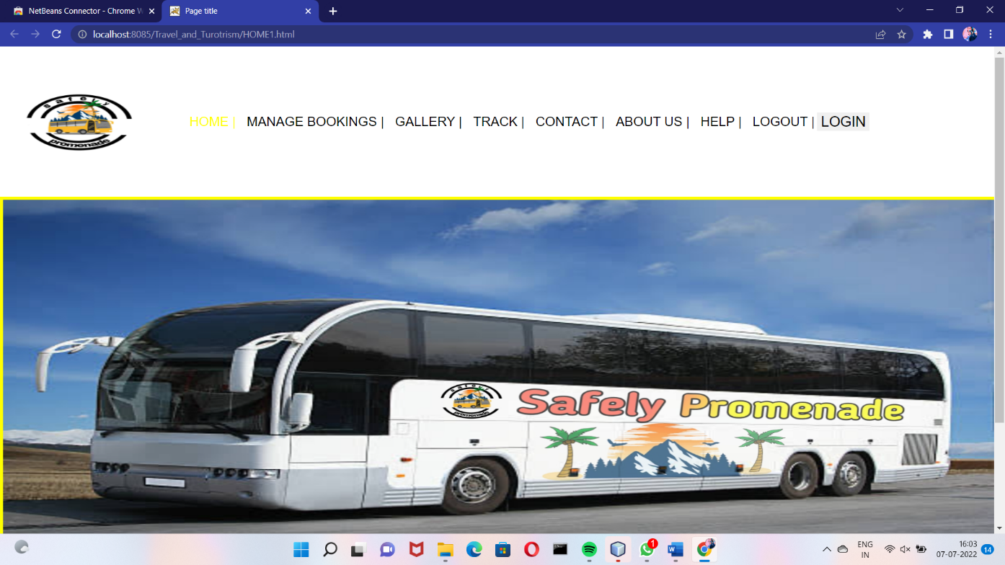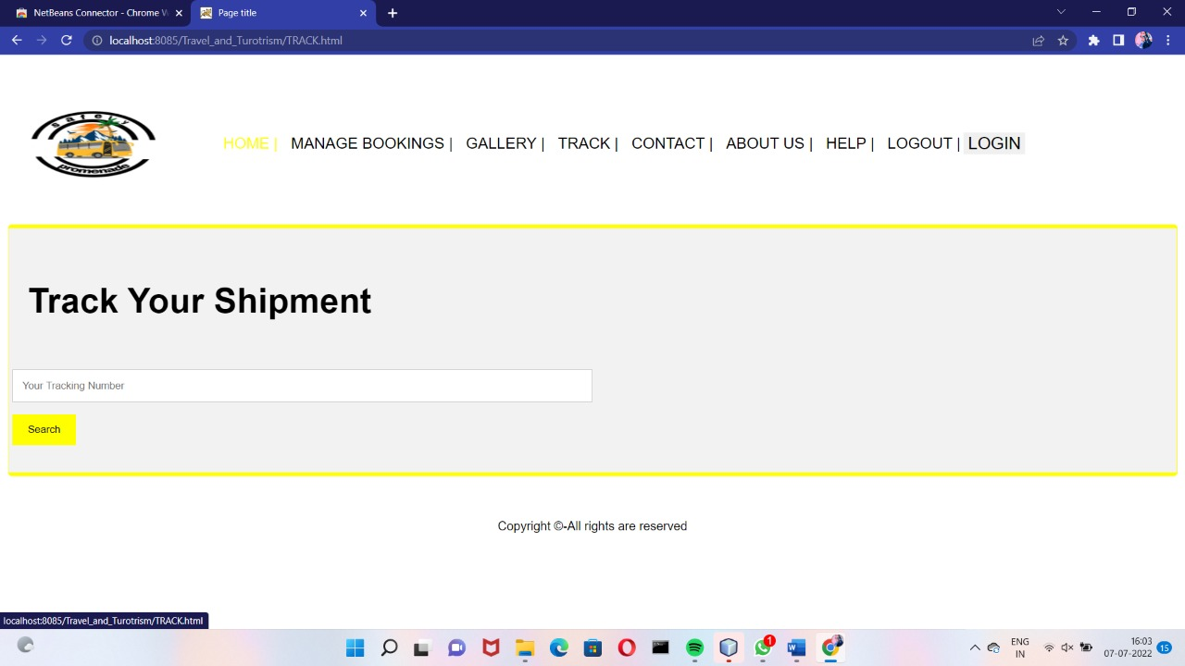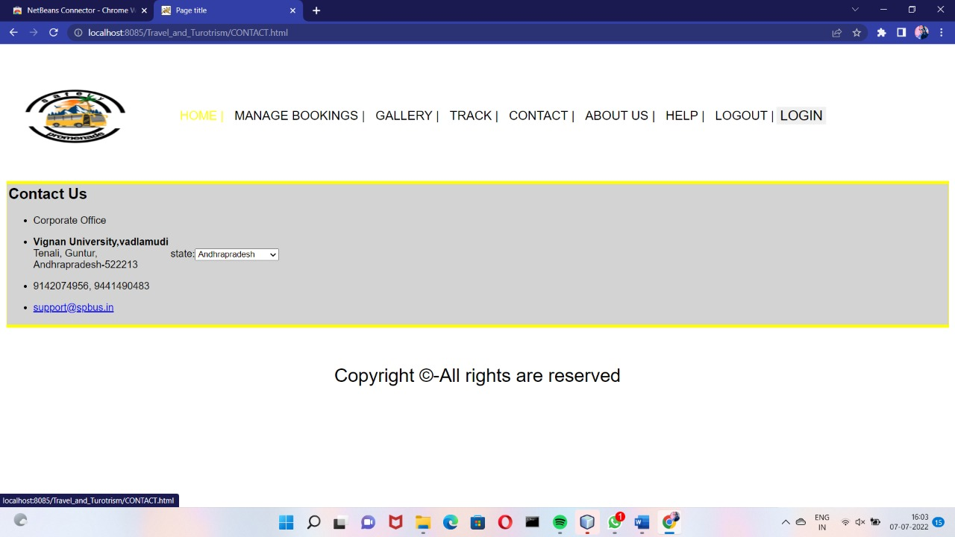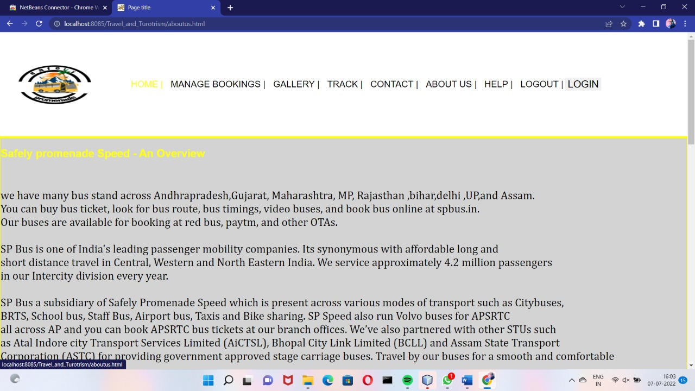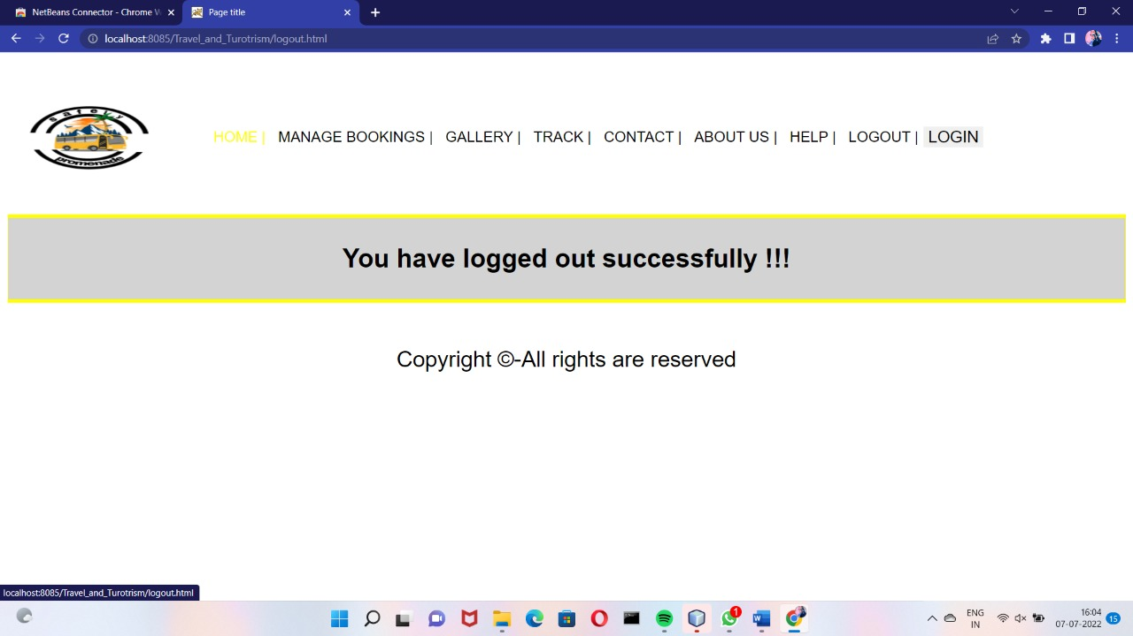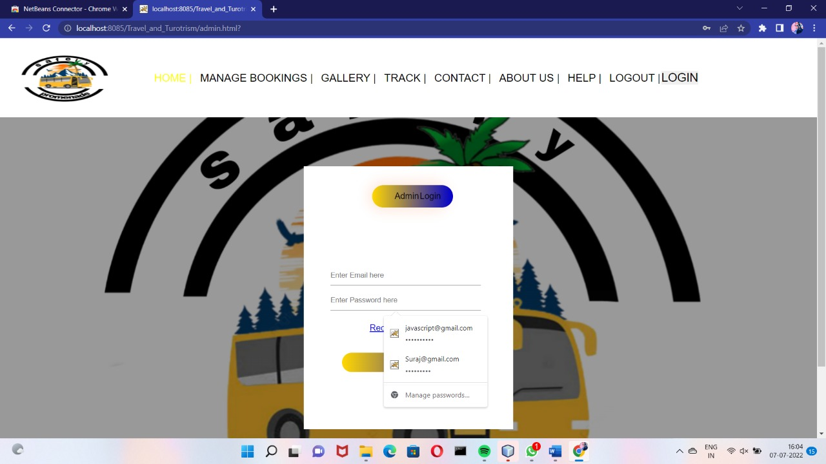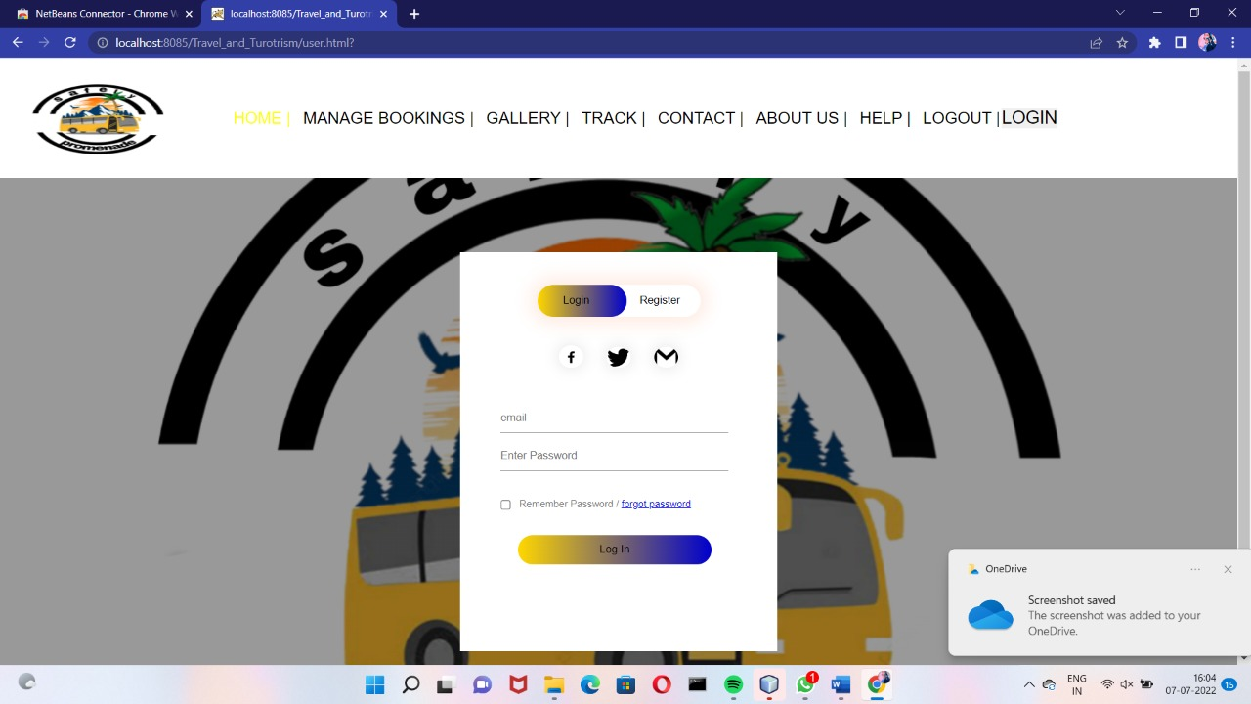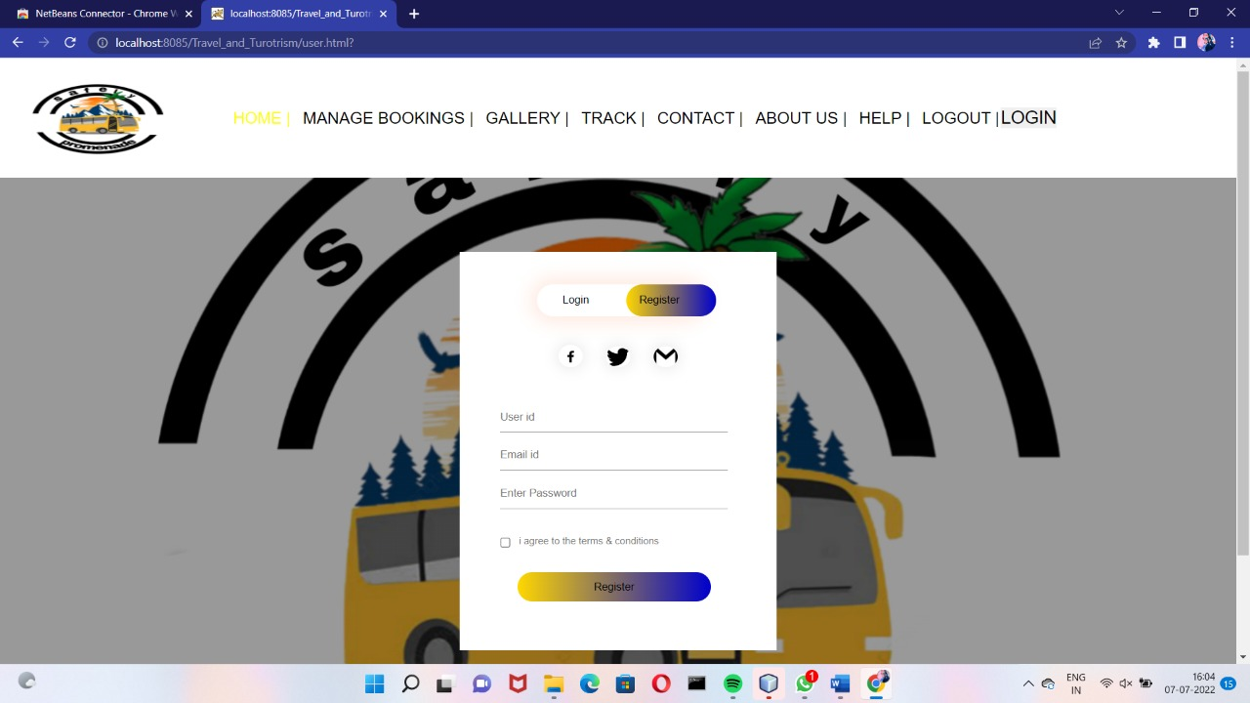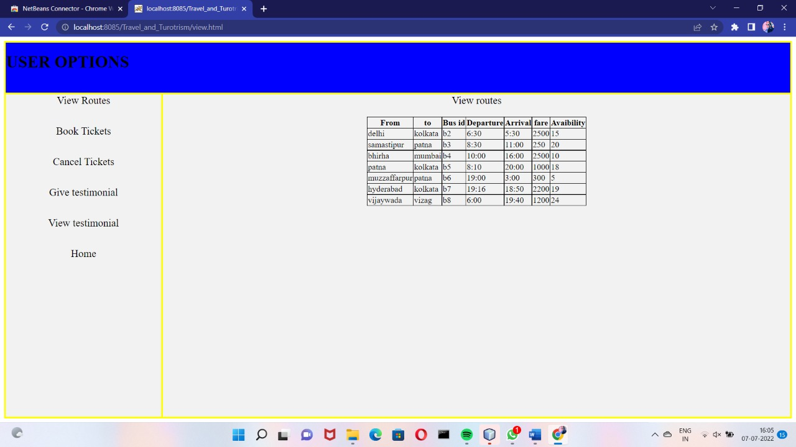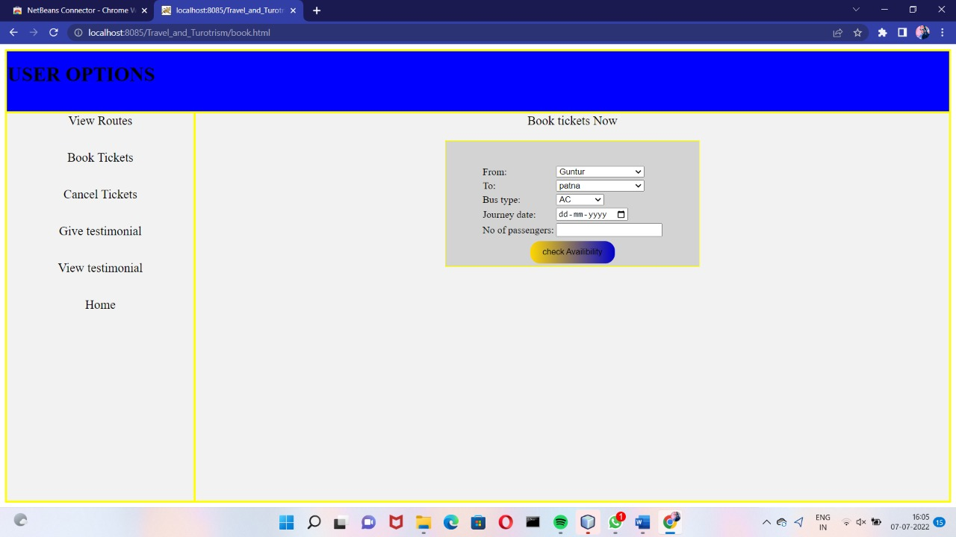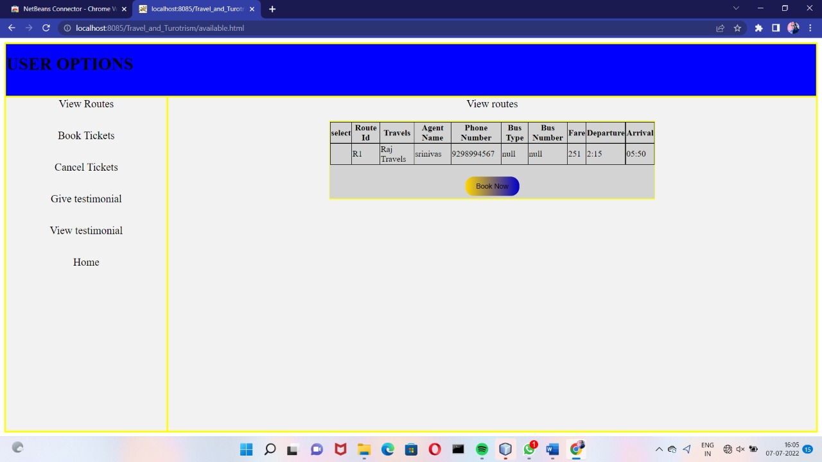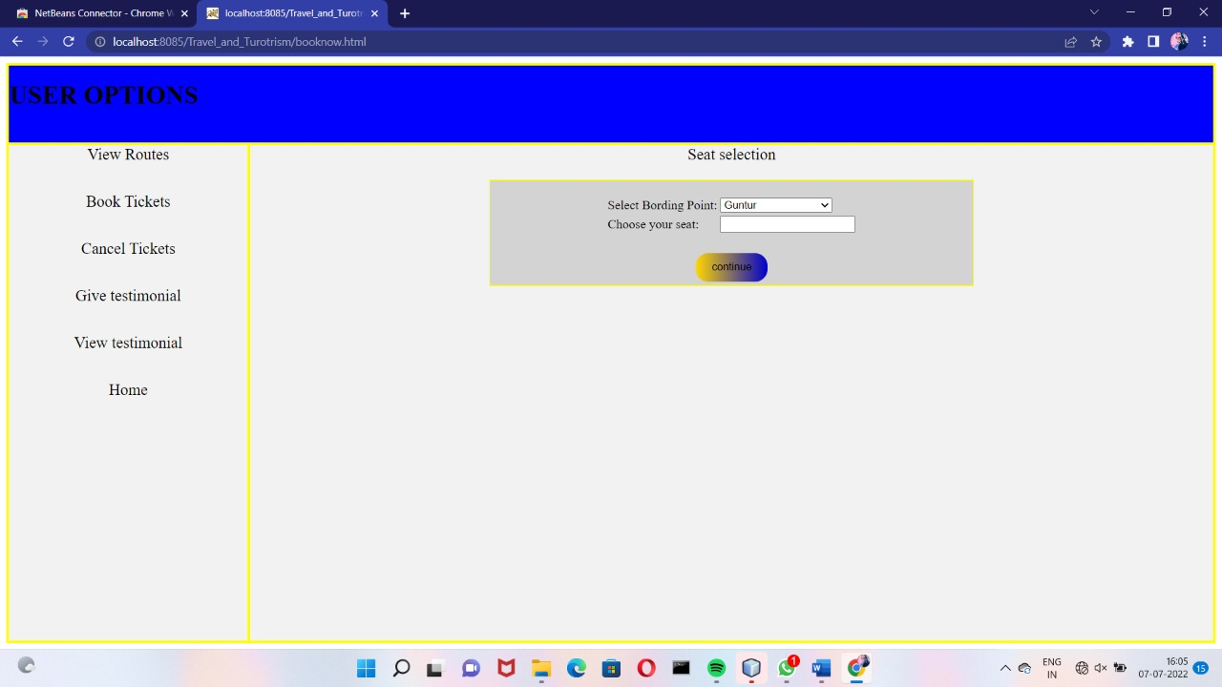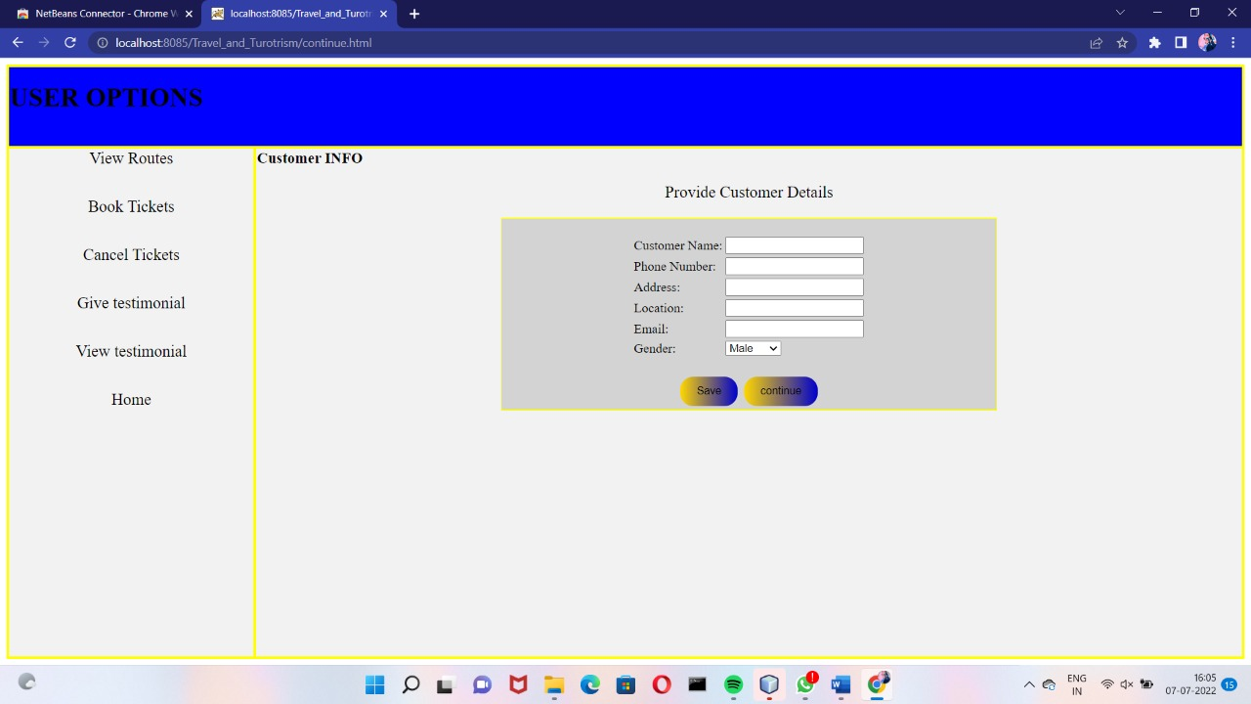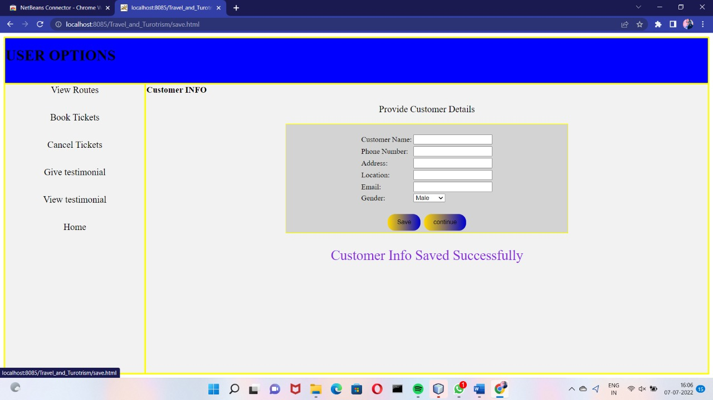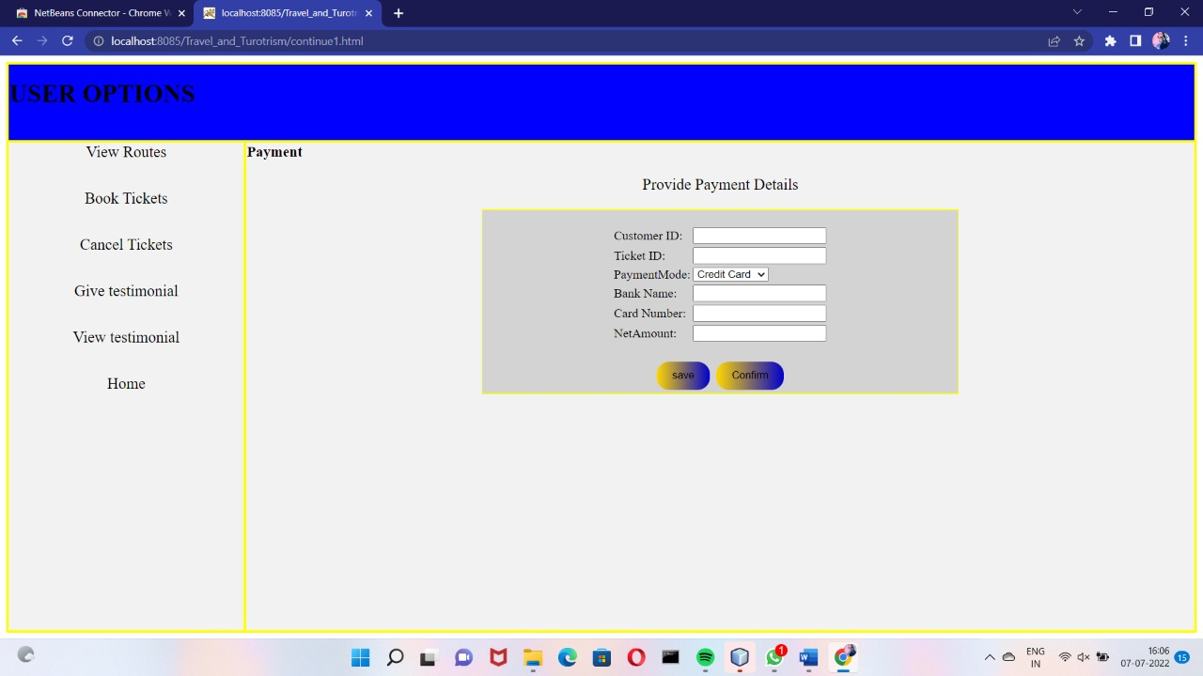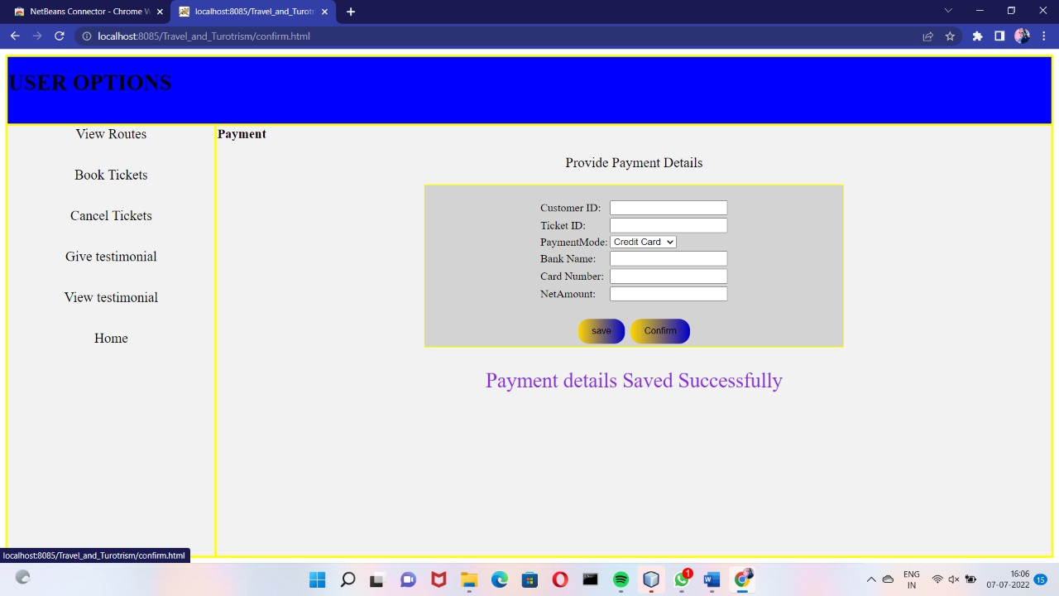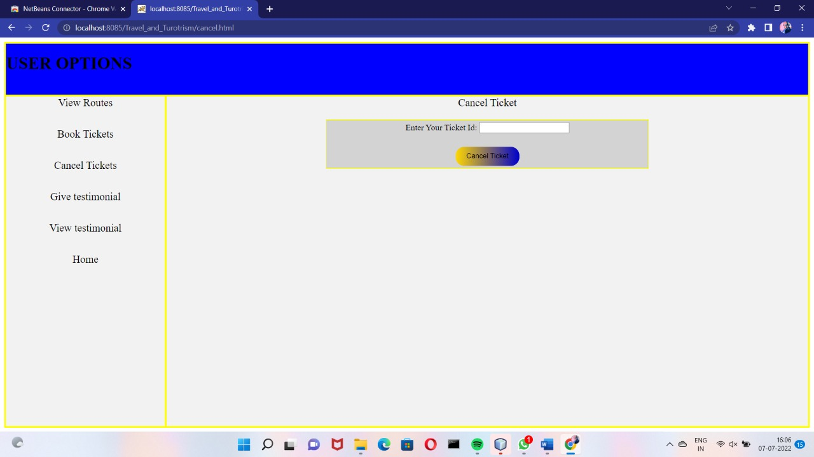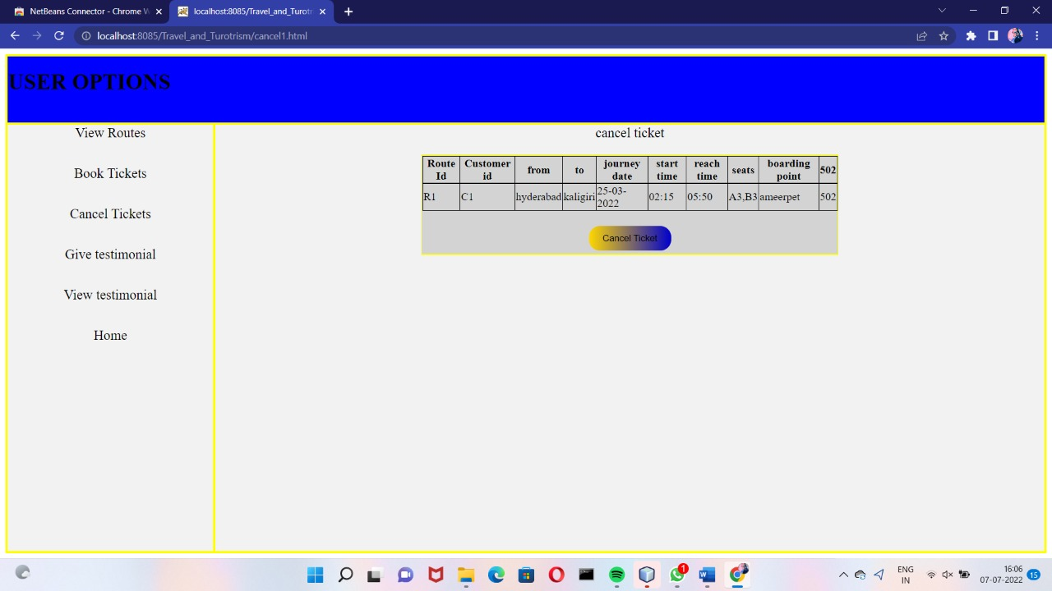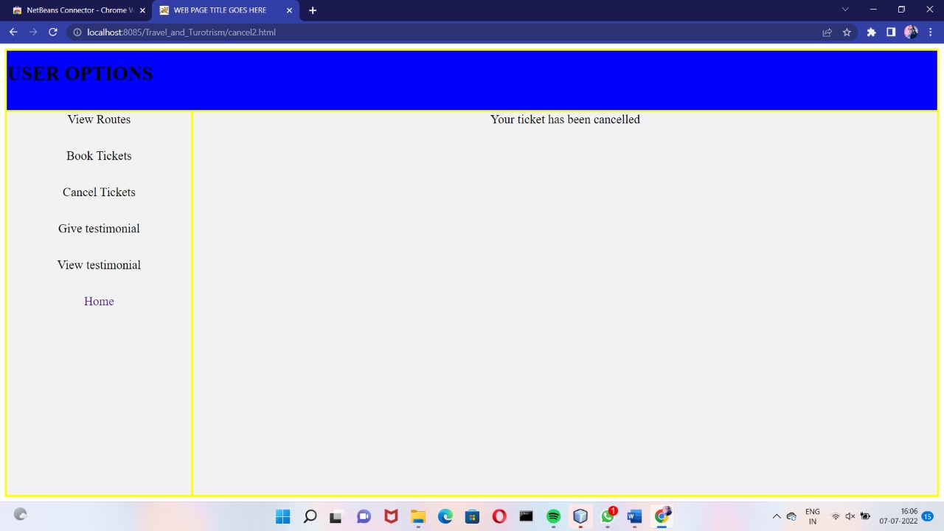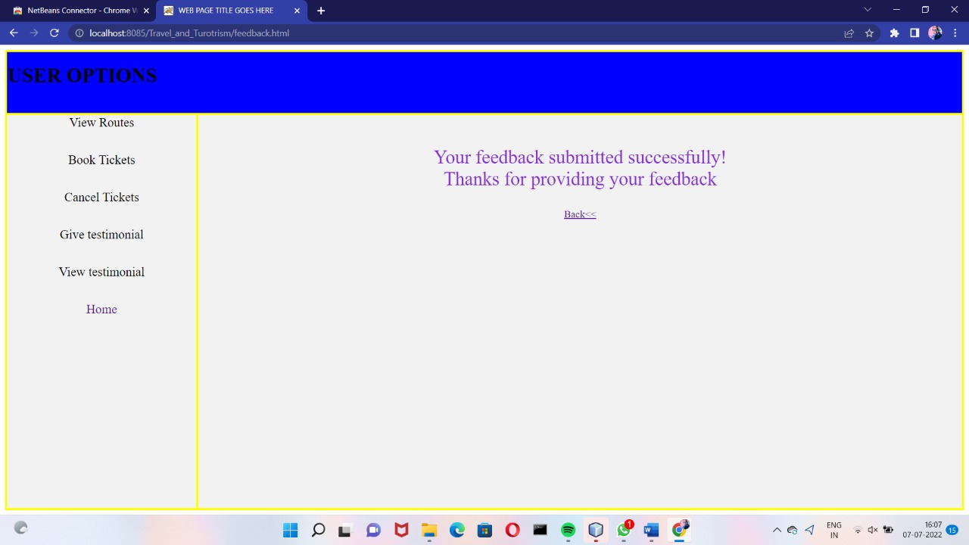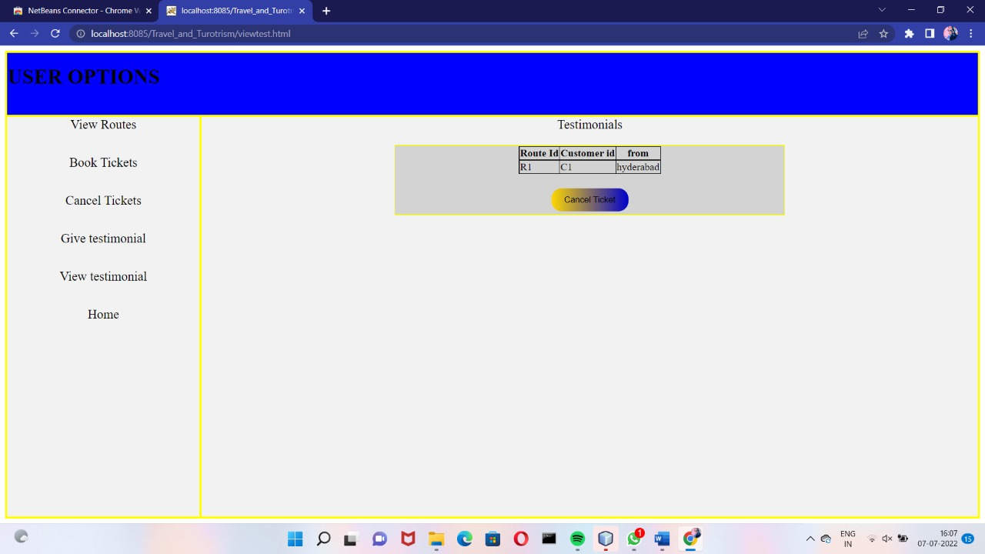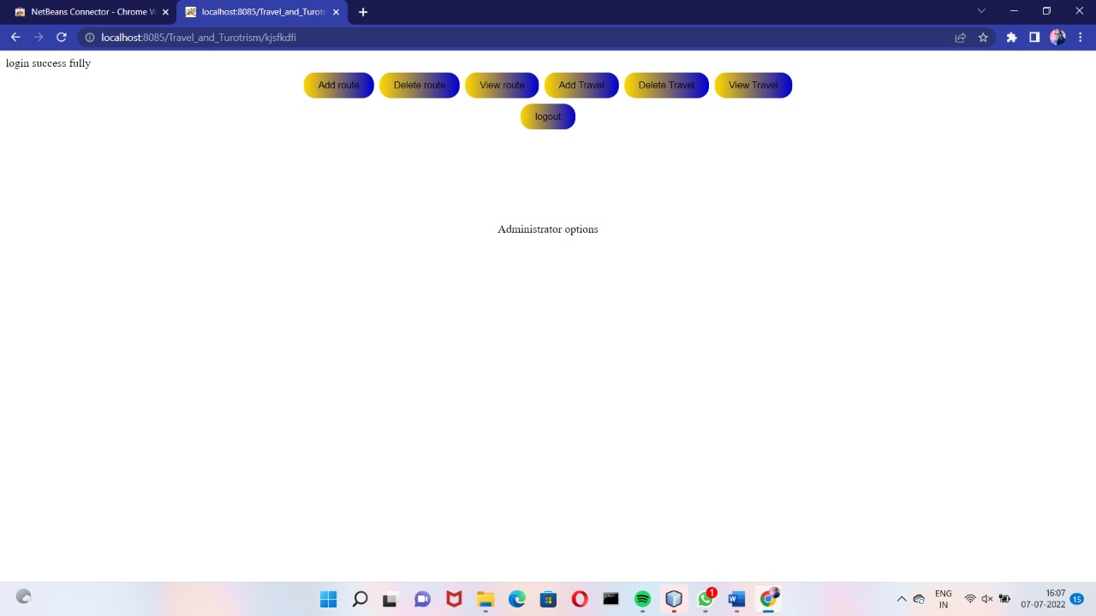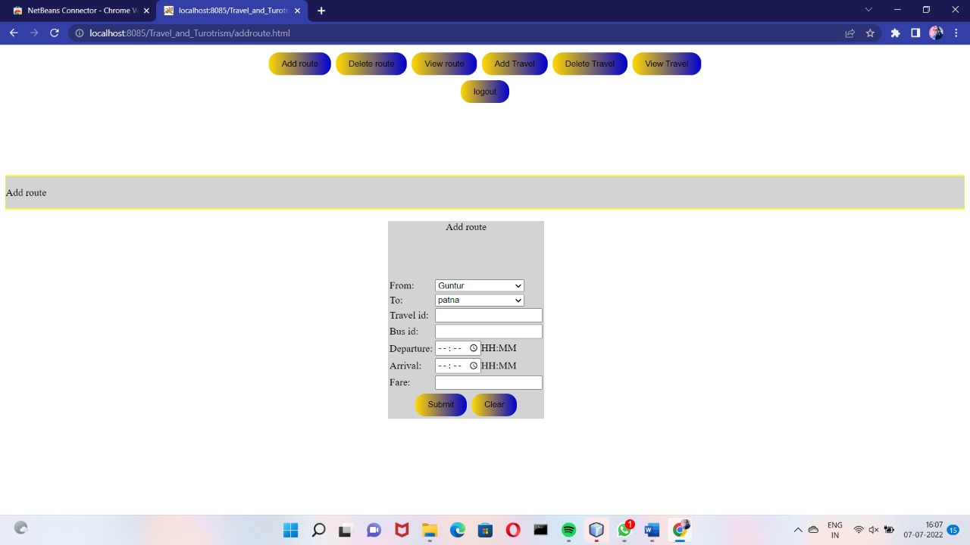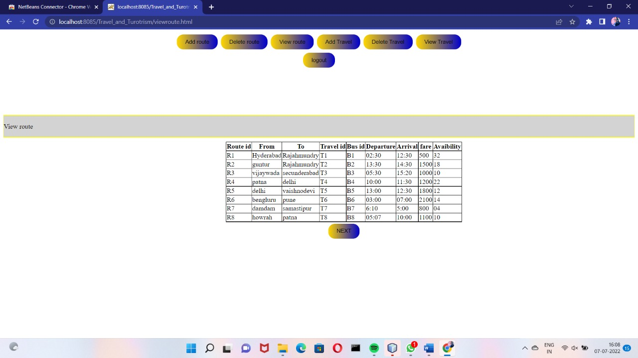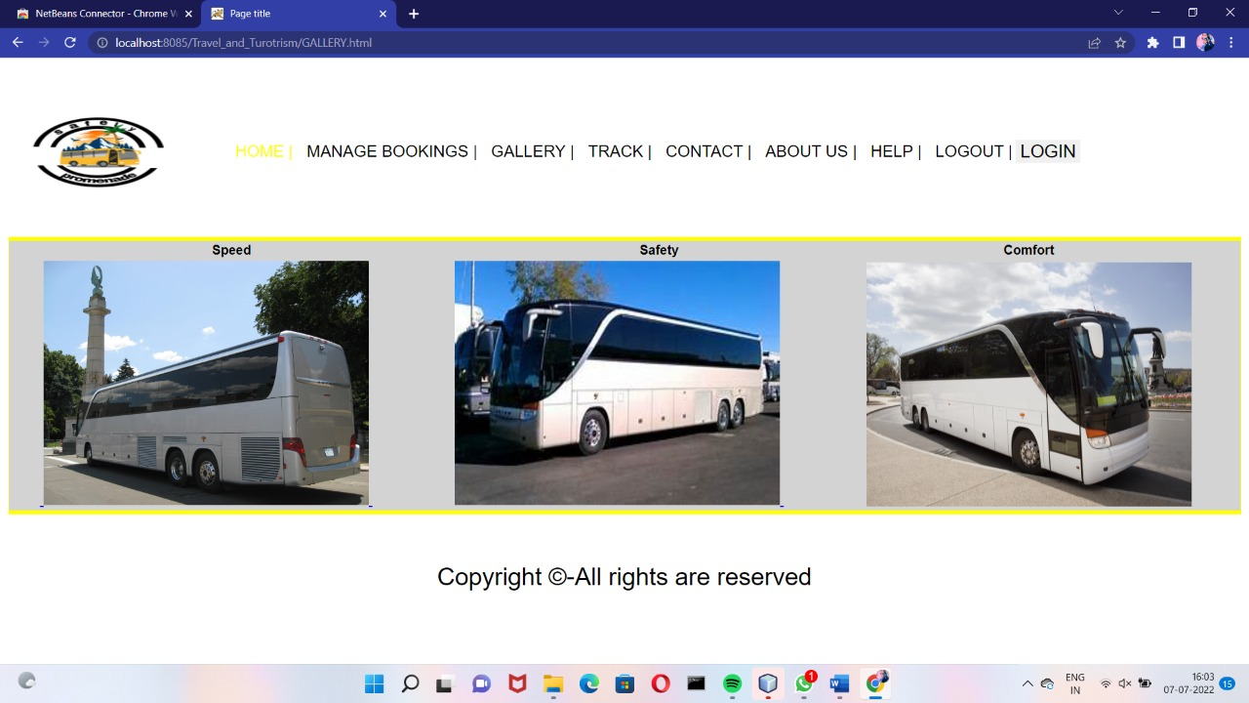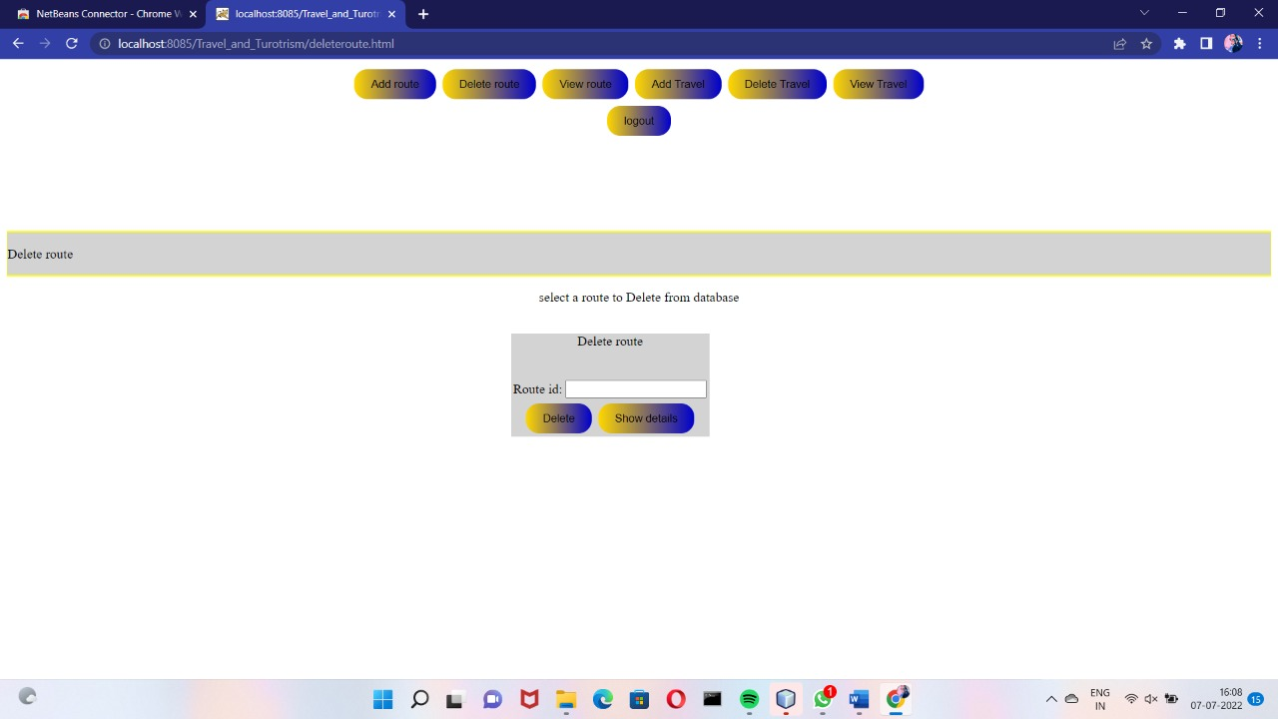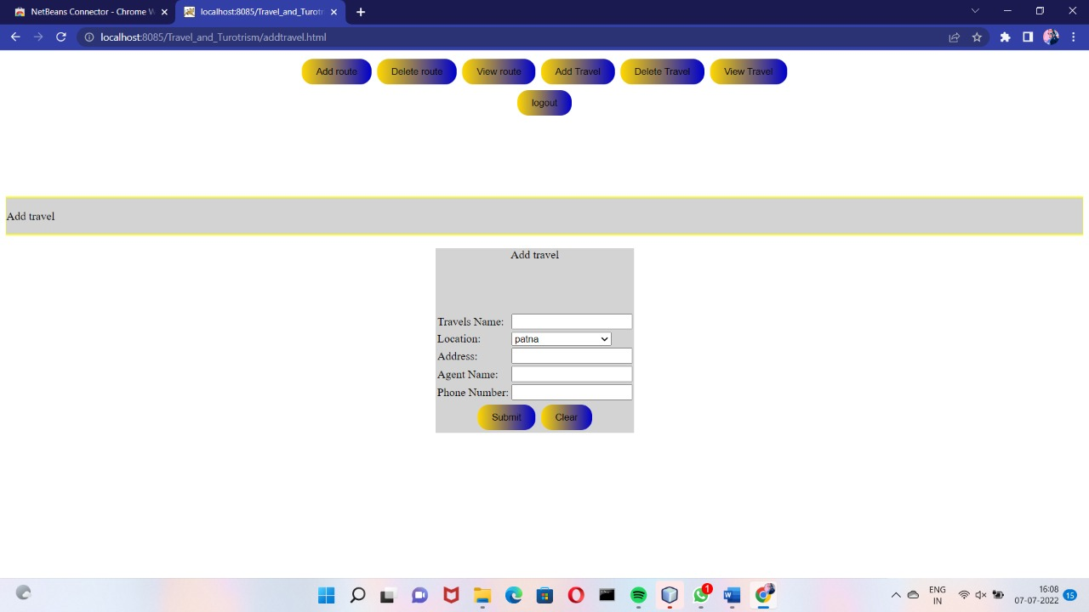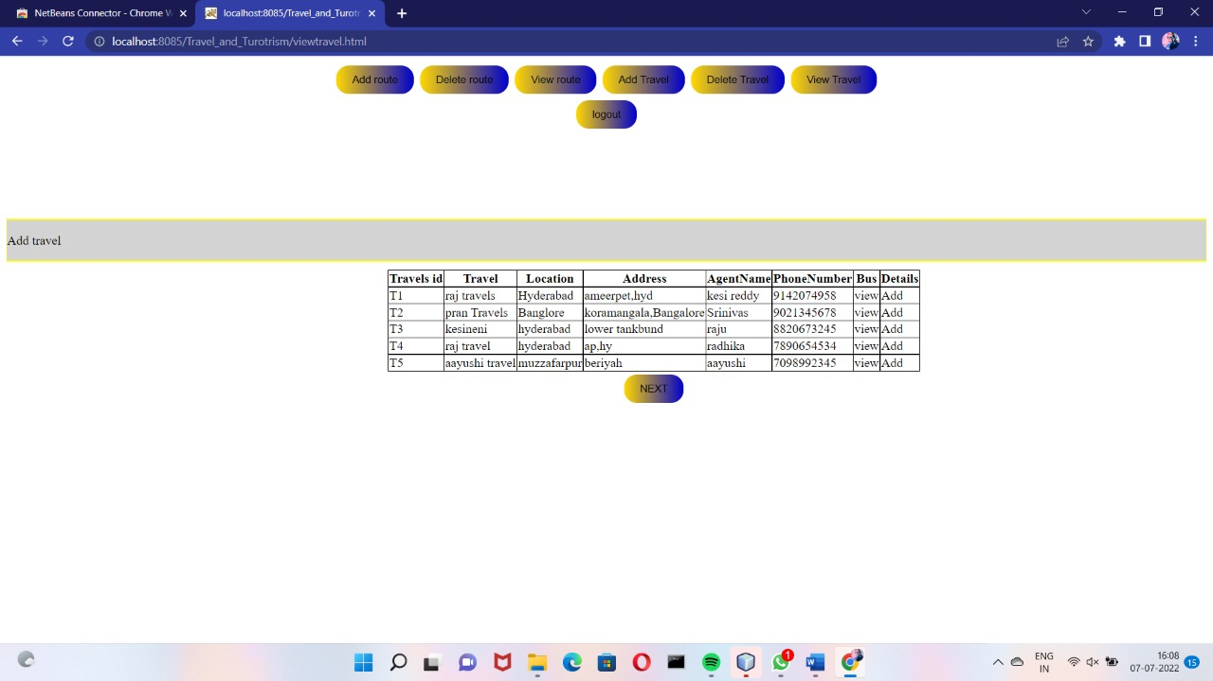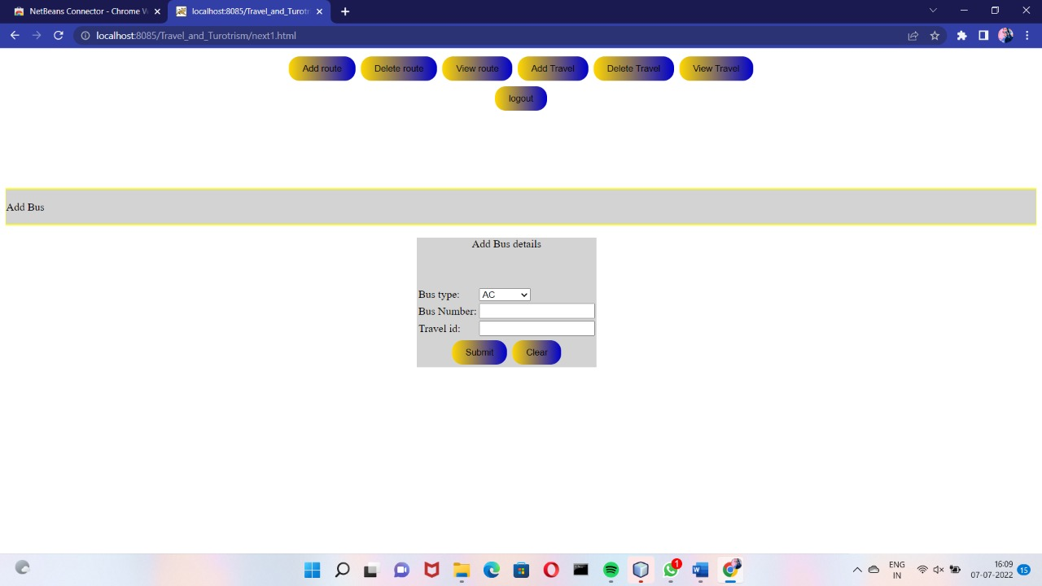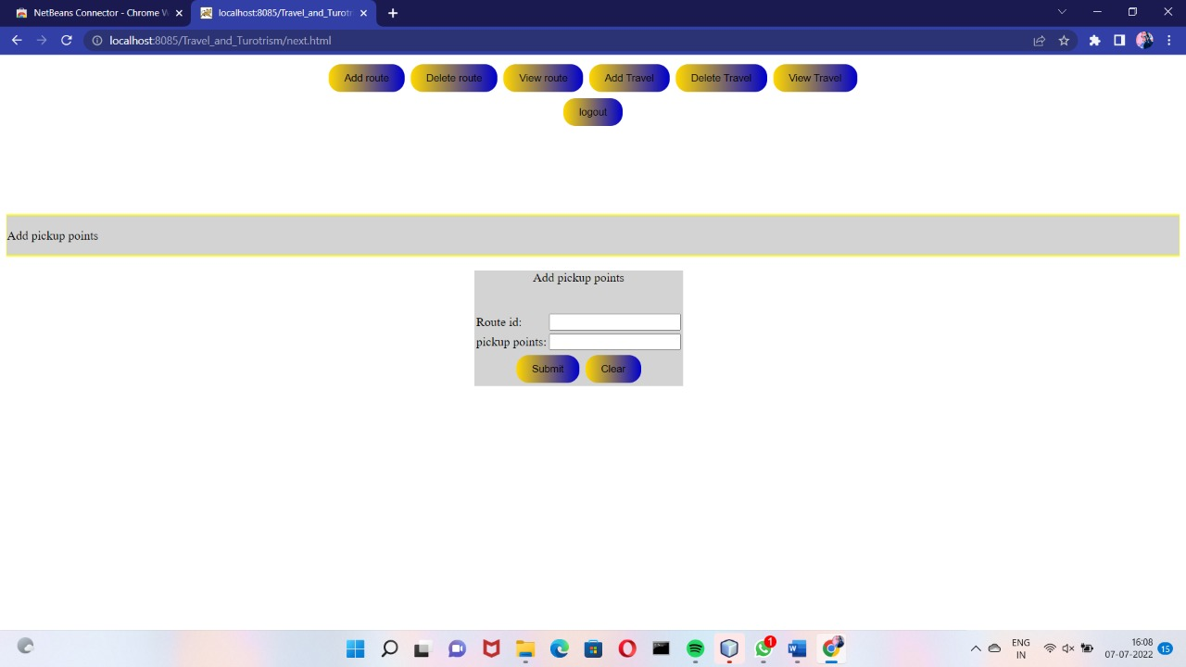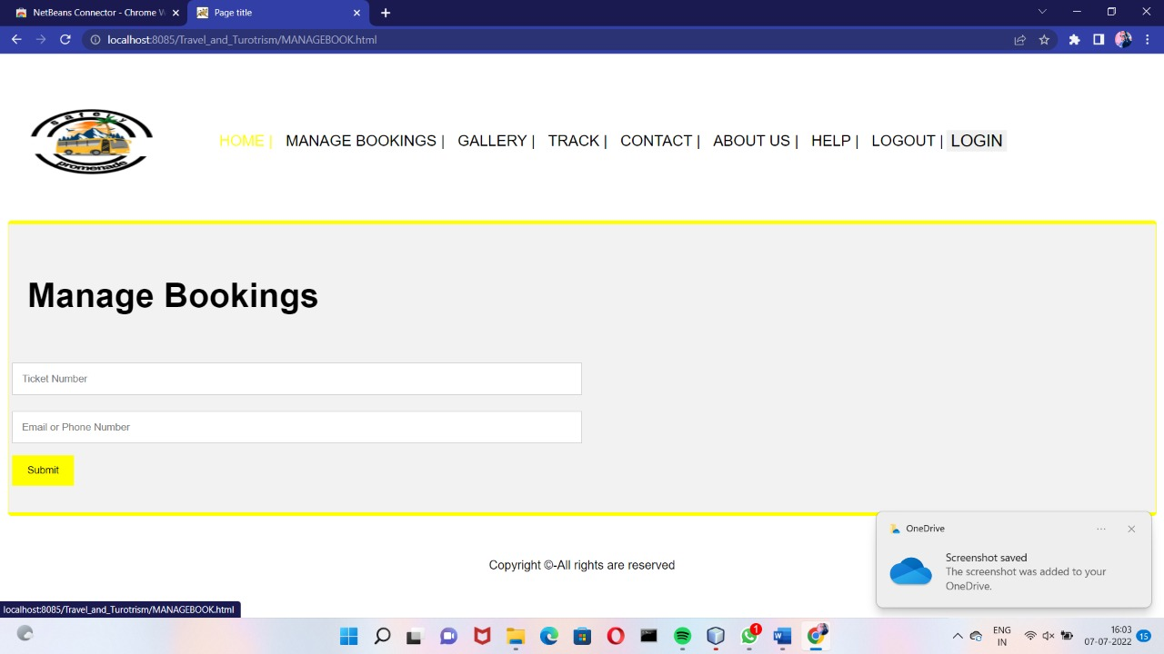

**8.TESTING**

**UNIT TESTING:**

The software units in a system are modules and routines that are assembled and integrated to perform a specific function. Unit testing focuses first on modules, independently of one another, to locate errors. This enables, to detect errors in coding and logic that are contained within each module. This testing includes entering data and ascertaining if the value matches to the type and size supported by java. The various controls are tested to ensure that each performs its action as required.

**INTEGRATION TESTING:**

Data can be lost across any interface, one module can have an adverse effect on another, sub functions when combined, may not produce the desired major functions. Integration testing is a systematic testing to discover errors associated within the interface. The objective is to take unit tested modules and build a program structure. All the modules are combined and tested as a whole. Here the Server module and Client module options are integrated and tested. This testing provides the assurance that the application is well integrated functional unit with smooth transition of data.

**9.CONCLUSION**

Travellers continue to seek authentic experiences. The tools they use to research and book these experiences are constantly changing due to innovations in technology. Destinations are also challenged by limited financial resources and strong competition for tourist dollars from other iconic and even lesser-known locations. The personalisation of travel suggests that independent travel will have a stronger presence than group travel, however, we must always consider the type of traveller. The travel services sector is being forced to innovate at a startling rate.

In the past, face to face consultations with a travel agent was paramount for booking both leisure and business travel. Technology and global circumstances, such as pandemics, financial collapses, and terrorism, have put pressure on tourism and travel services. With the development of OTAs and emerging and disruptive technologies, the travel services landscape is constantly changing.

“Travel and Tourism Management System” management process in travelling Fast processing and immediate results with high security Minimizing human effort and cost-efficient database Navigation through the site is very easy. The web site covers all the areas required for an including tourism.